



Swansea Council logo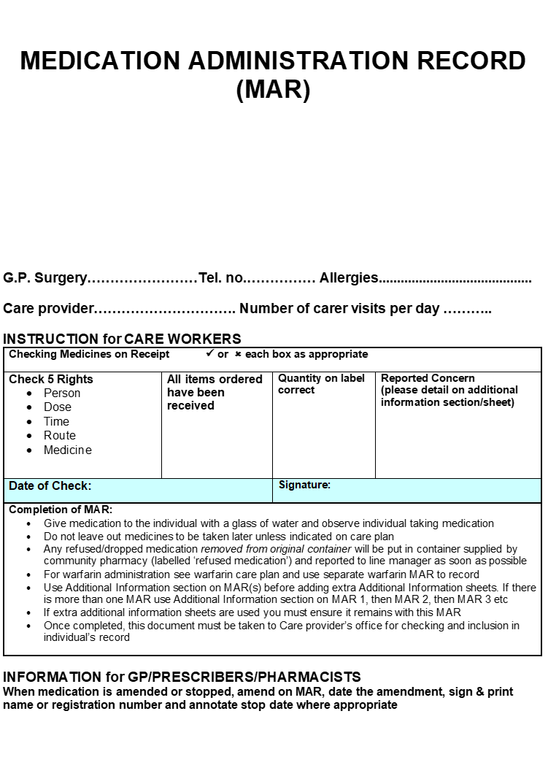

**Interim MAR Chart**

Individual: ____________________________________________________DOB: _________________________ Allergies: _____________________________________________________GP:_______________________________

|  |  |  |  |  |  |  |  |  |  |
| --- | --- | --- | --- | --- | --- | --- | --- | --- | --- |
| **Medicine & Instructions** | **Medication Administration Record** | | | | | | | | |
| Month: | |  | | | Year: | |  | |
| Day |  |  |  |  |  |  |  |  |
|  | M |  |  |  |  |  |  |  |  |
| L |  |  |  |  |  |  |  |  |
| T |  |  |  |  |  |  |  |  |
| N |  |  |  |  |  |  |  |  |
|  | M |  |  |  |  |  |  |  |  |
| L |  |  |  |  |  |  |  |  |
| T |  |  |  |  |  |  |  |  |
| N |  |  |  |  |  |  |  |  |
|  | M |  |  |  |  |  |  |  |  |
| L |  |  |  |  |  |  |  |  |
| T |  |  |  |  |  |  |  |  |
| N |  |  |  |  |  |  |  |  |
|  | M |  |  |  |  |  |  |  |  |
| L |  |  |  |  |  |  |  |  |
| T |  |  |  |  |  |  |  |  |
| N |  |  |  |  |  |  |  |  |
|  | M |  |  |  |  |  |  |  |  |
| L |  |  |  |  |  |  |  |  |
| T |  |  |  |  |  |  |  |  |
| N |  |  |  |  |  |  |  |  |

Written by:__________________________Signature: ____________________Designation______________________ Date:____________ Checked by:_________________________Signature: ____________________Designation _____________________ Date_____________

**Key:**

A = Individual is out, F = Family responsible for administering, H = Hospital/respite, 4 = for later, O = other, R = Refuse, S = Self-administer

        Individual’s Name_______________________________________________DOB:____________

|  |  |  |  |
| --- | --- | --- | --- |
| **Additional Information** | | | |
| **Date** | **Time** | **Details** | **Signature** |
|  |  |  |  |
|  |  |  |  |
|  |  |  |  |
|  |  |  |  |
|  |  |  |  |
|  |  |  |  |
|  |  |  |  |
|  |  |  |  |
|  |  |  |  |
|  |  |  |  |
|  |  |  |  |
|  |  |  |  |
|  |  |  |  |
|  |  |  |  |
|  |  |  |  |
|  |  |  |  |
|  |  |  |  |
|  |  |  |  |
|  |  |  |  |
|  |  |  |  |
|  |  |  |  |
|  |  |  |  |
|  |  |  |  |
|  |  |  |  |
|  |  |  |  |
|  |  |  |  |
|  |  |  |  |
|  |  |  |  |
|  |  |  |  |
|  |  |  |  |
|  |  |  |  |
|  |  |  |  |
|  |  |  |  |
|  |  |  |  |
|  |  |  |  |
|  |  |  |  |
|  |  |  |  |
|  |  |  |  |
|  |  |  |  |
|  |  |  |  |
|  |  |  |  |