

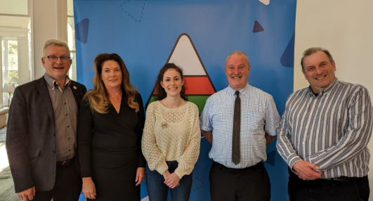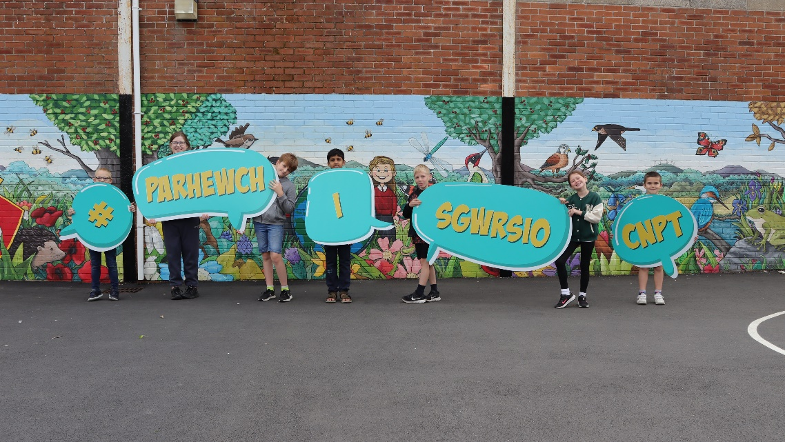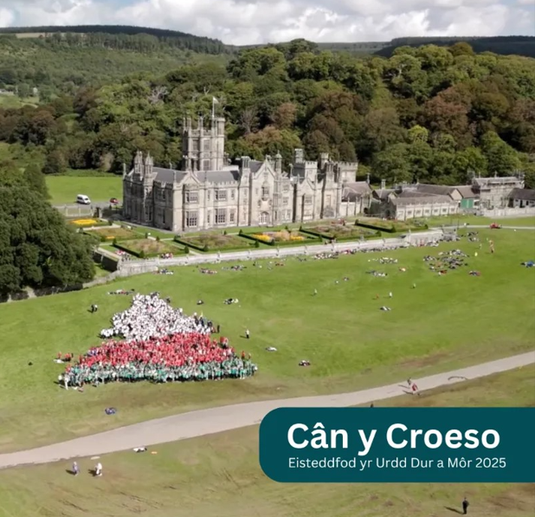

Neath Port Talbot County Borough Council

Welsh Language Promotion Strategy (WLPS)   
2023-2028

**Annual report 2023-2024**

**Welsh Language Promotion Strategy (WLPS)**

Mae’r ddogfen hon hefyd ar gael yn Gymraeg

This document is also available in Welsh www.npt.gov.uk/equalities

**Contents**

|  |
| --- |
| Introduction……………………………………………………………………………………….……….…………..……….. 2 |
| Developments during 2023-2024 …………………………………………………………………..…………..…………. 3-4 |
| Initiatives for Neath Port Talbot Council Employees 2023-2024…………………………….......................................... 5 |
| Progress on Action Plan for 2023-2024………………………………………………………………………..……….……. 6 |
| Strategic Theme 1: Increasing the numbers of Welsh speakers...……………………………….………………. 6 |
| Strategic Theme 2: Increasing the use of Welsh……………………………………………………..…………….. 9 |
| Strategic Theme 3: Creating Favourable Conditions: Infrastructure and Context…………………………..…. 13 |

If you require this report in larger print or in an alternative format, please contact the Corporate Policy Team on 07805 771506 or email: policy@npt.gov.uk

**Introduction**

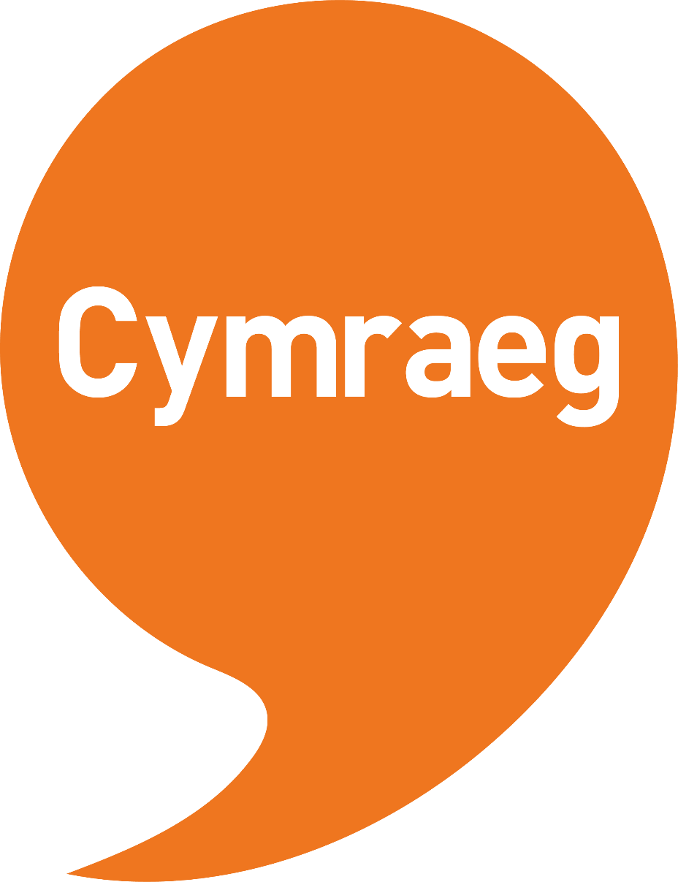

*In 2021, an estimated*

*538,000 usual residents in Wales*

*aged three years and over (17.8%)*

*reported being able to speak Welsh - a*

*decrease since 2011 (562,000, 19.0%)*

*(Census 2021).*

*One of the main factors contributing to the overall decrease in the percentage of people who reported being able to speak Welsh between 2011 and 2021 was the decrease in children and young people aged 3 to 15 years who reported this skill.*

*Whilst this number is consistent throughout Wales, within Neath Port Talbot data from our Pupil*

*Level Annual School Census (PLASC)*

*shows the projected target of pupils*

*in Welsh Medium Schools for 2023*

*is met at 16.2%, or 3,329*

*pupils out of a total*

*of 20,529.*

Our revised Welsh Language Promotion Strategy (WLPS) 2023-2028 was adopted by Council on 12 July 2023.

The strategy aims to ensure that by 2028 Welsh is much more audible and visible in local communities and used by more people in their daily lives.

In reflects the strategic themes of the Welsh Government’s ‘Cymraeg 2050’ Welsh Language Strategy, and sets out how we will work towards:

* increasing the number of Welsh speakers.
* increasing the use of Welsh; *and*
* creating favourable conditions (infrastructure and context) in the county borough.

In addition to promoting the use of the Welsh Language within our communities we also aim to promote the use of Welsh across the Neath Port Talbot Council workforce.

This is the first annual report for the Welsh Language Promotion Strategy (WLPS) 2023-2028. It covers the period from 1 April 2023 to 31 March 2024 and highlights our work in progressing the actions within the strategy with target dates of 2023 and 2024 during this time.

While progress was made in many areas there are some actions that have not moved forward as much as anticipated for a variety of factors.

Where some specific targets have been missed, the aim will be to achieve these within the next year to bring the plan back in line with its original timescales

**Developments during 2023-2024**

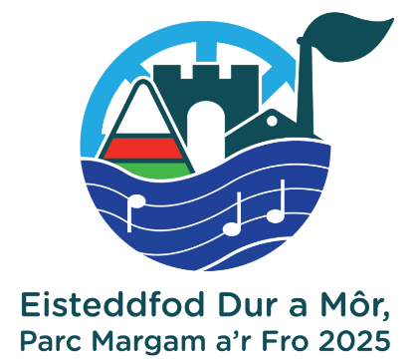**Urdd Gobaith Cymru**

In April 2023 Urdd Gobaith Cymru announced that Margam Park will be the venue for the 2025 Urdd Eisteddfod.

The Urdd Eisteddfod 2025 will be the largest Welsh language event to take place in the county borough since it last visited Margam Park in 2003. It will present unrivalled opportunities for Neath Port Talbot to proudly promote Welsh language, culture and heritage in the lead up to, during and after the festival.

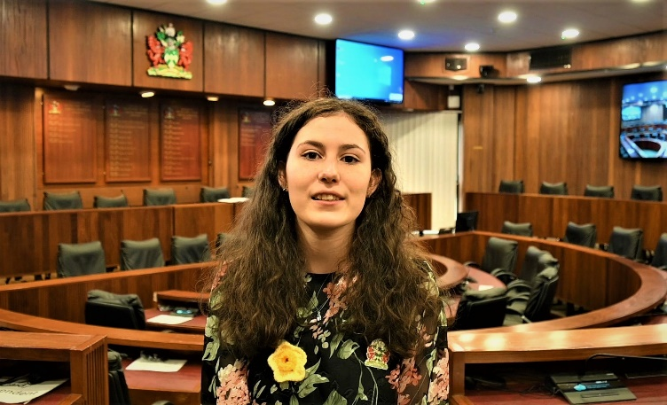**Youth Mayor**

March 2023 saw the inauguration of a new Youth Mayor for Neath Port Talbot. For her year in office Maddie Pritchard, a fluent Wesh speaker, chose to focus on the Welsh language as one of her priorities in support of the Welsh Government target of one million Welsh speakers in Wales by 2050.

Maddie was also the first Welsh Language Champion for NPT Youth Council and the legacy of this is that the Youth Council will have a Welsh Language Champion every year going forward.

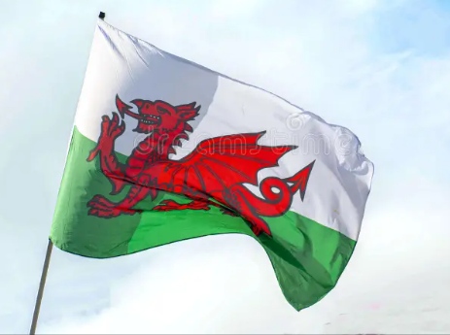**Welsh Language Champions**

Following the sad loss of our Welsh Language Champion, Cllr. Marcia Spooner, in 2023 two new Welsh Language Champions were appointed.

Cllr. Rebecca Phillips and Cllr. Rosalyn Davies will advocate for the Welsh Language and promote its use in Neath Port Talbot.

**Developments during 2023-2024 (cont.)**

**Welsh Club**

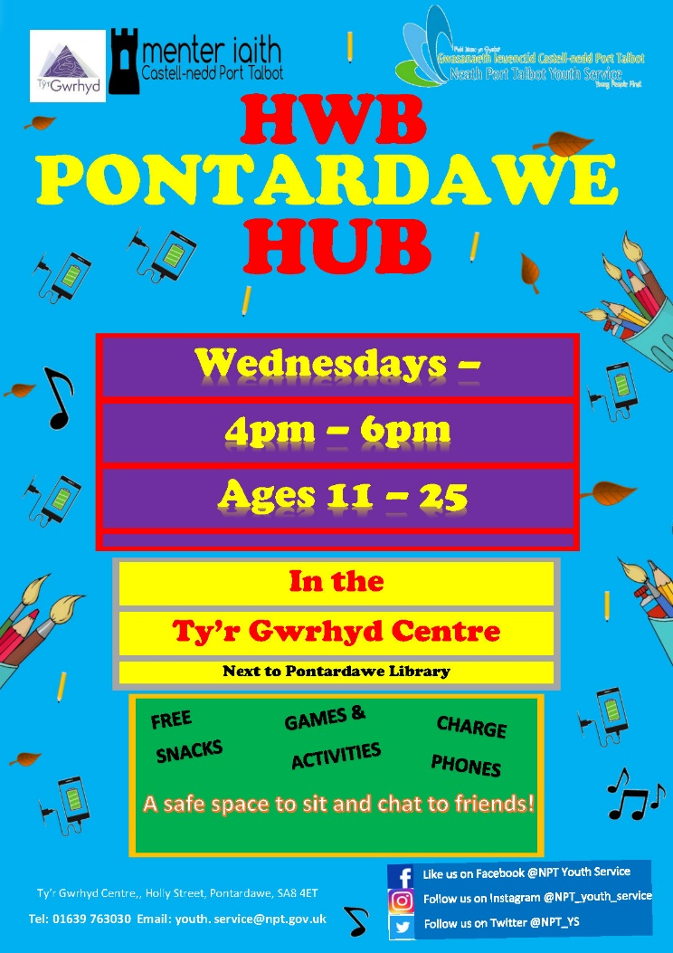

An after-school Welsh Club was piloted in Pontardawe, offering young people somewhere safe to socialise whilst also being able to practice their Welsh language skills.

The club, run by NPT Youth Service and Menter Iaith CnPT with a bilingual youth worker, was attended by a total of 27 young people. Following the success of the pilot, a second Welsh Language Youth Club was launched in Trebannos and is well attended by young people.

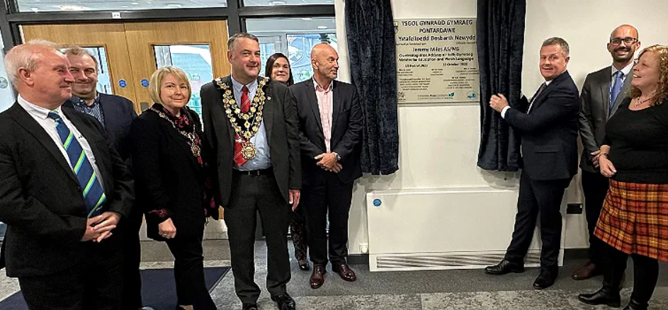**New school facilities to strengthen Swansea Valley Welsh medium education**

New classrooms and a Welsh Language Immersion Centre were officially opened on Friday, October 13th, 2023 at Ysgol Gynradd Gymraeg Pontardawe by the then Minister for Education and Welsh Language, Jeremy Miles MS.

The project enabled the school to increase capacity by 60 pupils and the existing childcare setting by 12 full time places

**Learning Welsh**

The ‘Learning and Using Welsh’ page on the council’s website saw an increase of 166 hits or 44.5% in 2023-2024, compared to 2022-2023.

**Initiatives for Neath Port Talbot Council Employees 2023-2024**

Activities continued throughout the year to promote the Welsh language to NPT Council employees:

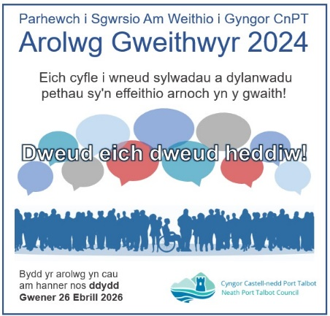

**NPT Council Employee Engagement Survey**

The first NPT Employee Engagement Survey for all council employees  
  
was launched during 2023-24 (March 2024).

In order to make the survey inclusive and accessible to all employees,   
  
and to provide opportunities to use the Welsh language in the workplace,   
  
respondents were offered the choice of taking part via a Welsh or English   
  
language questionnaire. There were 796 responses of which 8 were in  
  
Welsh; we aim to increase this figure at each future survey.

**Diwrnod Shwmae Su’mae Day**

In October 2023, two new videos were produced to promote the annual Diwrnod Shwmae Su’mae Day to staff. Rhys Locke, Teacher Development Officer and Noelwyn Daniel, Director – Strategy & Corporate Services both shared their pride and appreciation for the Welsh Language as part of their cultural identity.

**Training Opportunities**

Menter Iaith CnPT provided six weeks of free, informal Welsh Language “Hyder-ish” sessions. These were aimed at improving confidence in speaking Welsh amongst fluent speakers and more advanced learners in a relaxed environment. The sessions also included weekly activities such as crafts and quizzes.

Welsh Language courses were promoted for staff working in Education. Provided by the National Centre for Learning Welsh, the courses ranged from beginner to advanced. These courses were a delivered via mixture of virtual and blended learning, to suit individual lifestyles and made available to all staff aged 18-25 years old.

**Progress on Action Plan for 2023-2024**

**Strategic Theme 1: Increasing the numbers of Welsh speakers**

**Area of work: Support the implementation of the WESP 2022-2032**

|  |
| --- |
| Action: 1.1 Promote the 'Welsh Homework Help' Facebook group to all pupils and their families who attend Welsh medium schools |
| Progress 2023-2024: |
| Menter Iaith CnPT (MICnPT) attended a number of events in the area during the 12 months where they promoted the 'Welsh Homework Help' Facebook group to parents of children in Welsh education. MICnPT also attended school open days where they provide parents with a QR code to sign up to the group. MICnPT have also added a number of new resources to the Facebook group during the year for parents to utilise at home. |
| Action: 1.2 Update and promote the ‘Benefits of Bilingualism’ booklet to families |
| Progress 2023-2024: |
| Whilst the booklet has not yet been updated MICnPT has been distributing a leaflet outlining some of the benefits of bilingualism together with a booklet guide to Welsh education. |
| ‘Taith yr Iaith’ series of 4 videos to promote the benefits of bilingualism completed and is currently with the NPT media department ready to be released |
| Action: 1.3 Promote bilingualism to perinatal families |
| Progress 2023-2024: |
| All marketing and promotion materials produced in Welsh and English and social media. |
| Families are offered the choice to access services through the medium of Welsh or English |

**Area of work: Language transmission in the home**

|  |
| --- |
| Action: 1.4 Identify the availability (face to face and online), cost and location of Welsh language courses and promote these to residents |
| Progress 2023-2024: |
| MICnPT signposts parents and people within the community to the Dysgu Cymraeg ABA website and provides them with contact details. They also signpost people to the Clwb Cwtch course provided by Mudiad Meithrin |
| Action: 1.5 Develop and promote Welsh language awareness sessions to residents |
| Progress 2023-2024: |
| MICnPT delivered presentations within Welsh Primary school open days for parents and childcare settings within the year. |
| MICnPT also held a programme of events during the school holidays where they attended libraries and held craft events and silent discos. During these events opportunities were taken to speak to parents about the benefits of the Welsh language |

**Area of work: Support people learning/speaking Welsh**

|  |
| --- |
| Action: 1.6 Provide opportunities for Council staff to access appropriate levels of Welsh language learners/improvement courses |
| Progress 2023-2024: |
| The council’s Welsh Training Programme signposts individuals to the Welsh language Level and ‘Help me find a course’ checker |
| Council employees are encouraged to progress through the levels of training where possible. The majority of learning chosen are the Work Welsh funded courses through the Centre for Learning Welsh, however classes have been funded for staff when they wish to progress above the courses on offer. |
| All managers are encouraged to allow their teams to attend Welsh courses regardless of whether the language is required as part of the role and they are allowed day release from their typical workday to attend |
| A total of 19 staff accessed language improvement courses between April 2023-March 2024 |
| Action: 1.7 Create and promote Welsh language resources for families and the public more generally |
| Progress 2023-2024: |
| The “Learning and Using Welsh” page on the council’s website which was created on 15 March 2022 had 374 hits in its first full year (between 1 April 2022 and 31 March 2023). This rose to 540 hits between 1 April 2023 and 31 March 2024 - an increase of 166 hits or 44.5% |
| MICnPT created a number of new resources over the year for parents to use with their children at home. They also created a Welsh pack for the youth clubs within the local authority area to assist them in providing Welsh activities within their sessions. |
| MICnPT created a resource pack for day nurseries to assist them with providing and introducing Welsh during their sessions. They also attended the day nurseries to explain the pack and demonstrate some of the activities. |
| NPT Council Training: Through the Social Care Wales Workforce Development Grant, the wider social care workforce (private social care) is offered the opportunity to learn Welsh through online learning provided by Social Care Wales. This opportunity allows for the Welsh language to be more available and seen in communities across Neath Port Talbot through the provision of Health & Social Care, Early Years and Childcare Sectors. |
| In 2024 a new resource for the Social Care sector ‘Care and comfort in Welsh’ was introduced and has been promoted. This resource is designed particularly for palliative care workers to allow them to offer an element of care and comfort in the language of choice to individuals who are at end of life. |
| NPT Council recognises that employees are also part of our communities. As such our Training Programme also includes information, resources and signposting for:  • Resources for Teenagers and Young Adults  • Resources for Children |
| Action: 1.8 Develop/signpost to appropriate courses and support for teaching and non-teaching staff learning Welsh |
| Progress 2023-2024: |
| A programme of training and learning opportunities, including interactive applications is kept up to date using book creator, this means that any changes and updates are live and don’t require republication. This programme is available on NPT Connect to NPT Council employees, including teaching staff. Opportunities are also posted throughout the year through the staff engagement tool Viva Engage ‘Welsh Speakers and Learners community’. |
| The council’s corporate equalities budget is used to support Welsh language training when requested. Fully funded Work Welsh courses from the National Centre for Learning Welsh are advertised in the council’s programme via the Viva Engage platform. |

**Strategic Theme 2: Increasing the use of Welsh**

**Area of work: Support and promote the use of Welsh in social settings 2022-2032**

|  |
| --- |
| Action: 2.1 Explore opportunities with the Library Service to raise awareness of Welsh language books/materials with residents |
| Progress 2023-2024: |
| Throughout 2023-2024, a total of 8,971 Welsh Language items were loaned by the NPT library service |
| NPT Youth Council helped promote the NPT Library Service within Schools and held a World Book Day Stall in Aberavon Shopping Centre where more than 40 young people signed up as new library members. This work included the promotion of Welsh Language books which were on display during the event. |
| Action: 2.2 Explore opportunities to increase the visibility of the Welsh language at all leisure and cultural facilities |
| Progress 2023-2024: |
| The Gwyn Hall stages annual Welsh language pantomimes, information pertaining to attendance figures will be captured in the Annual Report for 2024-2025. |
| Welsh Language events were held throughout Neath Port Talbot Libraries, information on the number of events and attendees will be captured and reported in the WLPS AR 2024-2025 |
| The new Neath Port Talbot Culture & Heritage Strategy includes an action plan to showcase progress on the principal theme “Welsh at Heart”, it is anticipated that progress on these actions will be reflected in the WLPS 2024-2025 annual report.  The Urdd Eisteddfod is due to take place at Margam Country Park in May 2025, the council is working closely with the Urdd Team to take advantage of wider opportunities to boost involvement by schools in Neath Port Talbot and to promote the Welsh language across all activities which will be undertaken to promote the event.   * The Urdd Eisteddfod is due to take place at Margam Country Park in May 2025, the council is working closely with the Urdd Team to take advantage of wider opportunities to boost involvement by schools in Neath Port Talbot and to promote the Welsh language across all activities which will be undertaken to promote the event. * A new Commercial Marketing Team has been established to raise the profile of our country parks, theatres and other venues and to assist them in generating additional revenue. As part of this the team is ensuring that all promotional activity is delivered bilingually and that Welsh speaking audiences are fully considered in all activity undertaken. * Pontardawe Arts Centre works closely with Menter Iaith Castell-nedd Port Talbot and hosts regular Welsh language evenings and schedules high profile Welsh language acts as part of its programme. |
| Action: 2.3 Develop a second Welsh language Youth Club in partnership with the voluntary sector in Tairgwaith |
| Progress 2023-2024: |
| NPT Youth Services, working with the voluntary sector in Tairgwaith ran a Welsh language youth club at Canolfan Maerdy opening 1 night a week for 28 sessions. Led by Welsh speaking Youth Workers, the provision reached 33 individual young people and gave them the opportunity to use Welsh in a social setting. |
| The Welsh Language Youth Club in Trebanos continued to be delivered in partnership with MICnPT and NPT Youth Service. The club opens 1 night a week based on school terms and offers young people opportunities to use Welsh language in a social context. The club also delivers sessions on Welsh culture and heritage. |
| An after-school Welsh language youth club was piloted in Pontardawe in partnership with MICnPT and NPT Youth Service offering a provision for young people to go while waiting to be collected from school. This was set up as a bilingual provision giving Welsh speakers the opportunity to use their Welsh in a social setting and giving the non-Welsh speaking young people the opportunity to hear Welsh being spoken and hopefully improve their Welsh language skills. The provision reached 27 individual young people. |
| Between 1 April 2023 and 31 March 2024:   * 74 individual young people attended Trebanos Welsh Youth Club. There was an average attendance of 28 per night. * 72 young people attended Cwmllynfell Bilingual Youth Club, with and average attendance of 19 per night. |
| Action: 2.4 Explore with children and young people how Welsh can be used more in a social context. |
| Progress 2023-2024: |
| As outlined in 2.3, two Welsh Youth clubs were delivered in the county borough in partnership with MICnPT and NPT Youth Service. |
| MICnPT also delivered Welsh sessions in every youth club in the county and all of the clubs received a pack to help them deliver Welsh sessions themselves. MICnPT also created promotional material to promote the Welsh language and the benefits of using it. |
| Welsh language lunch clubs were established in three second language secondary schools within the county borough. |
| There is an officer based in the two Welsh secondary schools. This officer provides Welsh language activities during lunch times outside of the classroom. |
| MICnPT and NPT Youth Service took a group of young people to Llangrannog for a weekend residential. The young people where immersed in Welsh language during their stay. 13 young people attended the three-day residential at the Urdd centre at Llangrannog where they took part in a variety of activities including abseiling, a high rope course, skiing, go karts, quads, toboggans and an escape room. The young people also completed a Level 1 Agored accredited course in Welsh Culture: The Traditions and Customs of Wales. Welsh language was used throughout the stay and the Agored course was delivered and completed through the medium of Welsh language. This was designed with the help of the NPT Youth Council. MICnPT attended a number of events over the year to promote the use of the Welsh language and the benefits of using it. |
| MICnPT provided a number of sessions and events during the year for children and young people outside of school. The aim of these activities is to provide opportunities for people to use their Welsh outside of the classroom. |
| Welsh remains a feature of our Youth Clubs Curriculum. The Local Authority Youth Clubs have been set a target to deliver a minimum of 1 Welsh Language/Culture activity per month. These include St David’s Day and St Dwynwen’s Day. All youth clubs were provided with a pack of resources so they could deliver Welsh bingo and improve knowledge of numbers in Welsh. |
| A variety of events were attended and delivered to promote use of the Welsh language. Leaflets were handed out explaining the importance of learning and speaking Welsh and the lyrics for the national anthem were also distributed. The sessions were also used to promote local services and events that were available for Welsh speakers. |
| Working in Partnership, NPT Youth Service and MICnPT delivered sessions in 10 youth clubs where use of the Welsh language was used and promoted. Each of the youth clubs was given a pack of resources to use containing resources and ideas to promote and use the Welsh language. |
| 24 Welsh language activity sessions were delivered in Welsh medium schools. Most of the young people would normally use English when speaking with friends socially in school. These sessions provided young people with the opportunity to use the Welsh language in a social setting. Staff delivered activities that were fun and encouraged and supported any pupils who were struggling with using Welsh in conversation. |
| The NPT Youth Council appointed its first Welsh Language Champion during the year to help promote the use of the Welsh Language. This role also supports the Youth Mayor and the wider Youth Council by providing a Welsh Language speaker for public events and presentations. |
| Action: 2.5 Work with local musicians to provide creative sessions for young people - exploring personal journeys in Welsh music, etc. |
| Progress 2023-2024: |
| A local musician Bronwen Lewis attend a range of youth clubs and youth groups showcasing her journey in Welsh music. Young people were given the opportunity to listen to a range of Bronwen’s songs and take part in a ‘question and answer’ session. |
| The music project ended with a Celebratory Event with Bronwen Lewis, which was held at Pontardawe Art Centre. This proved to be a very successful evening with 24 young people attending. Awards were presented to young people for Promoting Welsh Language and Culture in their Communities and staff members were also presented with awards for Promoting Welsh Language and Culture within the workplace and thorough their projects. The event was also attending by parents, Local Authority Cabinet Members and the Assistant Director of Education. |

**Area of work: Expand the use of Welsh in the workplace etc**

|  |
| --- |
| Action: 2.6 Identify and promote alternative language skills training opportunities to Council staff |
| Progress 2023-2024: |
| Our Training Programme is fully inclusive, and we are pleased to promote various alternative training opportunities. These include:   * Online self-directed learning; * Online Virtual live teaching; * Face to face classroom based teaching; * Applications such as Duolingo and Say something in Welsh. * Welsh media, music and resources including Spotify, BBC sounds; and Y Pod; * Resources specifically for Teenagers and Young Adults including,  AM and HANSH; * Resource signposting for support and news updates including, S4C; Cysill; Ap Treiglo; and many more; * Resources for Children including, Gwefan Cyw, Cyw Tiwb, Campau Cosmig and Ar y Fferm   We understand that learning a language takes a commitment and that learning has to fit within busy schedules and lives. Promoting a range of different learning methods allows staff to choose the method(s) that best suits them both in and out of work. |
| Action: 2.7 Promote and embed the Council’s Internal use of Welsh Policy |
| Progress 2023-2024: |
| This action slipped due to limited capacity within the Corporate Policy team. Now that the post of Corporate Policy Officer (Equalities and Welsh Language) has been filled this will be actioned and progress reported in the 2024-2025 WLPS AR. |

**Strategic Theme 3: Creating Favourable Conditions: Infrastructure and Context**

**Area of work: Increase the visibility of the language across the area**

|  |
| --- |
| Action: 3.1 Develop and implement a new Culture and Heritage Strategy that promotes awareness, use and visibility of the Welsh language within Neath Port Talbot |
| Progress 2023-2024: |
| * The NPT Culture Strategy was adopted in September 2023, the principal theme around Welsh Language is “Welsh at Heart” and found throughout the strategy. * It is a vision of The Culture Strategy that by 2030, our Welsh Language and culture will thrive and help in delivering the seven wellbeing goals of the Wellbeing of Future Generations Act Wales (2015). * Welsh culture is at the heart of the strategy with partner organisations regularly offering Welsh Language Plays and shows at leisure facilities throughout Neath Port Talbot. * The Shared Prosperity Funded, **Heritage, Culture, Tourism and Events Fund** has been able to assist local organisations and strategic partners to deliver projects which meet the aims of the Culture Strategy, Destination Management Plan and the Heritage Strategy. Applicants to the fund must ensure that they have their own Welsh language policy in place to ensure that projects are delivered in line with the WLPS. In total the HCTE fund has £2.2 million. Examples of projects which have undertaken activities to directly encourage the use of the Welsh language include:   + The Urdd Eisteddfod who received funding to deliver enhanced inaugural festival within NPT,   + Calon Afan CIC received funding to develop resources to tell the heritage and history of Port Talbot and the Afan Valley through the Afan Always/Afan Erioed project   + St Giles Trust who include Welsh language workshops within the support that they deliver to their participants at Aberdulais Falls. |
| Action: 3.2 Promote Business Wales’ free Welsh translation and advice service, Helo Blod, to our business community |
| Progress 2023-2024: |
| MICnPT sends out a fortnightly newsletter that includes information on the Helo Blod scheme. They have also started the ‘hapus i siarad’ scheme which promotes businesses’ ability to provide Welsh language services to learners and Welsh speakers. |
| Action: 3.3 Ensure Welsh language, heritage and culture is a key component of the Destination Management Plan currently being developed. |
| Progress 2023-2024: |
| The Neath Port Talbot Destination Management Plan identifies the Welsh Language as key to encouraging a sense of place and creating Vibrant Communities. Page 13 of the plan notes that,  *‘As a visitor destination the Welsh language provides us with a sense of place which distinguishes Wales from other countries. Encouraging the use of Welsh and integrating the Welsh language into the way that we tell the heritage and cultural story of our county is an important tool in developing the area further as a visitor destination.’*  Relevant, specific actions within the plan are:   * Ensure that the Welsh language and Welsh culture is integrated into all communications and projects being developed by the council and within partner projects. * Advise stakeholders and businesses within the tourism sector on how to integrate the Welsh language and a sense of place into their own activities |
| Action: 3.4 Work with the BME Community Association to explore ways to increase awareness of the Welsh Language and culture within communities |
| Progress 2023-2024: |
| The Association has been working alongside Ysgol Cwm Brombil to raise awareness of the cultures and traditions held within the school. In the summer of 2023 and 2024 the association helped plan a ‘Culture Day of Celebration’. During this event, several cultures were celebrated including Welsh culture and the Welsh language. There were Welsh outfits on display, Welsh songs and information about the Welsh language. The Association continues to look at ways that Welsh language and culture within communities can be promoted. |
| Action: 3.5 Develop a Welsh focus for the Council’s ‘Let’s Talk’ campaign with ‘Let’s Talk Welsh’ ‘Dewch i sgwrsio Cymraeg’ |
| Progress 2023-2024: |
| This action slipped due to limited capacity within the Corporate Policy team. The Campaign will be developed to launch in Q4 of 2024-2025 to maximise the opportunities associated with the Urdd Eisteddfod being held in Margam Park in 2025 and progress will be reported in the 2024-2025 WLPS Annual Report. |
| Action: 3.6 Ensure Welsh is promoted as part of the SPF monitoring system for the Council’s Business Anchor project, i.e., gathering key data, and identifying if support is required to implement practices as part of the new Economic Development CMS system. |
| Progress 2023-2024: |
| All applicants to the SPF fund can choose their communication preference (Welsh or English) and all promotional materials and applications are bilingual. |
| The project is currently preparing for closure, throughout the project lifespan there have been more than 1,000 businesses supported, but there have been no requests for support to be provided through the medium of Welsh. |
| Action: 3.7 Explore the feasibility of creating a Welsh language promotion coordinator to work with services and partners |
| Progress 2023-2024: |
| A Welsh Language Promotion Coordinator post has been created and an individual has been appointed into post. Additional progress around work completed with services and partners will be reflected in the WLPS Annual Report 2024-2025 |

**Area of work: Embed Welsh into all our strategies and plans**

|  |
| --- |
| Action: 3.8 Develop and implement our internal language skills policy across our service areas |
| Progress 2023-2024: |
| This action slipped due to limited capacity within the Corporate Policy team. Now that the post of Corporate Policy Officer (Equalities and Welsh Language) has been filled this will be actioned and progress reported in the 2024-2025 WLPS Annual Report. |
| Action: 3.9 Ensure the Welsh language is central to the design and application of new technologies |
| Progress 2023-2024: |
| We are pleased to report significant progress in ensuring that the Welsh language is central to the design and application of new technologies that are delivered as part of our digital delivery plan. A Welsh content designer has been employed to ensure that the Welsh language is integrated into all aspects of our digital services. Our new resident account and corporate website www.npt.gov.uk have been designed with Welsh at the forefront, reflecting our commitment to promote and support the Welsh language in Neath Port Talbot. |
| This initiative supports our broader digital strategy and 'digital by design' approach, as outlined in our recent Digital, Data and Technology Strategy. This strategy articulates the importance of designing digital services that are user-centric and future-focused, ensuring that we make a positive difference to the lives of people in Wales where Welsh is their first language. |
| Furthermore, our efforts are guided by the NPT Digital Service Standards, which ‘Focus on current and future well-being of people in Wales’. These standards further highlight our drive to focus on outcomes that benefit our residents, rather than merely adhering to technical specifications. By integrating these principles into our digital service design, we are committed to creating services that are not only effective today support the Welsh Language Promotion Strategy (WLPS) but also sustainable for the future. |
| We have also factored Welsh Language Standard compliance into our non-functional requirements specification for new digital solutions, ensuring our supply chain are also able to comply. |
| Action: 3.10 Ensure Welsh is taken into account during the development of the commemoration of people and events in the public realm policy |
| Progress 2023-2024: |
| All marketing and promotion materials produced in Welsh and English. These are posted on Heritage NPT Social Media Platforms - Facebook and X. |
| Awarding of Community Heritage Grant April 2023 to March 2024 - 10 projects awarded funding but 12 awarded funding in total up to 31st March 2024. All marketing and promotion materials produced in Welsh and English as stipulation of funding requirement for projects and their activities. |
| A total of 28 engagement activities and events were held with members of the public by the Heritage Team. Of these activities, Welsh speakers were present to enable engagement and participation through the medium of Welsh at 14 events. |
| The Draft Heritage Strategy Consultation was open from 9th October 2023 to 5th November 2023. Welsh and English draft versions were produced for consulting upon. A Welsh language survey was created enabling Welsh speakers to participate and respond. There were two Consultation Workshops with partners/stakeholders and community groups/volunteers including Welsh speakers. A Welsh speaker from the Heritage NPT Team was present to enable engagement and participation in Welsh. |
| 'Be a Part of Our History’ competition ran until 4th October 2023 for 16-25 year olds to create a collage, drawing, painting, print, pictorial map (or any other appropriate art form) to celebrate our heritage in Neath Port Talbot and to express what it means to them. Welsh entry forms were produced so entrants could respond in Welsh. All forms and posters were shared with the county borough's Welsh Medium Schools, Sixth Forms and Colleges. |
| Action: 3.11 Review the target of 1% increase in the number of Welsh speakers in NPT following analysis of all relevant data |
| Progress 2023-2024: |
| This action slipped due to limited capacity within the Corporate Policy team. The target will be reviewed in Q4 of 2024-2025 and progress will be reported in the 2024-2025 WLPS Annual Report. |
| Action: 3.12 Explore the establishment of a Welsh Champion category in the Council’s internal Team NPT Awards |
| Progress 2023-2024: |
| This action slipped due to limited capacity within the Corporate Policy team. Draft criteria will be developed so that this category can be proposed to the project team for the 2025 Team NPT Awards to coincide with the Urdd 2025 in Margam Park. Progress will be reported in the 2024-2025 WLPS Annual Report. |