C:\Users\ei150145\AppData\Local\Microsoft\Windows\INetCache\Content.MSO\237E07A.tmp

C:\Users\ei150145\AppData\Local\Microsoft\Windows\INetCache\Content.MSO\E6F01E8C.tmp C:\Users\ei150145\AppData\Local\Microsoft\Windows\INetCache\Content.MSO\5A2DA215.tmp

**Reporting missed medications by Social Care providers for service users residing within Swansea Bay University Health Board (SBUHB)**

This document is for use only by care providers who are contracted and follow either Swansea local authority or Neath Port Talbot local authority Medication Policy and procedures. For all care providers who are not contracted, please follow your own policy and procedures for missed medications.

Care workers must report ALL missed doses immediately to their line manager. A Care supervisor MUST then complete and send an incident report within 48hrs to the relevant Community Medicines Management Team. This is essential for all missed doses and may highlight deficiencies in training that need addressing as a matter of urgency.

Within SBUHB there is a Critical Medication List which guides care providers who are providing level C support (MAR chart) when reporting missed doses. If the medication which has been missed is included on the Critical Medication List below, then in addition to completing an incident form, medical advice must immediately be sought from a health professional such as GP, Pharmacist, Out Of Hours, NHS 111 etc.

If the medication is NOT on the Critical Medication List AND no previous doses have been missed in the last 14 days, then medical advice is not needed. However, if the care worker/supervisor etc. have any concerns regarding the service user’s health then medical advice must be sough immediately. Please see flow diagram for the full process.

Please note, if a care call is delayed for any reason and the care worker is able to administer the medications but not at the correct prescribed time, medical advice must be sought before the medication can be administered as per normal procedures. This is regardless of whether the medications are listed on the Critical Medication List or not.

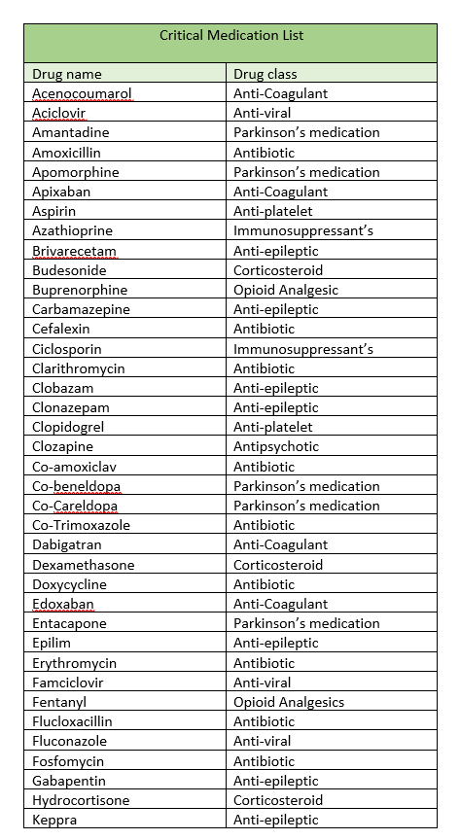

A table of critical meds list



Continued overleaf….

*****This document will be reviewed yearly- please ensure you only refer to the latest version*****

Process for a single* omitted dose on a MAR chart

*If more than one dose of **any** medication is missed in the last 14 days then medical advice must be sought