NEATH PORT TALBOT COUNTY BOROUGH COUNCIL CYNGOR BWRDEISTREF SIROL CASTELL-NEDD PORT TALBOT

(AFAN VALLEY ROAD, CIMLA, NEATH) (PROHIBITION OF WAITING, LOADING AND UNLOADING AT ANY TIME)

ORDER 2026
NOTICE is given that the Council intends to make an Order under Sections 1 and 2 of the Road Traffic Regulation Act 1984 (hereinafter referred to as “the Act of 1984”) and of all other powers them enabling and after consultation with the Chief Officer of Police in accordance with Part III of Schedule 9 of the Act of 1984, the effect of which is as set out in the Schedule below.

A copy of the draft Order, plan and statement of reasons can be inspected on the Council’s Internet Website https://www.npt.gov.uk/traffic-regulation-orders-tros.

Any objections should be submitted in writing, setting out the reasons thereof, to reach the Head of Engineering and Transport, The Quays, Baglan Energy Park SA11 2GG by the 30 November 2026.

If you have any further enquiries regarding this notice please send your email to: environment@npt.gov.uk.

Schedule

Prohibition of Waiting, Loading or Unloading at Any Time Order.

Schedule 1 – Prohibition of Waiting, Loading & Unloading at any time

  - Afan Valley Road, Cimla (North Side)

From a point approximately 103 meters east of its junction with Trevallen Avenue, for a distance of approximately 36 metres in an easterly direction.
  - Afan Valley Road, Cimla (South Side)
From a point approximately 67 meters east, and opposite of its junction with Trevallen Avenue, for a distance of approximately 70 metres in an easterly direction.

DATED 28th OCTOBER 2026 M C GRIFFITHS
CHIEF LEGAL OFFICER

Ordnance Survey Licence: © Hawlfraint a hawilau cronfa ddata’r goron 2013. Rhid trwydded yr arolwg ordnans 100023392. © Crown Copyright and Database Right 2013. Ordnance Survey 100023392.

NOTES
1. All dimensions are in millimetres unless otherwise stated.

KEY
AA31

PROPOSED PROHIBITION OF WAITING, LOADING AND UNLOADING AT ANY TIME TRAFFIC REGULATION ORDER
(DOUBLE YELLOW LINES AND KERB CLIPS)
Crynallt Primary School

Cimla Community Centre
TREVALLEN AVENUE
Drg. No.

AFAN VALLEY ROAD
APPENDIX 'A'

LOCATION
ASH GROVE
(Easting) 276582
(Northing) 196333

Rev
Details
Dr Ch Ap
Date

Client
OAK GROVE

ENGINEERING AND TRANSPORT

Job Title

NICOLA PEARCE BSC (Hons), Dip TP, MRTPI DIRECTOR OF ENVIRONMENT AND REGENERATION THE QUAYS, BRUNEL WAY
BAGLAN ENERGY PARK NEATH SA11 2GG
AFAN VALLEY ROAD, CIMLA

TRAFFIC REGULATION ORDER PROPOSAL

NO WAITING, LOADING OR UNLOADING AT ANY TIME

File No. Financial Code No.

Drawn

AM Checked

MCB Approved
HIH

Date
OCT26

Date
OCT26

Date
OCT26

Scales
Job Title

1:250 @ A1

Status

Drawing No.
C21360 / AVR / TRO1

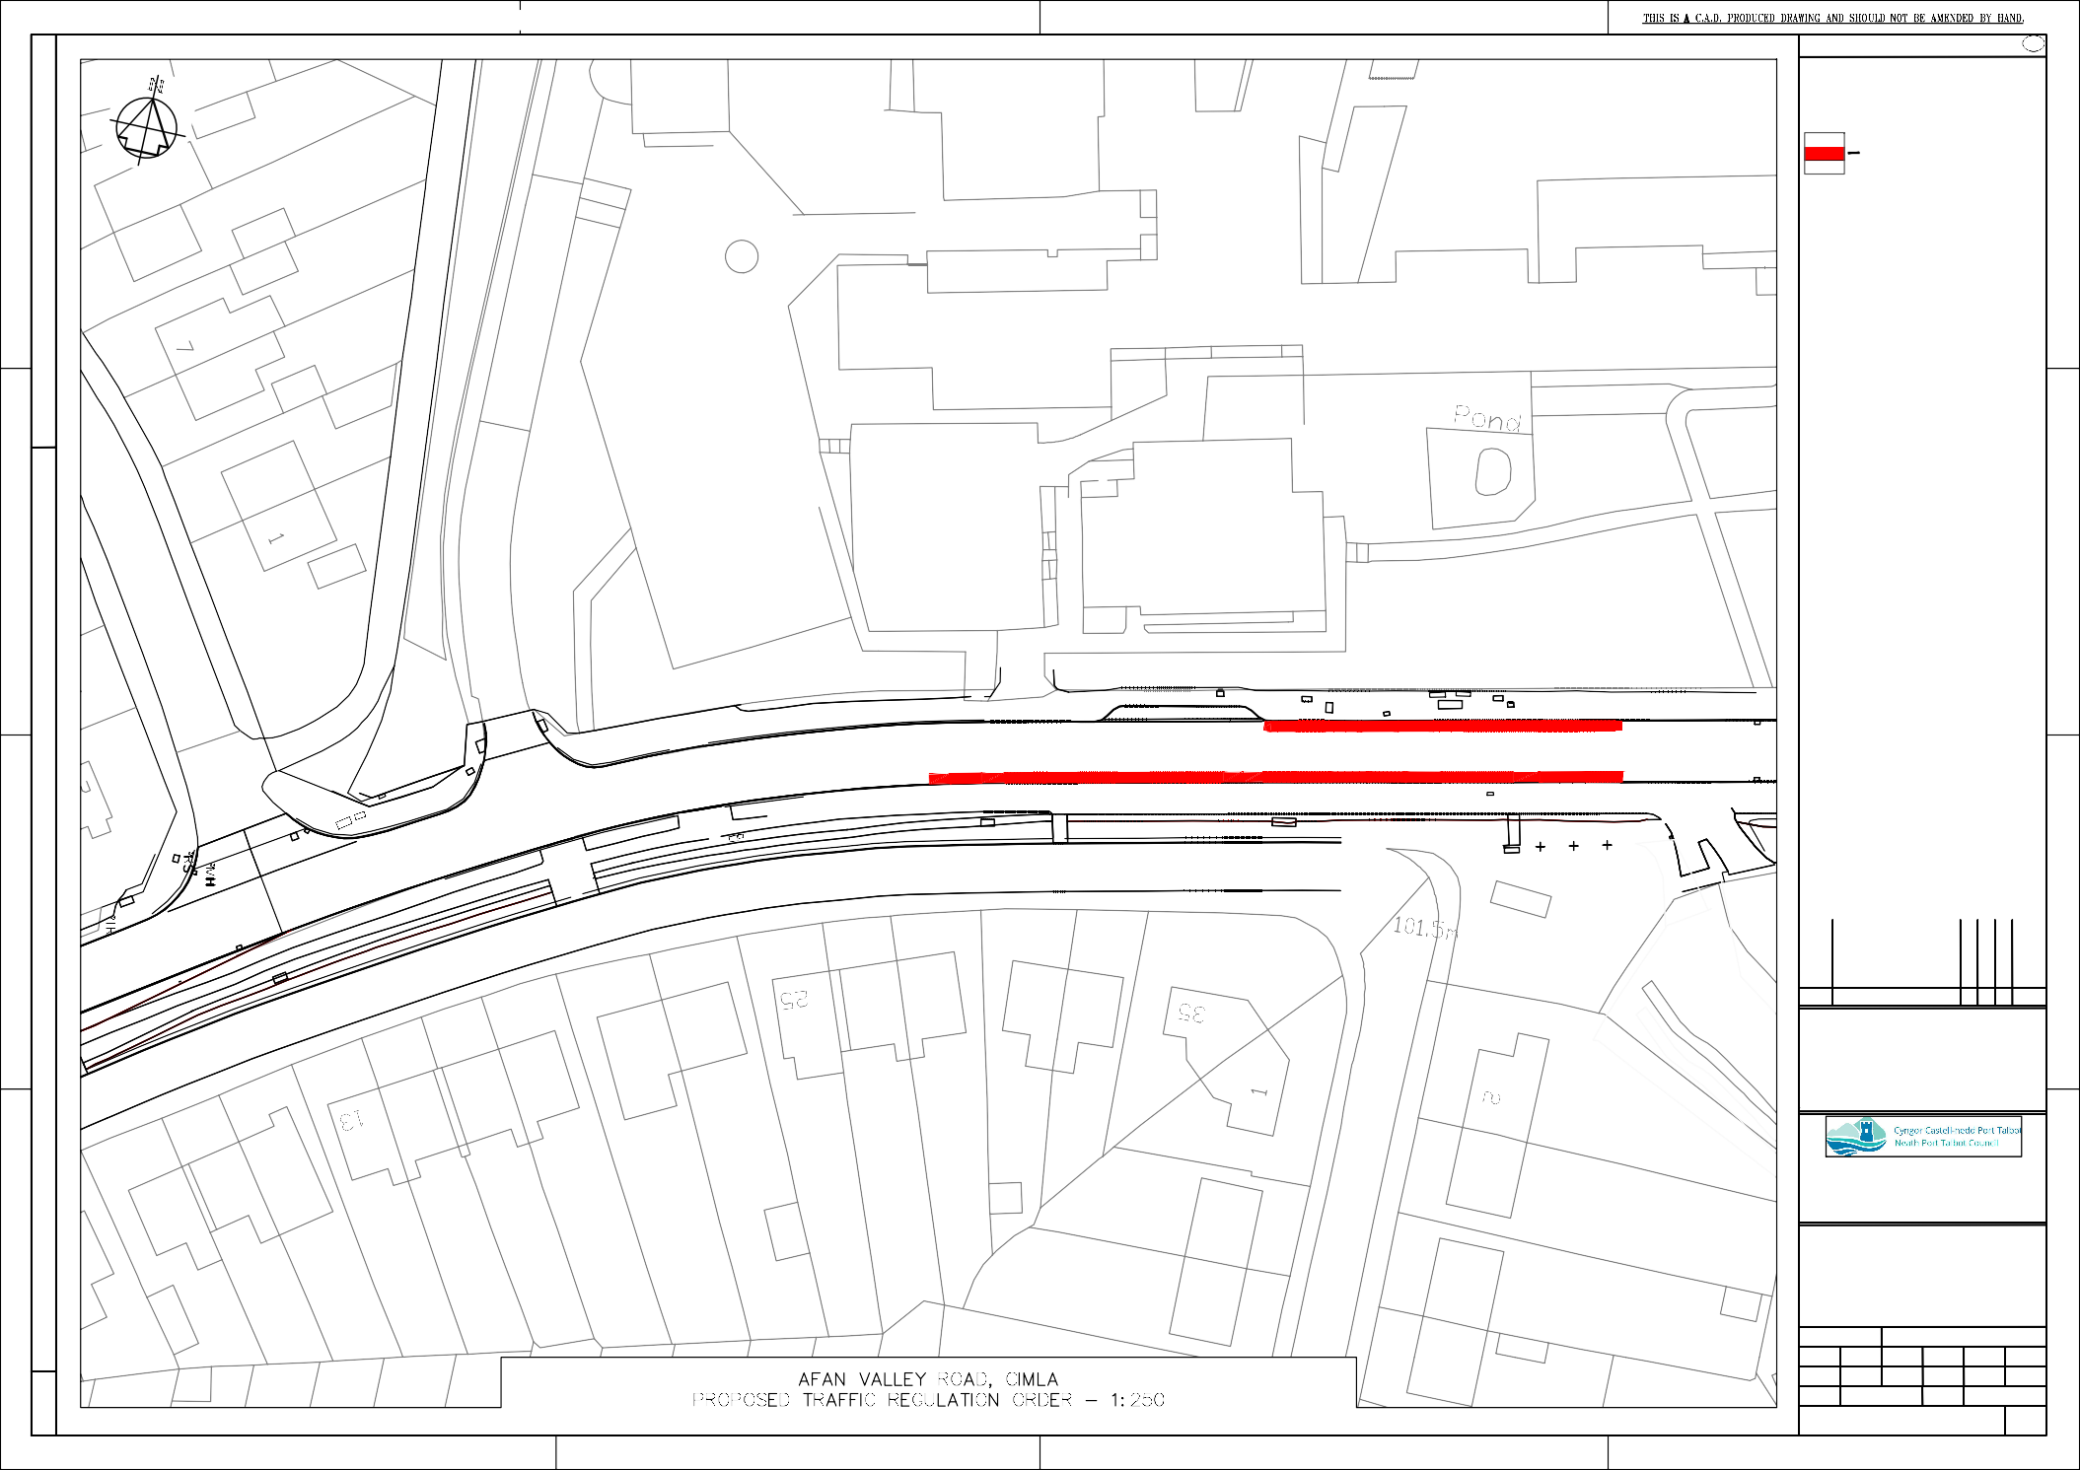
V:\ts988687 AM\CIMLA ACTIVE TRAVEL\Crynallt TRO\a. Drawings\TRO Drawing.dwg

