**ADMINISTERING MEDICINES WITH A MAR**

**Get ready:** Confirm level of support; obtain consent; wash hands & apply PPE; clear area to work and locate equipment needed.

**Check MAR:** Ensure correct individual; MAR is in date; medication has not already been given for time of call; and check Additional Information for any relevant updates.

**Prepare medicines:** Starting at the top of the MAR, select the medicines required at the call, check instructions on MAR and label match. Ensuring older packs are used first, prepare each medicine, re- checking the instructions and ensure:

* **the 5 rights** are checked: person; dose; time; route; medication
* any special instructions are followed, such as before/after food
* expiry date is checked
* name on foil strip matches the packet label
* MAR is signed (or appropriate code entered) after popping/pouring each medicine into clean container

**Administer medicines:** Administer medicines offering a glass of water, observe all medicines are taken and complete additional information sheet.

***Report and record any discrepancies immediately***

**After administering:** Check all documentation is completed; all medicines are safely and appropriately stored; and any equipment used is washed and dried.

I

[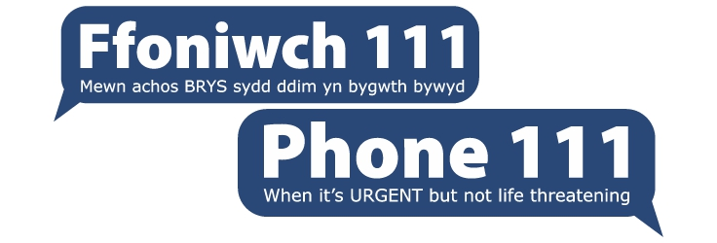](http://www.google.co.uk/url?sa=i&rct=j&q=&esrc=s&source=images&cd=&ved=0ahUKEwilqe2JhrTWAhVMvBQKHVPhBY8QjRwIBw&url=http://www.wales.nhs.uk/sitesplus/862/page/91415&psig=AFQjCNHHDi5oEBfhnFYjmo-6ImAz_IFkxA&ust=1506006625176816)

**ORDERING & RECEIVING MEDICINES**

**Ordering**

* At blue stripe on MAR check which medicines need ordering
* Contact named pharmacy (or family member if relevant) to order
* Sign and date blue stripe and document relevant details on additional information sheet

**Receiving**

* Check the new MAR and labels of new medication to ensure:
  + it is the right: person; dose; time; route; medication
  + all items ordered have been supplied
  + the quantity supplied is going to last for the 28 days of the MAR
* Inform pharmacy **AND** your supervisor straight away if any problems e.g. medicines are missing, incorrect etc
* Record receipt (and any problems/actions taken if relevant) on additional information sheet

**Storage/Housekeeping**

* Remove expired /unwanted medicines and follow procedure for disposal
* Place items in locked, lidded box or fridge as appropriate/per instructions
* Ensure all items in the box are clean and containers closed properly, removing any rubbish (empty packs, old Patient Information leaflets etc)
* Replace lid and place box in a cool dry place away from any direct source of heat such as a windowsill or radiator





 Swansea council logo