

Education, Leisure & Lifelong Learning Service

Strategic School Improvement Programme

**PROPOSAL TO CLOSE THE LEARNING SUPPORT CENTRE FOR PUPILS WITH SPECIFIC LITERACY DIFFICULTIES AT CWMTAWE COMMUNITY SCHOOL, FFORDD PARC YNYSDERW, PONTARDAWE, SWANSEA, SA8 4EG**

**CONSULTATION REPORT**

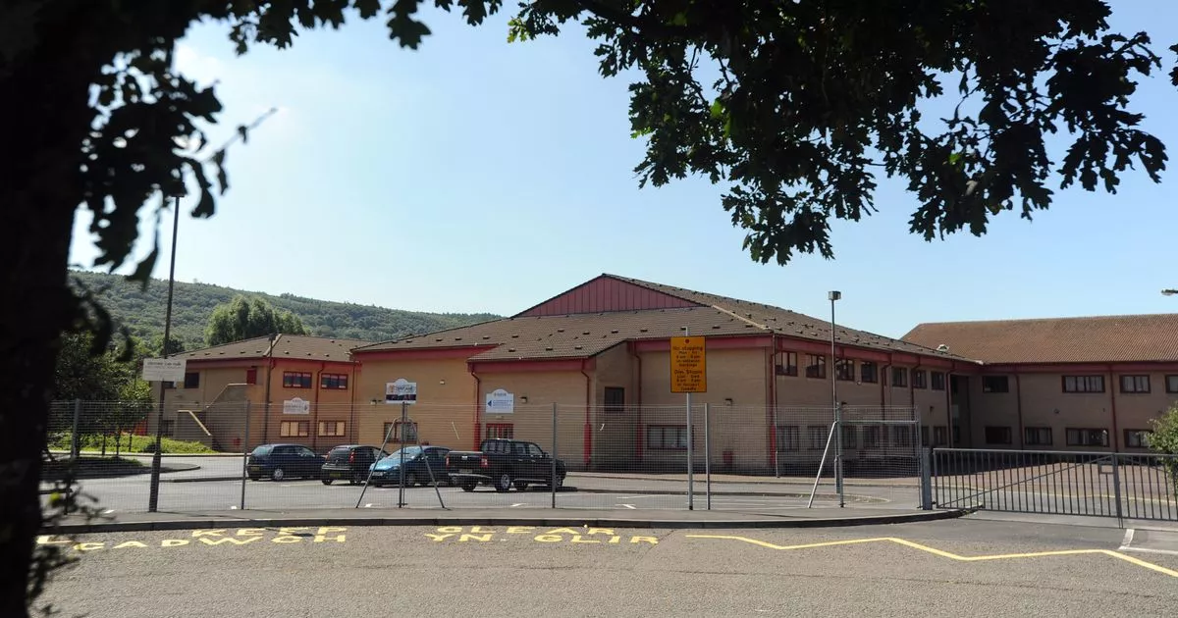

Large print and alternative format or language versions of this document are available on request

**CONSULTATION REPORT**

**Responses from formal consultation on the proposal to close the specialist learning support centre (LSC) provision for secondary age pupils with Specific Literacy Difficulties (SpLD) at Cwmtawe Community School, Ffordd Parc Ynysderw, Pontardawe, Swansea, SA8 4EG.**

**Introduction**

The Council has consulted with interested parties on its proposal to close the specialist learning support centre (LSC) provision for secondary age pupils with Specific Literacy Difficulties (SpLD) at Cwmtawe Community School. If implemented, this proposal will take effect on September 1st 2025.

**Background to the proposal**

The Council is responsible for promoting high educational standards and for delivering efficient primary and secondary education. Having the right schools and provisions in the right place and ensuring that they are fit for the 21st century learner is the challenge facing the Council. Achieving this will involve reviewing the number and type of schools the Council has in its area and assessing whether or not best use is being made of resources and facilities. This will include ensuring suitable provision for those pupils with special educational needs/additional learning needs.

Implementing the Strategic School Improvement Programme (SSIP) involves reviewing existing provision and determining the number and type of schools needed to deliver education effectively and efficiently across the County Borough. It will most likely lead to substantial change involving opening new schools, closing existing schools, merging or amalgamating schools, federating schools and promoting new initiatives that support collaborative working between schools. It will also involve re-organising education provision to ensure pupils gain access to and benefit from the specialist support, skills and expertise available within the County Borough.

The Council has decided to review its provision on the basis of:

* the need for places and the accessibility of schools
* educational standards
* the quality and suitability of school accommodation
* effective financial management

**The proposal and why change is being proposed**

It is proposed to close the LSC for pupils with SpLD at Cwmtawe Community School, Ffordd Parc Ynysderw, Pontardawe, Swansea, SA8 4EG with effect from 1st September 2025.

Neath Port Talbot Council are committed to promoting high standards of literacy for all children and young people. All learners should have access to high-quality, well-differentiated ‘quality first’ teaching across the curriculum within our mainstream schools and settings, as informed by current research and national guidance.

It is recognised that some children and young people find learning to read and write far more challenging than others, despite high quality opportunities and input. Research highlights the importance of identifying the needs of these individuals early and ensuring that they access a differentiated curriculum to make suitable progress, aligning with national policy and good practice for children and young people with Additional Learning Needs (ALN Code of Practice, 2021 para 20.10).

Early assessment and intervention are regarded as not only essential to addressing literacy difficulties, but also as vital to preventing the emotional distress and disengagement from learning that can arise as a result of these barriers to learning. Mainstream schools are best placed to identify and meet the needs of learners with literacy difficulties within a ‘literacy-friendly’, inclusive environment that promotes children’s rights. A focus on quality first teaching, alongside regular whole staff development is essential, as is working in partnership with parents and carers.

Through the successful implementation of IDPs, schools are increasingly supporting young people with a range of additional specific learning needs including SpLD. There are currently 10 pupils with SpLD across all Neath Port Talbot who hold a Local Authority Maintained IDP. All are educated and supported within mainstream schools, ensuring they are fully integrated and have equal access to all aspects of mainstream activities and opportunities.

The Learning Needs Code for Wales also states:

*“The Welsh Government considers that an inclusive education, where all pupils access common opportunities in ways relevant to their needs, and which ensures that they fully belong to the school community, is of benefit to all… The ALN system relies on the knowledge and experience of teaching staff to identify ways of providing appropriate access to the curriculum for every child and young person. Meeting the needs of learners with ALN ought to be part of a whole school or institution approach to school or institution improvement. The key to this lies in the teaching staff’s knowledge of each child and young person’s skills and abilities. Consequently, improvements in the teaching and learning of children and young people with ALN cannot be isolated from improvements in the teaching and learning for children and young people across a school or FEI as a whole.”*

At present, there are 0 pupils at the Learning Support Centre for pupils with SpLD at Cwmtawe Community School.

The proposal seeks to ensure that resources are utilised effectively in line with the need for specialist places within the County Borough.

**What options have been considered?**

The Council has the responsibility for ensuring that it is making the most effective use of resources and facilities in order to deliver the very best educational opportunities for children and young people.

*Option 1* **– status quo, maintain existing provision in Neath Port Talbot**

The Council has a responsibility to review the number and type of schools it has and whether or not it is making the best use of resources and facilities to deliver suitable educational opportunities for the children and young people of Neath Port Talbot.

Maintaining the status quo at Cwmtawe Community School Learning Support Centre for pupils with SpLD is not considered to be best use of resources and facilities and would result in funding the LSC with no pupils present. This could result in financial resources not being repurposed to provide additional provision in areas where we have identified the greatest need.

Maintaining the status quo will not realise opportunities to address concerns or to alleviate the current pressure to address demand for places in other areas. On the grounds of efficient use of public money, maintaining a provision with no pupils is not considered to be best use of Council resources.

This option is not preferred by officers.

*Option 2* **– Close the Cwmtawe Community School Learning Support Centre for pupils with dyslexia and continue to provide additional support in mainstream settings**

Continue to provide specialist support for pupils with SpLD in all mainstream establishments in line with individual pupil IDPs. This will form part of a continuum of support in line with the ALN Reform Act. In line with the Additional Learning Needs Code for Wales, mainstream schools have a duty to deliver additional learning provisions (ALP) to support learners with ALN as set out in their IDP. This will ensure that pupils with SpLD are fully integrated and will have equal access to all aspects of mainstream activities and opportunities in the language of their choice.

This option provides a more effective use of public money as the funding will be repurposed to provide additional provision in areas where we have identified the greatest need.

This option is preferred by officers.

*Preferred Option* ***- Option 2***

Having considered information gathered to date, it is the view of officers that Option 2 outweighs the alternative considered as it is this option that ensures that funding will be repurposed to provide additional provision in areas where we have identified the greatest need. Currently there are no pupils accessing the funded Cwmtawe Community School Learning Support Centre for pupils with SpLD as all secondary age pupils with IDPs for SpLD within the Local Authority are placed within mainstream classes in our secondary schools. Option 2 also ensures that Welsh first language secondary age pupils with IDPs for SpLD can continue with their Welsh-medium education within a Welsh-medium secondary school. It is, therefore, preferred as the basis of consultation.

**Legislative Process**

On 2nd October 2024, the Council’s Cabinet determined to consult on the proposal to close the specialist learning support centre (LSC) provision for secondary age pupils with Specific Literacy Difficulties (SpLD) at Cwmtawe Community School. The consultation period ran from 5th November 2024 to 16th December 2024. A list of consultees is included at Appendix 1. The consultation document was made available by e-mail to consultees. It was also available on the Council’s website. Hard copies were available on request.

The consultation document invited views and opinions to be submitted in respect of the proposal. Under the Welsh Government Statutory Code for School Organisation the Council is required to publish a consultation report summarising any issues raised by consultees, the Council’s response to those issues and Estyn’s view of the overall merit of the proposal.

**Consultation Responses**

Two written responses from Pontardawe Town Council and ESTYN were received on this proposal.

The Pontardawe Town Council response received stated:

“Pontardawe Town Council does not feel strongly one way or another regarding the proposal.”

**Estyn response to the proposal:**

Estyn overall response states that this proposal is likely to, at least, maintain the standard of education provision in the area. ESTYN note, ‘The council has presented a suitable rationale outlining the reasons for the proposal’.

Additionally, ESTYN note, ‘The council appropriately outlines its current approach and research in relation to meeting the needs of pupils with SpLD. It highlights that schools in Neath Port Talbot can successfully support pupils with an IDP in mainstream classes’.

The following is also noted, ‘Overall, the proposer identifies clearly and fairly the expected benefits and disadvantages of closing the LSC when compared with the status quo as well as how they will manage any risk. One of the main advantages is the improved use of public money as the funding will be repurposed to provide additional provision in areas where they have identified the greatest need. It provides acceptable reasons as to why they have discounted maintaining the status quo’.

The full Estyn response is included as Appendix 2.

**Next Steps**

If approved, the next stage of the process is to publish a statutory notice outlining the proposal. This would need to be published for a period of 28 days and formal written objections would be invited during this time.

If objections are received, an objection report will be published summarising the objections and the Council’s response to those objections. The Council’s Cabinet will need to consider the proposal in light of objections received when making its decision on whether the proposal is to be implemented.

**APPENDIX 1**

**List of Consultees:**

|  |  |
| --- | --- |
| **List of Consultees** | |
| Cwmtawe Community School  Parents / carers  Staff  Governing Body  Wider School Community | NAASH (Secondary Schools Forum |
| LLAN (Primary Schools Forum) |
| Bordering authorities – Swansea/ Bridgend/ Carmarthenshire/ Powys/ RCT |
| All other NPT schools | Pontardawe Town Council  Cilybebyll Community Council |
| NPT Elected Members | WG Schools Management Division |
| Diocesan Directors of Education   * Diocese of Menevia, Swansa * Diocese of Llandaff, Vale of Glamorgan | MP and MS  For Neath |
| Trade Unions | Regional Members of the Senedd |
| Estyn | ALN Partners- SNAP, Action for Children, Child and Adult Mental Health Services (CAMHS), Consultant Community Paediatrician, The Children’s Centre NPT Hospital (Therapeutic Services), National Autistic Society, NPT Special Needs Support Group |
| Regional Education Consortium (ERW) | Children and Young Person Partnership (inc.Early Years Development and Childcare) |
| NPTCBC Integrated Transport Unit | Police and Crime Commissioner |
| Communities First Partnership | NPTC Officers |

**APPENDIX 2**

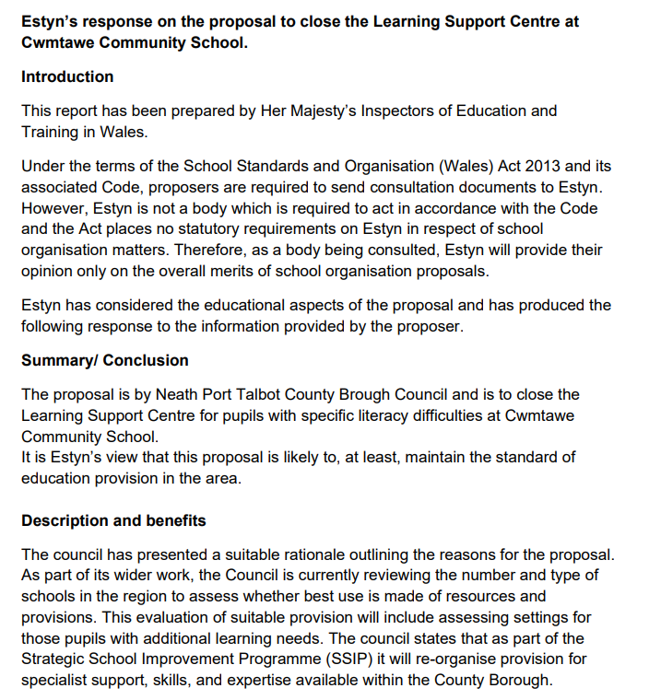

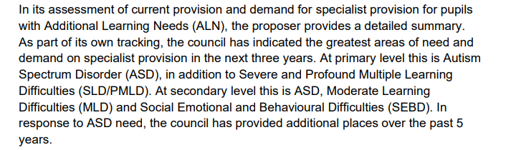

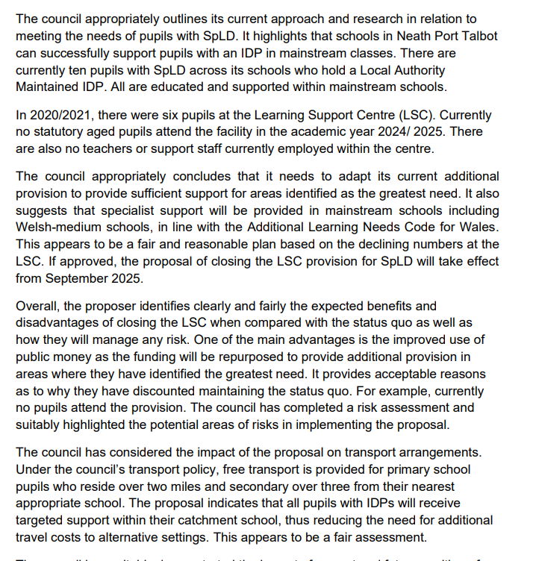

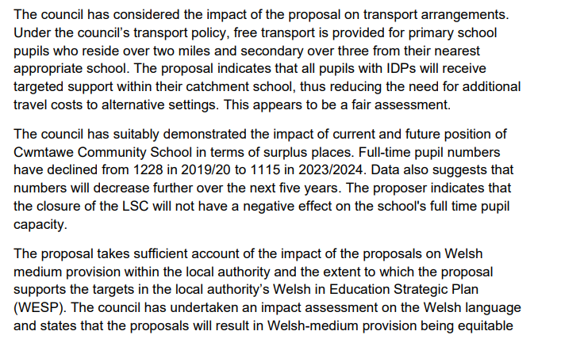

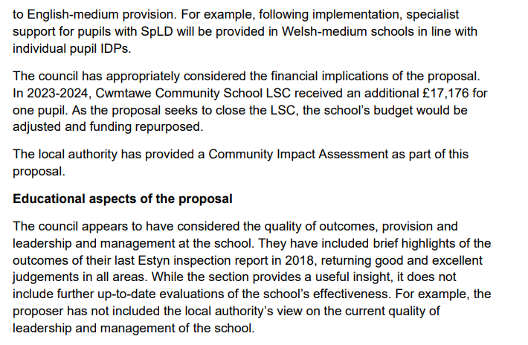

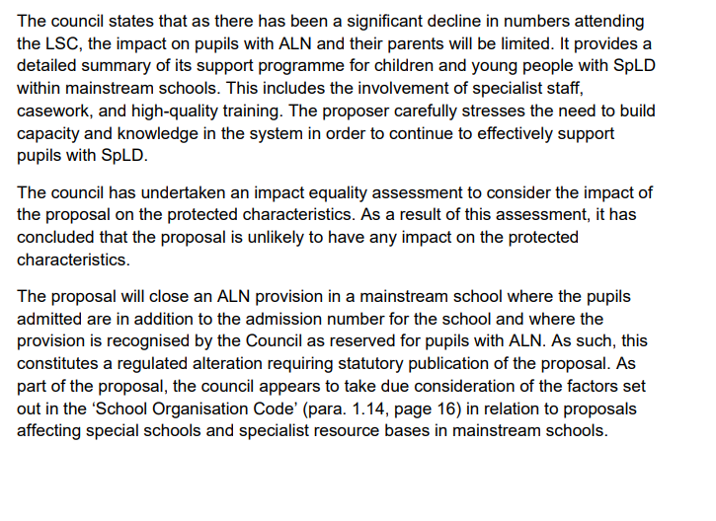



**This Statutory Notice is published by Neath Port Talbot County Borough Council, Civic Centre, Port Talbot. SA13 1PJ**

**NOTICE** is given in accordance with Section 42 of the School Standards and Organisation Act (Wales) 2013 and the School Organisation Code that Neath Port Talbot County Borough Council having consulted such persons as required, propose to:

**Close the Learning Support Centre for secondary age pupils with Specific Literacy Difficulties (SpLD) at Cwmtawe Community School, Ffordd Parc Ynysderw, Pontardawe, Swansea, SA8 4EG.**

Neath Port Talbot County Borough Council undertook a period of consultation before deciding to publish this proposal. A consultation report containing a summary of the issues raised by consultees, the Council’s response to these issues and the views of Estyn are available on the NPT Council website.

It is proposed to implement the proposal on **1st September 2025**.

There are currently 0 pupils at the Learning Support Centre for pupils with SpLD at Cwmtawe Community School. All mainstream schools and settings are provided with advice for Inclusive Learning Provision (ILP) and ALP, which further details how to include pupils with SpLD.

Through the successful implementation of IDPs, schools are increasingly supporting young people with a range of additional specific learning needs including SpLD. There are currently 10 pupils with SpLD across all Neath Port Talbot who hold a Local Authority Maintained IDP. All are educated and supported within mainstream schools, ensuring they are fully integrated and have equal access to all aspects of mainstream activities and opportunities.

Transport arrangements will be in line with Neath Port Talbot County Borough Council’s Home to School Travel Policy.

Within a period of 28 days after the date of publication of this proposal, that is to say by the 31st March 2025, any person may object to the proposal. Objections should be sent to: Andrew Thomas, Director of Education Leisure and Lifelong Learning, (marked for the attention of the SSIP Team), Civic Centre, Port Talbot SA13 1PJor e-mail to:[**SSIP@npt.gov.uk**](mailto:SSIP@npt.gov.uk).

Signed:



Andrew Thomas, Director of Education, Leisure & Lifelong Learning

**Dated: 4th March 2025**

**Explanatory Notes:**

(This note does not form part of the Notice but is intended to explain its general meaning)

1. It is intended to close the Learning Support Centre for secondary age pupils with Specific Literacy Difficulties (SpLD) at Cwmtawe Community School on 1st September 2025.
2. The reasons for the proposal are set out in the consultation document which is available on the SSIP webpage on the Council’s website: [proposal-to-close-the-learning-support-centre-for-pupils-with-specific-literacy-difficulties-at-cwmtawe-community-school.pdf](https://media.npt.gov.uk/media/dwnh5kw5/proposal-to-close-the-learning-support-centre-for-pupils-with-specific-literacy-difficulties-at-cwmtawe-community-school.pdf?v=20241101165002)
3. The Authority’s School Transport policy is available from the Council’s website: [npt_home_to_school_travel_policy_2017.pdf](https://www.npt.gov.uk/media/4231/npt_home_to_school_travel_policy_2017.pdf?v=20170627002146)
4. Hard copies or alternative versions of all documentation may be obtained upon request from the Strategic School Improvement Team, Education Department, 2nd Floor, Port Talbot Civic Centre, Port Talbot.