NEATH PORT TALBOT COUNTY BOROUGH COUNCIL CYNGOR BWRDEISTREF SIROL CASTELL-NEDD PORT TALBOT
(AFAN VALLEY ROAD, CIMLA, NEATH) (PROHIBITION OF WAITING, LOADING AND UNLOADING AT ANY TIME)

ORDER 2026

STATEMENT OF REASON

The Order is necessary to prevent indiscriminate parking in the interest of road safety along Afan Valley Road, Cimla, Neath.

Ordnance Survey Licence: © Hawlfraint a hawilau cronfa ddata’r goron 2013. Rhid trwydded yr arolwg ordnans 100023392. © Crown Copyright and Database Right 2013. Ordnance Survey 100023392.

NOTES
1. All dimensions are in millimetres unless otherwise stated.

KEY
AA31

PROPOSED PROHIBITION OF WAITING, LOADING AND UNLOADING AT ANY TIME TRAFFIC REGULATION ORDER
(DOUBLE YELLOW LINES AND KERB CLIPS)
Crynallt Primary School

Cimla Community Centre
TREVALLEN AVENUE
Drg. No.

AFAN VALLEY ROAD
APPENDIX 'A'

LOCATION
ASH GROVE
(Easting) 276582
(Northing) 196333

Rev
Details
Dr Ch Ap
Date

Client
OAK GROVE

ENGINEERING AND TRANSPORT

Job Title

NICOLA PEARCE BSC (Hons), Dip TP, MRTPI DIRECTOR OF ENVIRONMENT AND REGENERATION THE QUAYS, BRUNEL WAY
BAGLAN ENERGY PARK NEATH SA11 2GG
AFAN VALLEY ROAD, CIMLA

TRAFFIC REGULATION ORDER PROPOSAL

NO WAITING, LOADING OR UNLOADING AT ANY TIME

File No. Financial Code No.

Drawn

AM Checked

MCB Approved
HIH

Date
OCT26

Date
OCT26

Date
OCT26

Scales
Job Title

1:250 @ A1

Status

Drawing No.
C21360 / AVR / TRO1

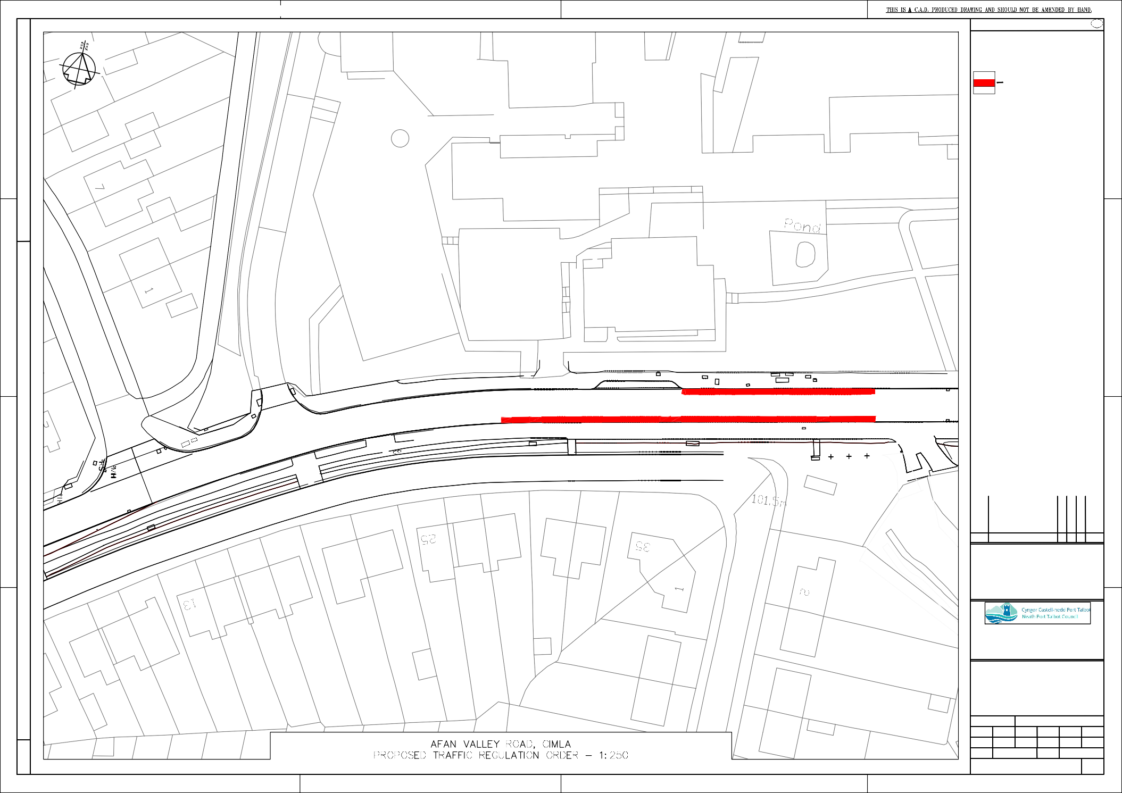
V:\ts988687 AM\CIMLA ACTIVE TRAVEL\Crynallt TRO\a. Drawings\TRO Drawing.dwg

