

INFORMATION

FOR

PARENTS

HANDBOOK

INFORMATION  FOR  PARENTS  HANDBOOK | 2027/28
 | WWW.NPT.GOV.UK
Education, Leisure & Lifelong Learning

School Terms and Holiday Dates
2026/2027 Academic Year

 |  | Mid Term Holiday
Term | Term Begins | Begins | Ends | Term Ends | Days
Autumn  2026 | Tuesday  1st  September | Monday  26th October  October | Friday  30th  October | Friday  14th December | 75
Spring  2027 | Monday  4th  January | Monday  8th  February | Friday  12th  February | Friday  19th  March | 50
Summer  2027 | Monday  5th  April | Monday  31st  May | Friday  4th  May | Tuesday  20th  July | 71
 |  |  |  | Total | 195

Schools will be closed to pupils for INSET/Staff Preparation on five days between Tuesday 1st September 2026 and Tuesday 20th July 2027.

Bank Holidays
Good Friday Friday 26th March 2027
Easter Monday Monday 29th March 2027
May Bank Holiday Monday 3rd May 2027
Spring Bank Holiday Monday 31st May 2027

NEATH PORT TALBOT COUNTY BOROUGH COUNCIL

Education, Leisure & Lifelong Learning

Information for Parents Handbook 2027/2028

If you have any comments or observations to make on this booklet please complete the pro-forma below and return it to Child and Family Support Team, Neath Port Talbot Council, Education Leisure & Lifelong Learning, Civic Centre, Port Talbot, SA13 1PJ, or email sfs@npt.gov.uk or tel: 01639 763600.

- Are you happy with the style and layout of the booklet?
Yes / No
If no please state how you think it could be improved.

- Did you find the information in the booklet informative and useful?
Yes / No
If no, what other topics would you like included?

- If you have any other comments to make, please give details below:

CONTENTS:

 | Page
School term and holiday dates 2026/2027 | 1
Parental Satisfaction Questionnaire | 2
Introduction by Director of Education, Leisure and Lifelong Learning | 4
When can my child start school? | 6
When can my child leave school? | 6
Where can my child go to school? | 6
What if I would like my child educated through the medium of Welsh? | 7
What if I would like my child educated at a church (voluntary aided) school? | 9
How do I register my child at a school? | 9
How can I get more information about schools in the area? | 9
Can my child be educated outside Neath Port Talbot County Borough? | 10
What if my child has Additional Learning Needs? | 10
What help is there for children from Ethnic Minority backgrounds? | 11
How can the Education Welfare Service help? | 12
Parent Partnerships and SNAP | 12
What safeguarding arrangements are in place? | 12
What about my child’s health? | 13
Will school meals be available?* | 13
Will my child get learner travel assistance? | 14
Will my child wear school uniform? | 15
What charges might I have to pay? | 16
What should I know about the insurance arrangements for my child? | 16
When will my child get careers information and guidance? | 17
What public examinations will my child take? | 17
How does my child’s school know who to keep informed? | 18
What education is available when my child is over 16? | 18
What financial help is available when my child starts sixth form or college? | 18
14-19 Learning Pathways | 19
Is the Duke of Edinburgh’s Award available to my child? | 19
What youth services are available? | 19
Can my child have a part-time job? | 20
What if my child wants to get involved with entertainment productions? | 20
Is there a local library for my child? | 21
What cultural and leisure facilities are available to my child? | 22
Local History & Museum Collections | 24
How are physical activities & sport supported locally? | 25
What are school governors? | 25
Can I become a school governor? | 25
How can parents influence the decisions of the County Borough Council? | 26
What can I do if I am not satisfied with my child’s education or have a complaint? | 27
Strategic School Improvement Programme (SSIP) | 27
Appendix A – Admissions to Schools Policy 2027/28 | 29
Appendix B – Faith Schools Admission Policies 2027/28 | 58
Appendix C – List of Neath Port Talbot County Borough Schools | 112
School term and holiday dates 2027/28 | 124
*Please read this section if you receive benefits of any kind. You may be eligible for further financial assistance.

Dear Parent/Carer,

At Neath Port Talbot we are committed to providing the best start in life for our children and young people, through positive learning experiences and wide-ranging opportunities, to ensure all our learners reach their potential. We want to ensure that learning is a safe, nurturing and fulfilling experience in all settings, where there is respect and due regard to equality, diversity and inclusion.

Our parents and carers have told us how important it is for their children to have access to good schools and high-quality education. Our children and young people’s experience of school is critically important and they want to be actively involved in shaping the decisions that affect them.

The choices you make are important and having the right information on which to base your decisions is essential. This guide provides you with the information you need when choosing a school for your child in Neath Port Talbot.

We are confident that all our schools are committed to realising the four purposes of the new curriculum in Wales, where children and young people are provided opportunities to develop as:

ambitious, capable learners, ready to learn throughout their lives enterprising, creative contributors, ready to play a full part in life and work ethical, informed citizens of Wales and the world healthy, confident individuals, ready to lead fulfilling lives as valued members of society.

Our schools are committed to meeting the needs of all learners, through providing an inclusive environment where all learners feel valued and make progress. All our schools will provide inclusive and additional provision as set out in the Code of Practice for Additional Learning Needs.

There are many sources of information available to you to help inform your decision, including impartial inspection reports provided by Estyn. We would also encourage you to visit the school you are considering applying for.

Choosing the right school for your child and their future is a very important decision. I hope you find this information useful and I wish your child every success for their future education.

Yours sincerely,
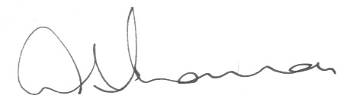

Andrew Thomas
Director of Education, Leisure and Lifelong Learning

PLEASE NOTE:
The information in this booklet is relevant and accurate at the time of publication. Some adjustment of policy, regulation, provision and resources may be necessary for, or during, the academic year 2027/28. If you would like help with reading this document or further information and advice, contact the Child and Family Support Team, Education Department, Port Talbot Civic Centre, Port Talbot SA13 1PJ. Email: sfs@npt.gov.uk Tel: 01639 763600

When can my child start school?
Depending on places being available, your child may start a part-time nursery class after his/her third birthday. There is no guarantee of a place and you may have to put your child’s name on a waiting list. Applications for admission are administered by the Local Authority (excluding voluntary aided schools other than Y7 pupil intake for St. Joseph’s RC Comprehensive School).

All children have to start school no later than the first day of the term after they reach 5 years of age. Full-time education is available at the beginning of the school year in which they are 5 years of age.

Between the ages of 5 and 11 education is provided in primary schools, except at St. Joseph’s Infant and St. Joseph’s Junior Schools Port Talbot where education is provided by separate schools. In these areas, pupils reaching 7 years of age by 31st August will generally transfer from infant to junior school at the start of the next school year.

The usual age of transfer to secondary school is at 11 years of age. Pupils reaching 11 years of age by 31st August will generally transfer from a primary to a secondary school at the start of the next school year.

Admission application forms will be forwarded to all parents as outlined within the Admission Policy (Appendix A). Parents may express a preference for a school of their choice. Every effort will be made to comply with this preference; however, it may not always be possible. If this is the case an alternative school will be offered.

Admissions to community schools can only be offered/confirmed by the local authority and not individual schools/Headteachers.

When can my child leave school?
Pupils may leave school on the last Friday in June in the school year in which they reach the age of 16.

Where can my child go to school?
Most children go to their local school. A place may be available for your child at a Welsh medium school serving your area should you wish him/her to be educated through the medium of Welsh.

When it is getting near the time for your child to go to school you should contact the local authority admissions officer for an application form. You may also wish to contact the school in the area of your choice to arrange a visit.

The Welsh Government Schools Admissions Code-005/2013 issued in July 2013 sets out the requirements on the local authority and governing bodies in relation to school admissions and school admission appeals. Parents can apply for a school place online (excluding nursery places) at www.npt.gov.uk or by completing and returning an application form. For nursery places parents must contact the admissions team for an application form.

The names, addresses and telephone numbers of all schools can be found in Appendix C of this handbook. They can also be found on the website: www.npt.gov.uk

You may wish to choose a school other than the local English or Welsh medium school. If you do, you need to know that places are not guaranteed and that your child will only be admitted if there is room available. You will also be responsible for the cost of transport to the school.

All Schools in Neath Port Talbot are co-educational; that is a school in which both boys and girls are admitted to all classes in the school.

What if I would like my child to be educated through the medium of Welsh?
Without doubt, giving your child two languages is giving your child a bright future and a flying start. Having two languages will give your child a head start in the work place and open doors for them as they will benefit from opportunities which are available through the medium of both Welsh and English.

There are currently 10 Welsh-medium primary schools and 1 dual site Welsh-medium all-through (3-18) school in Neath Port Talbot.

At primary level at least 70% of the teaching and learning is delivered through the medium of Welsh and opportunities are provided for all pupils to become confident Welsh language learners. Welsh-medium education is an option for all pupils from both Welsh speaking and non-Welsh speaking homes.

Opportunities are provided for primary pupils to attend residential courses through the medium of Welsh to improve their Welsh language skills and the Local Authority has a specialist Language Centre, ‘Y Cwm’, to support pupils who wish to transition from English-medium education to Welsh-medium education. The Language Centre also provides additional Welsh Language support for pupils currently in Welsh-medium education.

At secondary level, education through the medium of Welsh is available at Ysgol Gymraeg Ystalyfera – Bro Dur, an all-through Welsh-medium community school for pupils aged 3 - 18. The school has two campuses, one in Ystalyfera in the north of the county and the other in the south at Sandfields.

Ysgol Gymraeg Ystalyfera – Bro Dur organises an annual programme of Welsh language activities for all Y5 and Y6 pupils in the cluster. This ensures that every pupil benefits from Welsh language support prior to transfer into Y7.

These activities have a positive impact on pupils’ confidence and achievement in the Welsh language and secure successful transition for Y6 pupils from the 10 Welsh medium partner primaries in the Ysgol Gymraeg Ystalyfera – Bro Dur cluster.

Teaching and learning at KS3 is through the medium of Welsh and all KS3 pupils can access a range of Welsh-medium extra-curricular activities.

Pupils’ Welsh language skills are further developed throughout Key Stage 4 and in the Sixth Form. A wide range of academic, vocational and extra- curricular courses are on offer. Further details are available from the school.

Welsh-medium education at Ysgol Gymraeg Ystalyfera – Bro Dur is an option for all pupils from both Welsh speaking and non-Welsh speaking homes. Approximately 86% of pupils are from non-Welsh speaking backgrounds.

Our schools work closely with Menter Iaith Castell-nedd Port Talbot who support parents who do not speak Welsh and are concerned about how they can help their child with school work. This is, of course, in addition to the support provided by schools when your child becomes a pupil within the Welsh medium sector.

The Welsh-medium Additional Learning Needs (ALN) Learning Support Centre provides a highly specialised and nurturing provision for pupils from Welsh-medium schools across Neath Port Talbot. Situated within the grounds of Ysgol Gynradd Gymraeg Trebannws, the Centre offers a supportive bilingual learning environment where pupils' individual needs are met through tailored teaching and targeted interventions.

The Centre has capacity for up to eight pupils and enables learners to access
specialist support while maintaining strong links with Welsh-medium
education and culture. Provision is designed to promote pupils' academic,
social, emotional, and communication development, ensuring they are
supported to achieve their full potential.

The Centre is led by Mrs Eleri Bevan, Deputy Headteacher, whose leadership
ensures a high-quality, inclusive provision that places the wellbeing and
progress of every learner at its heart. Through close collaboration with
schools, families, and specialist services, the Centre supports pupils to
develop the skills, confidence, and independence needed to succeed within
a Welsh-medium setting.

If you need more details regarding the provision, admission criteria, or
would like to arrange a visit, here is the direct contact information:
Phone: 01792 864004 or Email: swyddfa@yggtrebannws.npt.school

What if I would like my child to be educated at a church (voluntary aided) school?
There are two Church-in-Wales primary schools; one Roman Catholic infant school, one Roman Catholic junior school and two Roman Catholic primary schools in the County Borough. At secondary level, faith school education is available at St. Joseph's Catholic School and 6th Form Centre, Port Talbot. Copies of each of the faith school’s admissions policies are attached as Appendix B.

Information about faith school education is also available directly from: Church in Wales - The Head of Education, Lisa Ceri Taylor, 2, Callaghan Square, CF10 5BT. (Contact tel.: 029 2034 8200) or email lisactaylor@cinw.org.uk

Roman Catholic – Paul White, Director of Education, Archdiocese
of Cardiff-Menevia, Archbishop’s House, 41/43, Cathedral Road,
Cardiff, CF11 9HD. (contact Mr. Paul White on tel: 029 2022 0411 or
paul.white@cardiffmenevia.org.uk). Website: www.rcadc.org

How do I register my child at a school?
When you have chosen a school for your child, you will need to apply online at www.npt.gov.uk or complete a school admission application form.

Arrangements for school admissions can be found in Appendix A of this handbook. This tells you how decisions are reached when places at schools are allocated.

How can I get more information about schools in the area?
All schools publish a school prospectus, which provides information on how the school is organised, the curriculum and teaching and learning. A list of schools, with addresses and telephone numbers, is available in Appendix B of this handbook. The list is also available on the web site: www.npt.gov.uk

The majority of Neath Port Talbot schools also have their own dedicated websites. These can be accessed via the web site: www.npt.gov.uk

If you would like further information and advice regarding admissions to schools, contact: School Admissions Officer, Child and Family Support Team, Port Talbot Civic Centre, Port Talbot, SA13 1PJ email: admissions@npt.gov.uk or tel. 01639 763730/763580.

Can my child be educated outside Neath Port Talbot County Borough?
If you wish to send your child to a school outside the County Borough you should make contact with the relevant Local Authority where the school is located. Please note it is likely you will be responsible for the cost of the transport to and from the school. Neath Port Talbot County Borough does not offer free or assisted places at any independent school.

What if my child has Additional Learning Needs?
A child with Additional Learning Needs (ALN) has a significantly greater difficulty in learning than the majority of others of the same age and/ or has a disability, which hinders them from the making use of facilities for education of a kind generally provided for others of the same age in mainstream school. There is a wide range of learning difficulties or disabilities, but they can be broadly classified into the following four areas:

- Communication and interaction;
- Cognition and learning;
- Behaviour, emotional and social development;
- Sensory and/ or physical.

A child with ALN will require Additional Learning Provision (ALP), in order to ensure their needs are met and any barriers to learning are removed. It is important that children with ALN are identified early in their school career, so appropriate intervention can be put in place at the earliest opportunity. Class teachers have a key role in this identification process.

Each school within Neath Port Talbot has a financial allocation within their budget to help meet the needs of pupils who have ALN. Each school is also required to have an Additional Learning Needs Coordinator (ALNCo), who has responsibility for coordinating provision for learners with ALN.

All schools in Neath Port Talbot also have regular access to support and advice from the Inclusion Service, which consists of a range of professionals who have expertise in supporting Children and Young People with ALN. This includes Advisory Teachers, Educational Psychologists, Speech and Language Therapists, Occupational Therapists and Wellbeing Practitioners. The aim of the Inclusion Service is to promote achievement and wellbeing for all Children and Young People and in line with the United Nations Convention on the Rights of the Child (UNCRC), the service is committed to ensuring every Child or Young Person has an equal opportunity to make the most of their lives and talents. As a result, Person Centred Practice (PCP) underpins the work of the service and ensures that Children, Young People and their Parents / Carers have their views, wishes and feelings heard.

The majority of learners with ALN will have their needs met through school based support and provision. However, in some instances, enhanced support from the Local Authority will be required. These include instances where the learner:

- Has a low incidence condition / rare condition which requires specialism that the school cannot provide;
- Requires regular advice and support from external agencies which is over and above that which can be reasonably arranged and accessed by the school;
- Requires equipment that can only be used by one pupil or cannot be re-used or is beyond the reasonable resources of the school; or
- Requires very intensive daily support which cannot be reasonably funded or secured by the school’s budget.

If you are concerned that your child may have ALN, the first step is to talk to the class teacher or the school’s ALNCo. You can also contact the Local Authority’s Additional Learning Needs Support Service at alnss@npt.gov.uk

What help is there for pupils from Ethnic Minority (EM) backgrounds and for pupils who are learning English as an Additional Language (EAL), learners from the Gypsy Traveller (GT) community and learners from Armed Forces families?
The Vulnerable Learners Service (VLS) provides specialist support for learners of English as an Additional Language (EAL), Ethnic Minority (EM) Groups, learners from the Gypsy, Roma and Traveller (GT) Communities and can signpost parents of Service Children (SC) to supporting agencies. VLS recognises the importance of these specific groups given these learners face different challenges and are often less likely to achieve academically within the education system and are more at risk of becoming NEET (not in Education, Employment or Training).

The VLS provides a range of support and interventions for EM/EAL/GRT learners in Neath Port Talbot schools and works in partnership with other agencies in order to ensure learners’ participation, achievement, attainment and wellbeing. You can contact the service by emailing VLS Manager Julie Stapleton j.a.stapleton@npt.gov.uk and VLS Deputy Manager and GT Engagement Officer Helen Gibbon h.gibbon@npt.gov.uk

How can the Education Welfare Service help?
Children need to attend school if they are to benefit from the educational opportunities available locally. The Education Welfare Service can help with problems that may prevent children from attending school regularly. The service is available to pupils, parents and teachers. It provides an important link between home and school and helps parents and teachers work in partnership. You can contact the Education Welfare Service through your child’s school.

Parent partnerships and SNAP
The Liaison Officer within the Additional Learning Needs Support Team can provide information about a range of organisations that support parents. For further information, please telephone 01639 763158.

SNAP Cymru is an organisation providing an independent parental support service to families of children and young people who have, or may have, special educational needs. The service is free to families and is confidential.

SNAP Cymru seeks to promote partnership and participation in planning and decision making. It can also provide you with help in completing paperwork and support you in meetings with professionals.

What safeguarding arrangements are in place?
The care and well-being of pupils is a principal concern of all schools. Schools must have a clear Safeguarding and Child Protection policy in place that staff must follow in order to safeguard and promote the welfare of children. Each school has a named, designated, teacher who is responsible for all safeguarding matters and handling individual cases of suspected abuse. You will find the details of this person in your child’s school. Where abuse is suspected the school is obliged to refer the matter to Social Services for investigation. In order to protect and safeguard a child it will sometimes be necessary to make referrals without seeking the consent of or informing parents; the school has a statutory duty to act in the best interests of the child. This is a sensitive area of work and the support of parents is important when schools take action to safeguard children.

Please be assured that school staff are working with the well-being of children firmly in mind.

Any actions undertaken by schools must comply with the Wales Safeguarding Procedures, in line with the Social Services and Wellbeing (Wales) Act 2014

What about my child’s health?
All schools have a named school doctor and nurse. They visit all schools and arrange for health screening of children for vision and growth. The health professionals provide advice for parents and teachers to ensure that any health difficulties in the school setting are addressed and appropriate help and support is arranged.
For more information about the Schools Health Service ask for the policy statement for school health services, available from your child’s Headteacher or the Consultant Community Pediatrician, Community Office, Children’s Centre, Neath Port Talbot Hospital on 01639 862713.

Will school meals be available?
Freshly cooked meals are provided at every school and the Authority is committed to providing a healthy balanced meal that children will eat and enjoy.

Our Primary School Meal Service provides food and drink in primary schools that is compliant with the Welsh Government's Healthy Eating in Schools (Wales) Regulations 2013 , which set out the types of food and drink that can and cannot be provided during the school day and defines the nutrient content of school lunches.' The Healthy Eating in Schools (Nutritional Standards and Requirements) (Maintained Primary Schools) (Wales) Regulations 2025 will replace the 2013 Regulations and a transition period for compliance will be implemented from the 31st October 2026.

The primary school menu will be nutritionally analysed to ensure it meets the legislation. Special diets such as medical, vegetarian, halal, coeliac, diabetic etc. will be catered for and free milk is available for all nursery and infant school pupils.

By choosing a school meal for your child you can be sure that you are making a healthy choice for them.

Welsh Government have announced universal free school meals for all primary aged children across Wales who will receive a free school meal from September 2024.
We are currently offering Universal Free School Meals to all primary school pupils in Neath Port Talbot
All Primary schools in Neath Port Talbot participate in the free breakfast scheme, funded by Welsh Government. We maintain a school meal/breakfast club website where all primary school menus can be accessed on the primary school meals page of the Neath Port Talbot Council website or on the individual school website. This website will tell you which schools participate in the free breakfast scheme.

For primary school meals/primary school breakfast club enquiries please contact us by telephone 01639 763036/763725 or e mail: ams@npt.gov.uk For secondary school meals enquiries please contact the individual school for any enquiries.

Will my child get Learner Travel Assistance?
It is the parent/carer's responsibility to ensure their child attends school. However, in some circumstances, your child may be eligible for Learner Travel Assistance.

Eligibility criteria may include:
- The learner attends their catchment school or nearest suitable school.
- The home address is 2 miles or more from the catchment or nearest suitable primary school.
- The home address is 3 miles or more from the catchment or nearest suitable secondary school.
- There is no suitable walking route between the home and the catchment or nearest suitable school.
- The Council has provided a place for a child with additional learning needs in a specialist educational provision that is beyond the relevant distance threshold or where no suitable walking route exists.
- Exceptional circumstances arising from a learner's individual needs mean that travel assistance is necessary for them to access education.

Please note that eligibility is assessed individually. If an older sibling receives Learner Travel Assistance, this does not automatically mean that a younger sibling attending the same school will also qualify, as each application is assessed against the prevailing policy.

If you believe your child qualifies for Learner Travel Assistance, you may submit an online application. Applications should be submitted by 30 June .
Learner Travel Assistance is available from the beginning of the school year in which a child reaches 5 years of age.
The type of travel assistance offered will be determined by the Council following an assessment of the learner's needs and circumstances. This may include:
- A public bus or rail pass.
- A seat on a contracted school transport vehicle.
- A Personal Travel Budget (PTB).
- Independent Travel Training.
- Active Travel Support.
- Other suitable transport arrangements provided by the Council.

Parents and carers cannot choose the type of assistance, vehicle, or transport operator. Following completion of the travel assistance assessment, the Council will notify parents/carers of the outcome and any travel assistance awarded.

If your child receives Learner Travel Assistance, it remains your responsibility to ensure they are safely delivered to and collected from the transport vehicle where required. Continued access to travel assistance is also subject to compliance with the Council's Travel Behaviour Code.

For further information on the Council's Learner Travel Assistance Policy, please visit www.npt.gov.uk.

For eligibility enquiries, email: educationtransport@npt.gov.uk.

For enquiries regarding transport vehicles or routes, email: passengertransport@npt.gov.uk.

Will my child wear school uniform?

School Essentials Grant
Welsh Government has introduced a School Essentials Grant. The purpose of which is to provide grant assistance to families on low incomes for the purchase of:
- School uniform including coats and shoes;
- School sports kit including footwear;
- IT Equipment: laptop and tablets ONLY (School Essentials should only be used in limited situations where a school is unable to loan equipment to the family);
- Uniform for enrichment activities, including but not limited to, scouts; guides; cadets; martial arts; performing arts or dance;
- Equipment e.g. school bags and stationery;
- Specialist equipment where new curriculum activities begin such as design and technology; and
- Equipment for out of school hour’s trips such as outdoor learning e.g. waterproofs.

We advise families to contact their child’s school/setting to discuss loaning
equipment before purchasing.

Parents need to keep receipts for audit purposes.

Who is eligible?
We are awaiting confirmation from Welsh Government regarding the eligibility criteria for the School Essential Grant for the 2026/2027 academic year.
Only one claim per school year is permitted.
Pupils who receive Free School Meals due to transitional protection arrangements do not qualify for this funding.
Any queries please contact the Child and Family Support Team on 01639 763515 or email: fsm@npt.gov.uk
All information was correct at the time of printing and is subject to change by Welsh Government.

What charges might I have to pay?
During your child’s time at school, the majority of the activities offered are free of charge. However, there are occasions when you will be asked to make a contribution towards costs. Details of charges and remissions are available from your child's school.

A charge is made for accommodation and food if your child is involved in an overnight stay with the school. However, this may be waivered for an agreed residential course or camp if you are in receipt of additional benefits of any kind.

What should I know about the insurance arrangements for my child?
The County Borough Council insures its buildings and their contents for fire damage. If your child’s personal property is damaged in a fire in a Neath Port Talbot school, it might be possible for a claim to be made against your own household policy.

It is recommended that you consider seeking your own insurance protection for loss or damage to all your child’s personal property and this can normally be arranged through a standard household contents policy by way of an extension. The County Borough Council is not obliged to arrange personal accident insurance for pupils attending its schools. You are advised to consider whether you should seek to arrange your own insurance for personal accidents to your child.

For more advice on insurance matters, contact the Authority’s Insurance Section tel: 01639 763614 or Insurance@npt.gov.uk

When will my child get careers information and guidance?
Impartial careers information, advice and guidance is available to secondary age pupils and their parents to help with decisions about career paths through Careers Wales. Careers Advisers work in schools with pupils in Key Stages 3 and 4, especially at key transition times including Year 9 when pupils are choosing their subject options and in Years 11 and 13 when options for further and higher education or training and employment are being considered.

There is an experienced team of Additional Learning Needs Advisers to help clients who may need additional help to develop their career plans. They will help draw up a transition plan to prepare children with statements of special educational needs for life after school.

Pupils, students and parents can also access information, advice and guidance from Careers Advisers via the Careers Wales Connect Helpline 0800 028 4844. You can also chat online to our Careers Advisers at www.careerswales.com. The website also provides the opportunity to search for information on careers,
courses, training and job vacancies anywhere in Wales, get tips and support to help you manage your career planning, use interactive games and quizzes, create your own personal e-portfolio and lots more, too.

You can gain further information by contacting your local Careers Wales Office at: Neath Careers Centre, 7 Water Street, Neath, SA11 3EP or Port Talbot Careers Centre, Work Station (outreach centre), Water Street, Port Talbot, SA12 6LF.

What public examinations will my child take?
The decision to enter your child for public examinations is taken by the school. There is a fee to be paid for each examination. The school meets the cost of this fee when your child is entered for the first time. If your child misses an exam without a valid medical reason then you will be liable for the fee. The school will be able to provide you with further details.

All schools will provide you with details of their public examination results if you ask them.

How does my child’s school know who to keep informed?
When your child starts at a school you will be asked for important information that will help the school keep in touch. Along with your child’s details, you will give contact names and telephone numbers for use in an emergency and information about you as parent and any other person who has parental responsibility. If any of the details that you give to the school later change, it is very important for you to inform the school as soon as possible.

A school needs to know who is to be kept informed about your child’s progress and who needs to be contacted when decisions need to be taken about your child’s education or when permission is needed for your child to take part in a school activity.

For a school, a parent can be the natural parent (whether married or not), any person who has care of a child (this means the person the child lives with, even if they are unrelated), and any person who has parental responsibility.

What education is available when my child is over 16?
The majority of mainstream secondary schools in Neath Port Talbot cater for pupils aged 11–16 and, therefore, do not have a sixth form. There are two exceptions, St. Joseph’s Catholic School and 6th Form Centre and Ysgol Gymraeg Ystalyfera – Bro Dur, whose sixth forms offer a range of academic and vocational post 16 courses.

Pupils attending a school without a sixth form can transfer to Neath Port Talbot College to continue their education.

What financial help is available when my child starts sixth form or college?
Young people from low income households who are continuing in further education can get up to £40 a week under the Welsh Government’s Education Maintenance Allowance (EMA) Scheme. EMAs are available to 16-18 year olds.

For full details, please visit Student Finance Wales

Learning Pathway
All young people are unique, they all act differently, think differently and they all have different talents. To support young people develop these talents the Welsh Government has developed Learning Pathways for all 14-19 young people in education and training. Over the coming years all 14-19 year olds will be able to plan their own Learning Pathway as they progress through school, college or training.

Learning Pathways offers a lot more choice than students had in the past. With the support of their teachers, tutors and parents/guardians they will be given the chance to design their own personal pathway to success. Learning Pathways gives young people the opportunity to broaden their options and provide them with a chance to study a wider range of subjects. Young people entering year 10 now have access to options over a range of curriculum areas which will either be provided by their school or by other local education and training providers. These Options will include a number of vocational courses that may be studied at school, the local college or with training providers and local employers and will help young people prepare for further education, university or employment. Learning Pathways will give each young person the opportunity to get the most out of school and to leave with worthwhile qualifications.

To help support young people in making their choices all schools have trained staff that will be available to students who may need some extra support while making their choices. These will work alongside young people’s teachers and their careers advisor to help them plan their Learning Pathway and offer advice and support. Young people will also be able to get help with any personal issues that may affect them.

Is the Duke of Edinburgh’s Award available to my child?
The Duke of Edinburgh’s Award offers a programme of activities for young people between the ages of 14 and 25 and is available in all secondary schools.

It offers young people an opportunity to take up challenges and experience new and exciting activities, gaining a sense of achievement and self-esteem, in a non-competitive environment.

The Award is at three levels, Bronze, Silver and Gold. The highest, Gold, involves undertaking a residential project designed to develop social and organisational skills. Should you want more information about the Award, enquire at your child’s school or contact the Duke of Edinburgh Development Officer, Llangatwg Comprehensive School, Cadoxton, Neath tel: 07980 727116 or online at www.nptdofe.co.uk or www.dofe.org

What youth services are available?
The Youth Service provides a wide range of services and activities to young people aged 11 - 25. Services include 14 community based youth clubs and a Welsh Language youth club for young people aged 11 – 18, health initiatives and relationship advice, a Youth Council, work with unemployed young people and young people who are at risk of disengaging from school. The service also provide accredited programmes and courses such as food hygiene and First Aid, Duke of Edinburgh Awards Scheme.

The Youth Service also works with vulnerable young people on a one to one basis and with group activities and we also engage with specialist groups such as young carers, LGBT young people, young parents and young people with speech language and communication needs. Youth workers will also provide non-clinical youth work support for young people with issues such as loneliness and isolation and also raise awareness on youth homelessness to schools and youth groups.

For further information please contact the Youth Service on youth.service@npt.gov.uk and keep up to date with service activities on Facebook (facebook.com/nptyouthservice) and Twitter (@npt_ys).

Can my child have a part-time job?
Many school children have a part-time job. The employment of children is strictly regulated by law and there are limits to the hours children may work on school days, at weekends and during holidays, restrictions on the type of work that can be undertaken and the age at which they can work.

If your child would like a part-time job you will need to apply for a permit. Application forms, obtainable from your child’s school, must be completed by both you and the employer. If the employment is approved, a permit will be issued which your child should carry whilst working. An explanatory leaflet is available from the school or Child and Family Support Team, Education Department, Civic Centre, Port Talbot SA13 1PJ email sfs@npt.gov.uk Tel: 01639 763600 or by downloading online at www.npt.gov.uk

What if my child wants to get involved with entertainment productions?
Some children have the opportunity to take part in the world of entertainment, such as on stage or in films and television. A performance licence is needed for this and, as with part-time employment, there are conditions to follow. The person arranging the production is responsible for applying for a performance licence and this needs to be done at least 21 days before the first day of the performance. There is a section of the application form for the parent to complete and if your child is involved in an entertainment production you will need to make sure that a licence has been issued. Licence application forms are available from Child and Family Support Team, Education Department, Civic Centre, Port Talbot SA13 1PJ email sfs@npt.gov.uk Tel: 01639 763000 or by downloading online at www.npt.gov.uk

Is there a local library for my child?

Neath Port Talbot Library Service operates eight main libraries and one mobile library across the county. These main Branch libraries are located at Baglan, Cwmafan, Glynneath, Neath, Pontardawe, Port Talbot, Sandfields and Skewen. The Mobile Library visits smaller communities on a three-weekly basis. In addition they support six community run libraries which are managed mainly by volunteers.

Why should my child join the library?
- It is FREE to join
- There are thousands of amazing books for children which will help your child develop a love of reading
- Your child can access, for FREE, our online resources. These include ebooks, emagazines, eaudiobooks
- There are NO FINES for any books that are returned late
- There are skilled and helpful staff who can support your child with their homework and reading needs
- Access to wide range of FREE online information services which can be used at the library or from home

What else does the library provide?
- FREE internet access
- Printing, including Wi-Fi printing, and photocopying* (*for a small fee)
- Study spaces where children can catch up on school work
- A regular programme of events and activities
- Regular song and rhyme sessions for the under 5s
- A range of clubs that your child can be part of e.g. Lego Clubs
- A safe space where children are always welcome

What can my child do in the school holidays at his/her local library?
Your child can take part in the Summer Reading Challenge or enjoy many of the activities being held at libraries.
For more information about what goes on in Neath Port Talbot libraries, visit our website at www.npt.gov.uk/libraries find us on Facebook at www.facebook.com/nptlibraries on Instagram www.instagram.com/nptlibraries and discover us on YouTube.

For further information please contact Library Headquarters, Neath Road, Briton Ferry, Neath Tel: 01639 899829 or E Mail: npt.libhq@npt.gov.uk

What cultural and leisure facilities are available to my child?
Yr Aelwyd. Port Talbot's Theatre.
Located in the heart of Port Talbot, Yr Aelwyd is a major theatre and entertainment venue, presenting a diverse programme of live performance, comedy, music, family shows and community events.
Currently undergoing a major transformation, the theatre is set to reopen in 2027 with enhanced facilities and an exciting programme.
For the latest updates, please visit their website as the exciting developments unfold. We’re eagerly looking forward to its grand reopening.

Pontardawe Arts Centre is one of the finest cultural venues in South Wales. Renowned for its diverse high-calibre events, from folk, world, and blues music to classical performances, stand-up comedy, and children's theatre. The traditional theatre and new cinema offer something for everyone, with each season packed with exciting shows and first release films. Through live events, film screenings, and participatory events, they aim to enrich lives, challenge, inspire, educate and entertain.

The Gwyn Hall, situated in Neath town centre, reopened its doors in 2012 after extensive refurbishment. This magnificent facility, managed by Celtic Community Leisure in partnership with Neath Port Talbot County Borough Council, offers a diverse range of activities including live entertainment and the latest 3D and digital cinema. The 393-seat auditorium hosts an excellent and varied programme of seasonal live events, featuring genres such as circus dance, drama, live music, theatre, children’s shows, and live comedy. Additionally, the venue boasts a studio cinema and a cinema pod, ensuring there is something for everyone to enjoy.

Margam Country Park, renowned for its natural beauty and rich heritage, offers a diverse range of activities and events throughout the year, making it one of the best family days out in Wales. The 850-acre Green Flag awarded Country Park features the stunning 19th-century Tudor-Gothic Margam Castle, the 12th-century ruins of Margam Abbey, and the restored 18th-century Orangery, the longest in the UK. Families can enjoy the Fairytale Village and Adventure Playground, while animal lovers can explore the farm trail and walk the alpacas. The park's famous deer herd, dating back to Norman times, roams within 500 acres of Parkland. Visitors can enjoy seasonal events, relaxing walks, mountain biking and adrenaline-pumping activities like the Go Ape Treetop Challenge. Additional adventures include go-karting, stand up paddle boarding, kayaking, and bike hire at Margam Park Adventure.

Margam Discovery Centre is a state of the art, low carbon footprint building situated within Margam Park. The Discovery Centre is managed by the Field Studies Council, an environmental education charity that aims to create outstanding opportunities for everyone to learn about nature. The Discovery Centre offers residential and day field trips for students studying biology and geography, providing an exceptional learning environment amidst the park's natural beauty.

Gnoll Country Park offers 240 acres of woodland and meadows to explore, along with three purpose-built playgrounds designed for all ages and accessibility needs. The fully accessible Visitor Centre features a café serving locally sourced food and drinks, a south-facing balcony overlooking the lake, and Treetops indoor soft play. The Toddler and Accessible Playground is perfect for younger children, with inclusive equipment including a ground-level trampoline and Rhianna's Swing for wheelchair users. The Adventure Playground Gnoll Towers features Treetop climbing towers, spiral slides, swings, a zip wire and a giant tower challenge for adventurous explorers. The Natural Playground has sustainable play equipment including tyre trails, log steppers, a climbing wall and a racing car.

Afan Forest Park is perfect for adventure seekers and families alike who love the great outdoors. Well known for its breathtaking views, mountain bike trails, family-friendly cycle routes, and walking trails, it offers something for all ages and abilities. At the heart of the park, visitors will find the Afan Forest Visitor Centre, which is home to Base Wales Café and South Wales Miners Museum. There is also Afan Valley Bike Shed bike hire shop on site.
Whether you're after a gentle cycle or keen to try one of the beginner mountain bike trails, there’s plenty to keep the whole family active and engaged. For those looking for more of a challenge, Afan Forest Park also offers a range of advanced routes, perfect for experienced riders seeking thrilling descents and technical terrain.
For those exploring on foot, the park’s woodland trails wind through towering trees, where sunlight filters through the leaves and nature have gently reclaimed the remnants of the area’s industrial past making every walk a quiet journey through history.

Craig Gwladus Country Park is considered a hidden gem. A network of pathways weave through varied woodland, providing a haven for adventure and discovery. Ruins of historic mine buildings, viewpoints, streams and picnic areas compliment a visit to this wildlife rich site. There are fairy doors throughout the park, providing interest for younger children and a sprinkling of magic.

The Active Young People team are responsible for developing and delivering physical activity and sport opportunities across the County Borough. The AYP team works with several partners to ensure the programme can reach as many as possible. Strong links have been made with all schools, this has ensured positive and regular communication and delivery of activity to young people. For information Telephone: 01639 861100

For information on any of the above venues or services:
- Yr Aelwyd - www.porttalbottheatre.com
- Pontardawe Arts Centre – www.pontardaweartscentre.com
- Gwyn Hall – www.gwynhall.com
- Margam Country Park - www.margamcountrypark.com
- Gnoll Country Park www.gnollcountrypark.co.uk
- Margam Discovery Centre - www.field-studies-council.org/locations/margam
- Afan Forest Park - https://afanforestpark.com/visitor-facilities-attractions/
- Active Young People - https://beta.npt.gov.uk/leisure-parks-and-culture/sports-and-activities/npt-physical-activity-and-sport-service/active-young-people-team

Local History & Museum Collections
The museum collection holds artefacts from fossils to the Bronze Age, from the Roman auxiliary fort, Welsh Lordships and hillforts, the Medieval Neath Abbey, Victorian homes and industry to twentieth century life.

The Heritage Education Officer works closely with schools, heritage organisations, local history and community groups maintaining a proactive learning experience for residents and visitors. Our outreach services include exhibitions, talks, school visits, object handling & reminiscence sessions. The Young Archaeologists’ Club based at Neath library meets once a month on a Saturday afternoon from 1-3.
The club is open to everyone aged 8–16 years, YAC members
get involved in all sorts of activities, including visiting and investigating archaeological sites and historic places, trying out traditional crafts, taking part in excavations, and lots more.
If you’d like to get involved with NPT YAC or find out more about how the club is run, get in touch with the team using the details below

Why not contact us to find out more? heritage@npt.gov.uk
Heritage Education Officer – Harriet Eaton is based at Library Headquarters and can be contacted by emailing: h.eaton@npt.gov.uk

How are physical activity and sport supported locally?
There are many opportunities for young people to enjoy a more active and healthy lifestyle locally. The Physical Activity & Sport Service (P.A.S.S.) supports and delivers many different projects/initiatives working in Partnership with the Sports Wales, Disability Sport Wales, Governing Bodies of Sport, the Voluntary Sector Clubs, and Schools. We aim to provide opportunities to enable the Community to become more active and enjoy healthier lifestyles. P.A.S.S delivers the Active Young People program which includes officers working within the cluster of their Secondary school to develop inclusive after school provision and community based activities at little or no cost. PASS deliver a wide range of holiday activities across NPT and target outreach areas to provide opportunities for all children. Focus sports such as Mountain Biking, Badminton, Tennis and a Junior Netball league are also run by the team using local schools as Community clubs and facilities for matches.

We also offer the opportunity in schools for volunteering via our Young Ambassador scheme. Neath Port Talbot Physical activity and Sport Service are currently working with over 200 young ambassadors throughout our schools, these include bronze ambassadors based in primary schools, silvers based in comprehensive schools and Gold ambassadors that are NPT college students. The Young Ambassador scheme is a Sport Wales initiative and operates in each local authority. Every year Neath Port Talbot provides the Young Ambassadors with an annual training day to ensure that the young people are equipped to deliver inclusive activities within their schools..

To find out how we can help you become more physically active and enjoy a healthier lifestyle contact PASS tel: 01639 861143 or e-mail: m.hall12@npt.gov.uk; website: www.npt.gov.uk/pass Social media handles- Search @nptpass on Facebook, Instagram, Twitter and You Tube

What are school governors?
Every school has a governing body that works closely with the Headteacher to promote excellence in all aspects of school life. Governors are not involved in the day to day running of the school; that is the Headteacher’s responsibility. The Headteacher would normally deal with general queries and matters concerning pupils and staff. The governing body decides on the ethos and culture of the school and draws up policies on such things as the curriculum, behaviour and attendance. Each year the Governors provide a written report to parents on what has been happening at the school during the previous year and to share the governing body’s plans for promoting high standards of educational achievement.

If enough parents make a request to meet with Governors regarding an issue affecting the whole of the school, then all parents will be invited to this meeting. Parents can request to meet with Governors up to three times in a school year, providing certain criteria are met.

When your child starts school you should find out who the parent governors are, the school will be able to help you. You can speak to them if you have any comments about the general running of the school.

Can I become a school Governor?
All sorts of people become school governors. Governors don’t need particular qualifications or experience, many governors are not experts in education, but can offer time and other expertise to help improve the school. Most schools have between ten and twenty governors; the bigger the school, the more governors it has.

The governing body will always include:
      - parents, chosen by other parents at the school
      - staff, chosen by their colleagues at the school
      - people chosen by the governing body
      - people chosen by the County Borough Council
      - in voluntary aided schools – people chosen by the church authorities

Every four years (or sooner, if there is a vacancy) the school has to hold an election for parent governors. All parents can put themselves forward for election. If you can give some time to help your school and the next generation, then you could stand for election as a parent governor. To help school governors with their work regular training is provided. Training for new Governors is now mandatory.

If you would like to know more about school governing bodies, or find out how to become a governor, contact School and Family Support Team, email governors@npt.gov.uk tel. 01639 763600.

How can parents influence the decisions of the County Borough Council?
The County Borough Council has two parent governor representatives on its education scrutiny committee who are also invited to join the Neath Port Talbot Governors Association Management Committee.

The parent governor representatives express the views and concerns of parents when important decisions affecting education are taken. Parent governors from schools in the area choose the representatives.

What can I do if I am not satisfied with my child’s education or have a complaint?
If you have any concern about your child’s education, first try to resolve the matter on an informal basis through discussion with staff at your child’s school.

If you feel that your complaint has not been resolved, you can approach the Headteacher with your complaint, which you may be asked to put in writing.

If the problem is still unresolved you may refer your complaint to the governing body’s complaints committee. Your child’s school will be able to give you full details of the general complaints procedure. If your complaint is about a member of staff of the local authority you may have recourse to the Council’s Complaints Procedure.

Strategic School Improvement Programme (SSIP)
The Council is committed to providing high quality education for all children and young people across the County Borough. It has implemented a Strategic School Improvement Programme (SSIP) that will help ensure that the right schools are in the right places and that they are capable of delivering an education fit for children and young people in the 21st Century. The Strategic School Improvement Programme (SSIP) also informs the planning and decision making processes that will enable the Council to secure first class schools, delivering high standards of teaching and learning – for now and into the future.

Why is the School Improvement Programme (SSIP) necessary?
At the heart of the programme is the delivery of quality educational experiences that encourage and support pupil development - experiences that meet the aspirations of young learners, enhancing and enriching their lives and their life opportunities.

What changes will be seen?
Implementing the Strategic School Improvement Programme (SSIP) involves reviewing existing educational provision and determining the number and type of schools needed to deliver education effectively and efficiently across the County Borough. As a result of this, there is likely to be changes which will involve opening new schools, closing existing schools, merging or amalgamating schools, federating schools and promoting new initiatives that support collaborative working between schools. The changes will be necessary to improve standards of education, reduce surplus places, reduce large building repair bills and ensure the right schools in the right places for both English and Welsh medium education.

The Council has already brought about some of these changes and you are able to view all current and past proposals on the dedicated Strategic School Improvement Programme (SSIP) webpage. To access got to: www.npt.gov.uk and click on the Quick Links menu bar on the home-page, click on Schools then, click on School Improvement on the left menu bar.

Changes that have recently taken place include:

- Commencement of construction of a new sustainable, net zero carbon YGG Rhosafan, comprising a Winter Garden, Welsh-medium ALN learning support centre, childcare facility and Welsh immersion centre.
- Commencement of construction of the new 21st Century, net zero carbon Llangatwg Community School for pupils aged 11 to 16.
- Commencement of the significant refurbishment of the former ELRS building in Port Talbot to accommodate Trefelin Skills Centre, a pre-vocational skills centre for learners aged 14 to 16.
- Commencement of the new-build extension to YGG Tregeles to accommodate the rapid growth in Welsh-medium pupil numbers within the area.
- Significant investment through the Community Focused Schools programme across a number of primary and secondary schools.

Do you have any suggestions about this booklet?
If you have any suggestions for improvements to this booklet, please contact the Child and Family Support Team, Neath Port Talbot County Borough Council, Education Leisure & Lifelong Learning, Civic Centre, Port Talbot, SA13 1PJ, or email sfs@npt.gov.uk or tel: 01639 763600.

School Admissions

Policy

2027-2028

(1 September 2027 – 31 August 2028)

Admission to Community Schools
2027/2028

- Introduction

The Council is the admission authority for all community maintained schools in the County Borough. As admission authority, the Council determines the criteria that will be applied when allocating places at community schools. This document sets out the admission arrangements that will apply during 2027/2028 for: nursery classes based at community primary schools; community primary schools; community secondary schools; and the Welsh medium sixth form at a community secondary school.

For voluntary aided (i.e. Faith) schools, it is each school’s governing body that determines the admission arrangements, details of which can be obtained from the respective governing body.

This policy document sets out the principles underpinning the admission arrangements for community schools together with the procedures and the timetables for admission during the 2027/2028 school year (appendices 1, 2, 3 & 4). Further details to assist parents in applying for a school place choosing a school for their child will be set out in the ‘Information for Parents Handbook 2027/2028’ which will be available to parents in September 2026, prior to the application date. The handbook will contain important information about schools in the County Borough including their admission numbers, the catchment areas they serve together and their partner school arrangements. The handbook also contains the published admission arrangements for individual voluntary aided (i.e. Faith) schools. In this respect, the ‘Information for Parents Handbook 2027/2028 forms an integral part of the information available to parents on school admission.

- Context

Neath Port Talbot County Borough Council aspires to deliver an inclusive education service that celebrates diversity and respects everyone’s right to education. The Council provides access to high quality learning experiences for every child and young person by encouraging and supporting individuals to realise their ambitions, achieve their potential and become active and responsible members of society.

To meet the educational needs of children, the County Borough Council delivers a range of provision, including:

- part-time nursery education, available in all primary and ‘all-through’ 3-16/3-18 schools. Successful learning begins in the nursery where children have access to rich experiences in a secure environment;
- primary phase education at primary and ‘all-through’ 3-16/3-18 schools (including Welsh medium and voluntary aided schools), providing a broad education based on practical experiences designed to meet individual needs, including national curriculum areas of study.
- secondary phase education at secondary and ‘all-through’ 3-16/3-18 schools, (including Welsh medium and a Roman Catholic school), setting high standards in examinations, sport and cultural activities, and personal and social education. Pupils in all schools have access to a wide range of curricular opportunities and the national curriculum;
- special schools, providing rich and stimulating learning experiences for pupils with severe and complex difficulties. All pupils attending these schools have a statement of special educational needs. Specialist support for primary and secondary age pupils with emotional and behavioural difficulties is available within the County Borough.
- learning support centres, based at a number of primary, secondary and ‘all-through’ schools, provide specialist support in mainstream schools for pupils with statements of special educational needs.

The Council’s admission arrangements for community schools ensure that admission procedures do not unfairly advantage or disadvantage any groups through the application of the Welsh Government School Admissions Code 005/2013.

- Admission to nursery classes at community primary and ‘all-through’ 3-16/3-18 schools

The Council is the admission authority for all nursery classes in community primary and ‘all-through’ 3-16/3-18 schools.

Children can access a part-time nursery place from the start of the term following their third birthday. Parents/carers who require a place in a nursery class will be required to submit an admission application. Application forms are available from (and, when completed, to be returned to) the Admissions Officer, Child and Family Support Team, Port Talbot Civic Centre, Port Talbot SA13 1PJ or parents can apply online at www.npt.gov.uk

Parents/carers can apply for a place at the catchment school or express a preference for a placement at an alternative school.
Admission to a nursery class prior to the start of the term following the child’s third birthday can only be agreed in consultation with the Admissions Officer.
The number of nursery places available may differ to the admission number of full-time year groups within a school (Reception).

Children who are in receipt of a LA Maintained IDP which identifies mainstream nursery education within a community school will be guaranteed a place at that setting. Schools have a duty to admit children with a LA Maintained IDP who have been placed in a school by the LA and these pupils are counted towards the number of pupils to be admitted unless their placement is within a school based Learning Support Centre.

The Council will consider each individual application received. If the number of applications exceeds the number of places available, places will be allocated according to the oversubscription criteria below, listed in priority order.

- Oversubscription Criteria

- Children looked after or previously looked after by a local authority in Wales, as defined in section 74 of the Social Services and Well-being (Wales) Act 2014 or England as defined in Section 22 of the Children Act 1989.

- Children who live within the catchment area of the nursery class for which an application is made.

- Children who have an older sibling who will be on the register at the school at which the nursery class is based when they are admitted. A “sibling” is defined as a full sibling, a half sibling (i.e. one shared parent), a step sibling (i.e. the child of a person co-habiting with a parent), a fostered sibling or an adopted sibling. In each case, at the time of the application the sibling must reside at the same address as the child or young person. Any sibling connection must be clearly stated in the application. In the case of multiple births, if it is not possible to offer all children a place in the nursery class, the parents will be asked to decide which child should be offered a place first or the parents may wish to consider an alternative setting for all children.

If children are equally entitled to a place in the nursery in categories a) to c) above, priority will be given to the child living nearest. This is measured by the shortest walking/travel route between the home and the school. The Council uses a Geographical Information System to calculate the shortest distance.

In all cases evidence of permanent residence of the pupil at time of application must be supplied.

Once an offer of a school place has been made the Council will only withdraw that offer where the place offered has been on the basis of a fraudulent or intentionally misleading application from a parent (for example, a false claim to residence in a catchment area) which effectively denied a place to a child with a stronger claim. A school place will not be withdrawn once a child or young person has started at the school, except where that place was fraudulently obtained. In deciding whether to withdraw the place, the length of time that the child had been at the school will be taken into account. Where a place is withdrawn on the basis of misleading information, the application will be considered afresh, and a right of appeal offered if a place is refused.

The home address is considered to be the child’s along with their parents’ principal place of residence on the published date, i.e. where they are normally and regularly living. If a child is resident with friends or relatives (for reasons other than fostering arrangements) the friends or relatives address will not be considered in relation to application for admission to schools in Neath Port Talbot.

Where parents have shared responsibility for a child and the child lives with each parent for part of the school week then the home address will be determined as the address where the child lives for the majority of the school week, e.g. 3 out of 5 days. Parents will be required to provide documentary evidence to support the address they wish to be considered for allocation purposes.

No account will be taken of the particular primary school the child is likely to attend subsequently or to the length of time the school has been aware of the parental intention to apply for a place at the school.

Only applications received by the published closing date for receipt of application forms will be processed in the initial round of allocation of places. Application forms received after the closing date will be considered as late applications. These will be considered on a weekly basis once the initial allocation is complete and places will be allocated in accordance with availability.

As nursery education is non-statutory provision parents have no statutory right of appeal. If they are unsuccessful in gaining a nursery place, wherever possible, children will be offered a place within two miles of the child’s place of residence.

Attendance at a nursery class does not automatically entitle a child to a place at a reception class in the same school. A separate application will have to be submitted for admission to the reception class at the school the parent wishes their child to attend.

Although a separate policy provision, the Council recognises the inter-relationship between admission and home to school transport and advises parents to refer to the Council’s Home to School Travel policy when applying for a place at a school for their child. The policy is available at www.npt.gov.uk

- Admission to community primary, secondary and ‘all-through’ schools

The County Borough Council is the admission authority for all community maintained primary, secondary and ‘all-though’ schools, (including Welsh-medium schools and sixth form provision).

All admissions to mainstream schools are approved by the Admissions Officer, Child and Family Support Team. Children are admitted to reception classes in the September following their fourth birthday. The Local Authority is obliged to ensure that any offer of a school place is held for parents who wish for their child’s admission into Reception to be deferred until later in the academic year. A parent, however, is not able to defer entry beyond the term following the child’s fifth birthday, nor beyond the school year for which the original application was accepted. Children transfer to secondary phase education in the September following their eleventh birthday.

Application forms are available from the School Admissions Section, Neath Port Talbot County Borough Council which the parent should complete and return to the Admissions Officer, Child and Family Support Team, Port Talbot Civic Centre, Port Talbot SA13 1PJ or parents can apply online at www.npt.gov.uk.

Requests for a place will be granted unless to do so would prejudice the provision of efficient education or the efficient use of resources.

Those parents who apply on time for a place at any school will be given priority over those who apply late.

The closing date for applications is 31st October 2026 for Secondary school applications and 15th January 2027 for Primary School applications.

Parents of pupils due to transfer from one educational phase to another at the end of the academic year will be notified during the Autumn Term. Parents will be advised of their child’s allocated secondary phase education place on 1st March 2027 and primary phase education place on 16th April 2027.

Attendance at a nursery class does not automatically entitle a child to a reception class place in the same school.

Children who are in receipt of a LA Maintained IDP which identifies mainstream education within a community school will be guaranteed a place at that school.

Oversubscription criteria primary phase education

Parents have the right to express a preference which will be considered individually and complied with wherever possible. Some schools have more requests for places than there are places available. Where a school is oversubscribed preferences will still be considered but the priorities set by the Council will be applied. In deciding which children to admit to a school the Council applies the criteria set out below in the order of priority shown - a) being the highest priority.

The Council will only admit up to a school’s admission number and will not breach the Infant Class Size Regulations of 30 or less, save exceptional circumstances.

a) Children looked after or previously looked after by a local authority in Wales, section as defined in 74 of the Social Services and Well-being (Wales) Act 2014 or England as defined in Section 22 of the Children Act 1989.

b) Children who live within the catchment area of the school for which an application is made.

c) Children who have an older sibling / a sibling of statutory school age (statutory school age is defined as pupils who are between the age of 5 and 16 i.e. pupils in any year group between and including reception to year 11) who will be on the register at the school at which the nursery class is based when they are admitted. A “sibling” is defined as a full sibling, a half sibling (i.e. one shared parent), a step sibling (i.e. the child of a person co-habiting with a parent), a fostered sibling or an adopted sibling. In each case, at the time of the application the sibling must reside at the same address as the child or young person. Any sibling connection must be clearly stated in the application. In the case of multiple births, if it is not possible to offer all children a place in the school, the parents will be asked to decide which child should be offered a place first or the parents may wish to consider an alternative setting for all children.

- Children who live outside the preferred school’s catchment area

If children are equally entitled to a place in the school in categories - a) to d) above, then priority will be given to the child living nearest. This is measured by the shortest suitable walking/travel route between the home and the school. The Council uses a Geographical Information System to calculate the shortest distance.

Only applications received by the published closing date for receipt of application forms will be considered in the initial round of allocation of places. Application forms received after the closing date will be considered as late applications. These will be considered on a weekly basis once the initial allocation is complete and places will be allocated in accordance with availability.

In all cases evidence of permanent residence of the pupil at time of application must be supplied.

Once an offer of a school place has been made the Council will only withdraw that offer where the place offered has been on the basis of a fraudulent or intentionally misleading application from a parent or young person (for example, a false claim to residence in a catchment area) which effectively denied a place to a child or young person with a stronger claim. A school place will not be withdrawn once a child or young person has started at the school except where that place was fraudulently obtained. In deciding whether to withdraw the place the length of time that the child had been at the school will be taken into account. Where a place is withdrawn on the basis of misleading information the application will be considered afresh and a right of appeal offered if a place is refused.

The home address is considered to be the child’s along with their parents’ principal place of residence on the published date, i.e. where they are normally and regularly living. If a child is resident with friends or relatives (for reasons other than fostering arrangements) the friends or relatives address will not be considered for allocation purposes.

Where parents have shared responsibility for a child and the child lives with both parents for part of the school week then the home address will be determined as the address where the child lives for the majority of the school week, e.g. 3 out of 5 days. Parents will be required to provide documentary evidence to support the address they wish to be considered for allocation purposes.

Right of Appeal

Parents/carers will be informed, in writing, as to whether their application has been successful. Where their application has been refused parents/carers will be informed in writing that they have right of appeal to an Independent Admission Appeals Panel. In the case of Primary phase education admission appeals to be submitted by 14th May 2027. Any decision made by the Panel being binding on the Council If the appeal is not successful a further application for a place at the same school will not be considered for the same academic year unless the Admissions Officer, Child and Family Support Team, determines that there are significant and material changes to the circumstances.

Waiting lists

The Council will keep a waiting list of unsuccessful applicants ranked in order of priority according to the Council's oversubscription criteria. As places become available these will be offered on the basis of the ranked order of priority. A waiting list will be maintained until 30th September in the school year in which the applicants applied.

Although a separate policy provision, the Council recognises the inter-relationship between admission and home to school transport and advises parents to refer to the Council’s Home to School Travel policy when applying for a place at a school for their child. The policy is available at www.npt.gov.uk

Oversubscription criteria secondary phase education

Parents have the right to express a preference which will be considered individually and complied with wherever possible. Some schools have more requests for places than there are places available. Where a school is oversubscribed preferences will still be considered but the priorities set by the Council will be applied.

In deciding which children to admit to a school the Council applies the criteria set out below in the order of priority shown - a) being the highest priority.

The Council will only admit up to a school’s admission number.

Parents/carers can apply for a place at the catchment school or express a preference for a placement at an alternative school. Requests for a place will be granted unless to do so would prejudice the provision of efficient education or the efficient use of resources

Those parents who apply on time for a place at any school will be given priority over those who apply late.

a) Children and young people looked after or previously looked after by a local authority in Wales as defined in section 74 of the Social Services and Well-being (Wales) Act 2014 or England as defined in Section 22 of the Children Act 1989.

b) Children and young people attending a partner primary school who live within the catchment area of the school for which the application is made.

c) Other children and young people who live within the catchment area of the school for which the application is made but do not attend a partner primary school.

d) Children and young people who have an older sibling who will be on register at the school when they are admitted. A “sibling” is defined as a full sibling, a half sibling (i.e. one shared parent), a step sibling (i.e. the child of a person co-habiting with a parent), a fostered sibling or an adopted sibling. In each case, at the time of the application the sibling must reside at the same address as the child or young person. Any sibling connection must be clearly stated in the application. In the case of multiple births, if it is not possible to offer all children a place in the school, parents will be asked to decide which child should be offered a place first or parents may wish to consider an alternative setting for all children.

- Children and young people attending a partner primary school, but who live outside the catchment area of the school for which the application is made.

If children are equally entitled to a place in the school in categories - a) to e) above, then priority will be given to the child living nearest. This is measured by the shortest suitable walking/travel route between the home and the school. The Council uses a Geographical Information System to calculate the shortest distance.

Only applications received by the published closing date for receipt of application forms will be considered in the initial round of allocation of places. Application forms received after the closing date will be considered as late applications. These will be considered on a weekly basis once the initial allocation is complete and places will be allocated in accordance with availability.
In all cases evidence of permanent residence of the pupil at time of application must be supplied.

Once an offer of a school place has been made the Council will only withdraw that offer where the place offered has been on the basis of a fraudulent or intentionally misleading application from a parent or young person (for example, a false claim to residence in a catchment area) which effectively denied a place to a child or young person with a stronger claim. A school place will not be withdrawn once a child or young person has started at the school except where that place was fraudulently obtained. In deciding whether to withdraw the place the length of time that the child had been at the school will be taken into account. Where a place is withdrawn on the basis of misleading information the application will be considered afresh and a right of appeal offered if a place is refused.

The home address is considered to be the child’s along with their parents’ principal place of residence on the published date, i.e. where they are normally and regularly living. If a child is resident with friends or relatives (for reasons other than fostering arrangements) the friends or relatives address will not be considered for allocation purposes.

Where parents have shared responsibility for a child/young person and the child/young person lives with both parents for part of the school week then the home address will be determined as the address where the child lives for the majority of the school week, e.g. 3 out of 5 days. Parents will be required to provide documentary evidence to support the address they wish to be considered for allocation purposes.

Right of Appeal

Parents/carers will be informed, in writing, as to whether their application has been successful. Where their application has been refused parents/carers will be informed in writing that they have right of appeal to an Independent Admission Appeals Panel. In the case of Secondary phase education admission appeals to be submitted by 26th March 2027. Any decision made by the Panel being binding on the Council. If the appeal is not successful a further application for a place at the same school will not be considered for the same academic year unless the Admissions Officer, Child and Family Support Team, determines that there are significant and material changes to the circumstances.

The Council will keep a waiting list of unsuccessful applicants ranked in order of priority according to the Council's oversubscription criteria. As places become available these will be offered on the basis of the ranked order of priority. A waiting list will be maintained until 30th September in the school year in which the applicants applied.

The LA will be under no duty to comply with preference expressed otherwise than in accordance with its arrangements.

Although a separate policy provision, the Council recognises the inter-relationship between admission and home to school transport and advises parents to refer to the Council’s Home to School Travel policy when applying for a place at a school for their child. The policy is available at www.npt.gov.uk

- Admission to Sixth Form

There are two sixth forms within the County Borough - a community school Welsh-medium sixth form at Ysgol Gymraeg Ystalyfera Bro Dur for which the Council is the admission authority and a voluntary aided school sixth form at St Joseph’s RC

School & 6th Form Centre for which the school’s governing body is the admission authority.

Young people who are in receipt of a LA Maintained IDP which identifies a particular sixth form provision will be guaranteed a place at that school.

- Oversubscription criteria (Welsh-medium 6th Form)

Parents and pupils have the right to express a preference which will be considered individually and complied with wherever possible. In the event of the number of requests for places exceeding the number of places available, preferences will still be considered but the priorities set by the Council will be applied. In deciding which young people to admit to the sixth form, the Council applies the criteria set out below in the order of priority shown - a) being the highest priority. The Council will not normally exceed the sixth form’s admission number.

- Young people looked after or previously looked after by a local authority in Wales, as defined in section 74 of the Social Services and Well-being (Wales) Act 2014 or, or England as defined in Section 22 of the Children Act 1989.

- Young people who have an older sibling who will be on register at the sixth form when they are admitted. A “sibling” is defined as a full sibling, a half sibling (i.e. one shared parent), a step sibling (i.e. the child of a person co-habiting with a parent), a fostered sibling or an adopted sibling. In each case, at the time of the application the sibling must reside at the same address as the child or young person. Any sibling connection must be clearly stated in the application. In the case of multiple births, if it is not possible to offer all young people a place in the sixth form, the parents will be asked to decide which young person should be offered a place first or parents may wish to consider an alternative setting for all young people.

If young people are equally entitled to a place in the sixth form in categories a) and b) above then priority will be given to the young person living nearest. This is measured by the shortest suitable walking/travel route between the home and the sixth form. The Council uses a Geographical Information System to calculate the shortest distance.

Only applications received by the published closing date for receipt of application forms will be considered in the initial round of allocation of places. Application forms received after the closing date will be considered as late applications. These will be considered on a weekly basis once the initial allocation is complete and places will be allocated in accordance with availability.

In all cases evidence of permanent residence of the pupil at time of application must be supplied if required.

Once an offer of a school place has been made the Council will only withdraw that offer where the place offered has been on the basis of a fraudulent or intentionally misleading application from a parent or young person (for example, a false claim to residence in a catchment area) which effectively denied a place to a child with a stronger claim. A school place will not be withdrawn once a child or young person has started at the school except where that place was fraudulently obtained. In deciding whether to withdraw the place the length of time that the child had been at the school will be taken into account. Where a place is withdrawn on the basis of misleading information the application will be considered afresh and a right of appeal offered if a place is refused.

The home address is considered to be the young person’s along with their parent’s principal place of residence (or the young person’s alone if they are living independently) on the published date, i.e. where they are normally and regularly living. If a young person is resident with friends or relatives (for reasons other than fostering arrangements) the friends or relatives address will not be considered for allocation purposes.

Where parents have shared responsibility for a young person and the young person lives with both parents for part of the school week then the home address will be determined as the address where the young person lives for the majority of the school week, e.g. 3 out of 5 days. Parents and young people living independently will be required to provide documentary evidence to support the address they wish to be considered for allocation purposes.

If a parent or young person is dissatisfied with the result of an application for a particular sixth form an appeal may be submitted to the independent Admission Appeals Panel by 26th March 2027. Any decision made by the Panel being binding on the Council. If the appeal is not successful, further applications for a place at the same sixth form will not be considered for the same academic year unless the Admissions Officer, Child and Family Support Team determines that there are significant and material changes the circumstances.

Although a separate policy provision, the Council recognises the inter-relationship between admission and home to school transport and advises parents to refer to the Council’s Home to School Travel policy when applying for a place a school for their child. The policy is available at www.npt.gov.uk

- Admission during the academic year

Requests for children and young people to transfer between schools at periods other than at the normal transfer age will be determined by applying the above arrangements. Application forms are available from the School Admissions Section, Neath Port Talbot County Borough Council which the parent (or young person in the case of a sixth form application) should complete and return to the Admissions Officer, Child and Family Support Team, Port Talbot Civic Centre, Port Talbot SA13 1PJ. Successful applicants will receive a leaving date from the school at which they are currently enrolled and a start date for the receiving school. Moving children and young people during the academic year is not encouraged and, unless otherwise stated, admission to the receiving school will be from the beginning of the following term.

Transfer into a school within the County Borough from another local authority, or a change of school necessitated by a change of address, will be authorised as soon as possible but within 15 school days or 28 calendar days whichever is the sooner.

Children and young people who transfer due to being in receipt of a LA Maintained IDP will be admitted into the named school as soon as possible but within 15 working days.

- Admission outside the normal age group

Although most children will be admitted to a school with their own chronological age group, from time-to-time parents seek places outside their normal age group for gifted and talented children, or those who have experienced problems or missed part of a year, often due to ill health. While it would not normally be appropriate for a child to be placed in a year group that is not concurrent with their chronological age, the Council will consider these requests carefully and make decisions on the basis of the circumstances of each case and in consultation with the parents and the school, and specifically in relation to what is most beneficial to the child.

Due regard will also be given to the Educational Psychologist’s report where available, and clear reasons will need to be established for such a decision to be made. If it is decided that there are grounds to consider an ‘out of year’ application, parents refused an application for a place at a school have a statutory right of appeal. However, there is no right of appeal if a place has been offered but not in the desired year group

- Admission number and class sizes – community schools

The admission number means the number of pupils that the Council can admit to a school. Each school has an admission number which is calculated using the Welsh Government’s ‘Measuring the capacity of schools in Wales’ assessment. Admission to a school cannot be refused unless the admission number has been reached (appendix 5)

Legislation requires the class size for classes containing pupils the majority of whom will attain the age of 5, 6 and 7 during the course of the school year not to exceed 30 pupils save for 'excepted pupils' as specified by Regulation. The relevant age group is the group at which children and young people are normally admitted, i.e. reception for primary schools and Y7 for secondary schools.

- Catchment areas and partner schools – community schools

For the purpose of admission to community schools, the term catchment area is defined as the geographical area served by a school, as determined by the Council.

For the purpose of admission to community schools, the term ‘partner’ school is defined as a school that has a catchment area in common with another school of the same category, e.g. an English-medium community primary with an English-medium community secondary or a Welsh-medium community primary with a Welsh-medium community secondary (voluntary aided schools excepted). An indicative list as at 1st September 2022 is attached as appendix 4.

Copies of school catchment area maps may be obtained from the Admissions Officer, Child and Family Support Team.

- Admission Process overview - Community Schools

All applications for admission into a community school (including sixth form) within the County Borough must be made on the appropriate form to the Council and not to the school. Parents can apply online at www.npt.gov.uk

Head teachers do not have the authority to admit children to their school. Applications have to be made to the admission authority which, for community schools, is the Council / LA.

All parents of children known to the Council and residing within the County Borough will be forwarded an admission application letter and accompanying admission arrangement notes during the Autumn Term prior to entry into school in September of the following academic year.

Parents should request an admission application form and, when completed, return it to the Admissions Officer or apply online, by the date given on the admission arrangements.

The outcome of all admission applications will be notified to parents in writing or by email as appropriate, with all outcomes sent from the central office on the date given on the admission arrangements.

Parents who are satisfied with the placement offered should confirm acceptance of the offer in writing to the Council or via the school admission website. Unfilled places will be allocated to children and young people whose parents have applied for admission ahead of those who have not formally accepted the initial offer of a place.

Parents who are not satisfied with the placement offered have a right of appeal.

Information regarding appeals will be within the contents of the letter received. Appeals will be heard by an Independent Appeal Panel constituted for the sole purpose of hearing appeals.

Requests for admission to the relevant age group submitted on or before the administrative closing date will be processed collectively. In this respect, no advantage shall be gained from the early submission of an admission request. Requests submitted after the closing date will be processed on a weekly basis.

Admissions will not be determined on the basis of selection criteria involving the sitting of tests, viewing of school reports, interviewing pupils, with or without parents for the purpose of assessing ability or aptitude.

Where requests for admission exceed the number of places available, places will be allocated by applying the Council's oversubscription criteria.

The Council will keep a waiting list of unsuccessful applicants ranked in order of priority according to the Council's oversubscription criteria. As places become available, these will be offered on the basis of the ranked order of priority. A waiting list will be maintained until 30th September in the school year in which applications were received applied.

Right of Appeal

Parents/carers will be informed, in writing, as to whether their application has been successful. Where their application has been refused parents/carers will be informed in writing that they have right of appeal to an Independent Admission Appeals Panel. In the case of primary phase education admission appeals to be submitted by 14th May 2027. Any decision made by the Panel being binding on the Council. If the appeal is not successful a further application for a place at the same school will not be considered for the same academic year unless the Admissions Officer, Child and Family Support Team, determines that there are significant and material changes to the circumstances.

Children attending the nursery class will not have an automatic right of admission to full time education at the same school. Similarly, children transferring from primary phase education to secondary phase education do not have an automatic right of admission to any school.

The Council will be under no duty to comply with preferences expressed otherwise than in accordance with its arrangements.

Separate admission arrangements apply to pupils for whom the Council holds a LA Maintained IDP. Pupils with a LA Maintained IDP must be admitted to the school named on their IDP.

Looked after and previously looked after children must, after children with a LA Maintained IDP, will be given first priority in the case of oversubscription.

- Co-ordinated Admission Arrangements

In accordance with Welsh Government regulations, the local authority (LA), under The Education (Co-ordination of School Admission Arrangements and Miscellaneous Amendments) (Wales) Regulations 2024 is required to formulate and publish a qualifying scheme to co-ordinate admission arrangements for all admission authorities, (local authority (LA) and Voluntary Aided (VA) schools) in the Neath Port Talbot local authority area, in relation to applications for the ‘normal admission rounds’ at a maintained primary school (Reception) maintained junior school (Year 3) or a maintained secondary school (Year 7) in Neath Port Talbot.

The co-ordination scheme is intended to simplify the ‘normal admission rounds’ process whilst reducing the likelihood of any child being left without a school place. It will also help to avoid pupils being offered multiple schools and parents/carers choosing to ‘hold’ offers for more than one Neath Port Talbot school. Co-ordination establishes a mechanism to ensure, as far as is reasonably practicable, that every parent/carer of a child who has applied to a Neath Port Talbot maintained school using the common application form, is sent a single offer of a school place by the LA. Details of the scheme can be located on Neath Port Talbot County Borough Council Website.

The co-ordinated admissions arrangements do not apply to applications for nursery places, sixth form places, or places at maintained special schools.

The co-ordinated school admission arrangements do not apply to in-year admissions/transfer applications.

The co-ordinated school admission arrangements for Reception and Year 7 include all community schools and the following voluntary-aided schools:

- Alderman Davies Church in Wales Primary School
- Bryncoch Church in Wales Primary School
- St Joseph’s Catholic Infant School
- St Joseph’s Catholic Primary School
- St Therese’s Catholic Primary School
- St Joseph’s Catholic School and Sixth Form Centre

The co-ordinated school admission arrangements for Year 3 in respect of the following voluntary-aided school:

- St Joseph’s Catholic Junior School

- Admission to Voluntary Aided (i.e. Faith) Schools

Although voluntary aided (i.e. Faith) schools are their own admission authority, through its on-line application system and in accordance with Neath Port Talbot Co-ordinated Admission Arrangements September 2027, the Council assists the application process for Reception, Year 3 and Year 7 for all Faith Schools within Neath Port Talbot County Borough Council.

Requests for admission will be determined by reference to admission criteria set by the governing body. (The governing bodies of Voluntary Aided Schools are responsible for determining their own admission arrangements)

appendix 1

Schedule of Events

Community Schools

Secondary Phase Education & Sixth Form Admission 2027/28

21th September 2026

Application forms / School Prospectus / Information for Parents Handbook distributed to parents. Parents of young people entering a new school (Year 7) have a minimum of 6 weeks to apply to a school of their choice.

Application forms to be returned to:
Mrs H Lewis, Schools Admissions Officer, Neath Port Talbot County Borough Council, Port Talbot Civic Centre, Port Talbot SA13 1PJ

31st October 2026

Closing date of submission of Admission Application Forms

Applications processed

1st March 2027

Parents and schools informed of allocation of secondary places to mainstream pupils.

26th March 2027

Appeals against refusal to admit

appendix 2

Schedule of Events

Community Schools

Primary Phase Education Admission 2027/28

7th December 2026

Application forms / School Prospectus, Information for Parents Handbook distributed to parents. Parents of children entering a new school (Reception) have a minimum of 6 weeks to apply to a school of their choice.

Application forms to be returned to:
Mrs H Lewis, Schools Admissions Officer, Neath Port Talbot County Borough Council, Port Talbot Civic Centre, Port Talbot SA13 1PJ

15th January 2027

Closing date of submission of Admission Application Forms
Applications processed

16th April 2027

Parents and schools informed of allocation of primary places to mainstream pupils.

14th May 2027

Appeals against refusal to admit

appendix 3

Schedule of Events for

Community Schools

Nursery Class Admission 2027/28

7th December, 2026

Application forms distributed to parents.

Application forms to be returned to:
Mrs H Lewis, Schools Admissions Officer, Neath Port Talbot County Borough Council, Port Talbot Civic Centre, Port Talbot SA13 1PJ

12th March 2027

Closing date of submission of Admission Application Forms
Applications processed

10th May 2027

Parents and schools informed of allocation of nursery places.

appendix 4

Partner Community Schools
(Indicative list as at 01/09/22)

PARTNER COMMUNITY SCHOOLS
Secondary | Primary
CEFN SAESON | Crynallt Primary, Gnoll Primary, Melin Primary, Tonnau Primary.
CWMTAWE | Alltwen Primary, Godre’rgraig Primary, Llangiwg Primary, Rhos Primary, Rhydyfro Primary, Tairgwaith Primary.
YSGOL BAE BAGLAN | Awel Y Mor Primary, Ysgol Carreg Hir, Baglan Primary, Blaenbaglan Primary, Sandfields Primary, Tywyn Primary.
DWR Y FELIN | Abbey Primary, Blaenhonddan Primary, Coedffranc Primary, Crymlyn Primary, Waunceirch Primary.
YSGOL CWM BROMBIL | Central Primary, Coed Hirwaun Primary, Cwmafan Primary, Eastern Primary, Croeserw Primary, Cymer Afan Primary, Glyncorrwg Primary, Pen Afan Primary.
LLANGATWG | Blaendulais Primary, Blaengwrach Primary, Catwg Primary, Cilffriw Primary, Creunant Primary, Cwmnedd Primary, Maesmarchog Primary, Ynysfach Primary.
YSGOL Gymraeg Ystalyfera – Bro Dur | YGG Blaendulais, YGG Castell-Nedd, YGG Cwmllynfell, YGG Cwmnedd, YGG Gwaun Cae Gurwen, YGG Pontardawe, YGG Rhosafan, YGG Trebannws, YGG Tyle’r Ynn, YGG Tregeles.

NB: Attendance at a partner school does not guarantee a place at the preferred school nor does it prevent parents applying to alternative schools of their choice.

This table does not include voluntary aided schools which are subject to separate admission arrangements.
appendix 5

Admission Number
September 2023
Name of school | Primary Phase
 | Admission Number
Abbey Primary | 60
Alderman Davies CIW Primary | 59
Alltwen Primary | 34
Awel Y Mor Primary | 42
Baglan Primary | 35
Blaenbaglan Primary | 40
Blaendulais Primary | 23
Blaengwrach Primary | 20
Blaenhonddan Primary | 32
Bryncoch CIW Primary | 31
Catwg Primary | 29
Central Primary | 55
Cilffriw Primary | 30
Coed Hirwaun Primary | 22
Coedffranc Primary | 53
Creunant Primary | 16
Croeserw Primary | 25
Crymlyn Primary | 15
Crynallt Primary | 63
Cwmafan Primary | 60
Cwmnedd Primary | 30
Cymer Afan Primary | 12
Eastern Primary | 26
Glyncorrwg Primary | 16
Gnoll Primary | 48
Godre'rgraig Primary | 23
Llangiwg Primary | 21
Maesmarchog Primary | 16
Melin Primary | 34
Pen Afan Primary | 18
Rhos Primary | 21
Rhydyfro Primary | 24
Sandfields Primary | 53
St Joseph's Infant | 43
St Joseph's Junior | 39
St Joseph's Primary | 29
St Therese's Primary | 28
Tairgwaith Primary | 21
Tonnau Primary | 30
Tywyn Primary | 52
Waunceirch Primary | 30
Ysgol Bae Baglan Primary Phase | 41
Ynysfach Primary | 25
Ysgol Carreg Hir | 60
Ysgol Cwm Brombil Primary Phase | 29
Ysgol Gymraeg Ystalyfera Bro Dur Primary Phase | 28
YGG Blaendulais | 17
YGG Castell Nedd | 48
YGG Cwm Nedd | 26
YGG Gwaun Cae Gurwen | 29
YGG Pontardawe | 52
YGG Rhosafan | 62
YGG Tyle'r Ynn | 35
YGG Cwmllynfell | 17
YGG Trebannws | 21
YGG Tregeles | 30

Name of School | Secondary Phase | Sixth Form
 | Admission Number | Admission Number
Cefn Saeson Comprehensive | 184
Cwmtawe Community | 256
Dwr-y-Felin Comprehensive | 220
Ysgol Cwm Brombil Secondary Phase | 210
Llangatwg Community | 233
St Joseph's RC School and 6th Form Centre | 144 | 143
Ysgol Bae Baglan Secondary Phase | 220
Ysgol Gymraeg Ystalyfera Bro Dur | 240 | 130

School Admissions and Appeals Sept 26

Name of School | Admission number | Number of applications | Number of successful applications | Number of appeals | Number of successful appeals
ENGLISH MEDIUM SECONDARY
Cefn Saeson Comprehensive School | 184 | 152 | 152 | 0 | 0
Cwmtawe Community School | 246 | 162 | 162 | 0 | 0
Dwr Y Felin Comprehensive School | 220 | 246 | 246 | 0 | 0
Llangatwg Community School | 233 | 124 | 124 | 0 | 0
Ysgol Bae Baglan | 180 | 136 | 136 | 0 | 0
Ysgol Cwm Brombil | 210 | 248 | 210 | 22 | 4
ENGLISH MEDIUM PRIMARY
Abbey Primary | 60 | 47 | 47 | 0 | 0
Alltwen Primary | 34 | 15 | 15 | 0 | 0
Awel Y Mor Primary | 42 | 36 | 36 | 0 | 0
Baglan Primary | 35 | 40 | 40 | 0 | 0
Blaenbaglan Primary | 40 | 17 | 17 | 0 | 0
Blaendulais Primary | 23 | 8 | 8 | 0 | 0
Blaengwrach Primary | 20 | 23 | 23 | 0 | 0
Blaenhonddan Primary | 32 | 26 | 26 | 0 | 0
Catwg Primary | 29 | 28 | 28 | 0 | 0
Central Primary | 55 | 49 | 49 | 0 | 0
Cilffriw Primary | 30 | 12 | 12 | 0 | 0
Coed Hirwaun Primary | 22 | 17 | 17 | 0 | 0
Coedffranc Primary | 53 | 43 | 43 | 0 | 0
Creunant Primary | 19 | 10 | 10 | 0 | 0
Croeserw Primary | 25 | 19 | 19 | 0 | 0
Crymlyn Primary | 15 | 12 | 12 | 0 | 0
Crynallt Primary | 57 | 42 | 42 | 0 | 0
Cwmafan Primary | 60 | 38 | 38 | 0 | 0
Cwmnedd Primary | 30 | 13 | 13 | 0 | 0
Cymer Afan Primary | 12 | 10 | 10 | 0 | 0
Eastern Primary | 26 | 15 | 15 | 0 | 0
Glyncorrwg Primary | 19 | 11 | 11 | 0 | 0
Gnoll Primary | 48 | 34 | 34 | 0 | 0
Godre’rgraig Primary | 23 | 4 | 4 | 0 | 0
Llangiwg Primary | 21 | 6 | 6 | 0 | 0
Maesmarchog Community Primary | 16 | 10 | 10 | 0 | 0
Melin Primary | 34 | 34 | 34 | 0 | 0
Pen Afan Primary | 18 | 11 | 11 | 0 | 0
Rhos Primary | 25 | 29 | 29 | 0 | 0
Rhydyfro Primary | 24 | 11 | 11 | 0 | 0
Sandfields Primary | 53 | 25 | 25 | 0 | 0
Tairgwaith Primary | 21 | 8 | 8 | 0 | 0
Tonnau Primary Community | 30 | 22 | 22 | 0 | 0
Tywyn Primary | 52 | 43 | 43 | 0 | 0
Waunceirch Primary | 30 | 13 | 13 | 0 | 0
Ynysfach Primary | 25 | 16 | 16 | 0 | 0
Ysgol Bae Baglan Primary Phase | 40 | 14 | 14 | 0 | 0
Ysgol Cwm Brombil Primary Phase | 30 | 30 | 30 | 0 | 0
Ysgol Carreg Hir | 60 | 32 | 32 | 0 | 0
WELSH MEDIUM
YGG Blaendulais | 17 | 15 | 15 | 0 | 0
YGG Castell –Nedd | 48 | 41 | 41 | 0 | 0
YGG Cwmllynfell | 13 | 10 | 10 | 0 | 0
YGG Cwmnedd | 26 | 13 | 13 | 0 | 0
YGG Gwaun Cae Gurwen | 25 | 20 | 20 | 0 | 0
YGG Pontardawe | 52 | 54 | 54 | 0 | 0
YGG Rhosafan | 62 | 54 | 54 | 0 | 0
YGG Tyle’r Ynn | 35 | 37 | 37 | 0 | 0
YGG Trebannws | 21 | 5 | 5 | 0 | 0
Ysgol Gyfun Ystalyfera - Bro Dur Primary | 26 | 15 | 15 | 0 | 0
Ysgol Gymraeg Ystalyfera – Bro Dur (Sec) | 240 | 269 | 269 | 0 | 0
YGG Tregeles | 30 | 21 | 21 | 0 | 0
FAITH SCHOOLS
Alderman Davies CIW Primary | 59 | 19 | 19 | 0 | 0
Bryncoch CIW Primary | 31 | 11 | 11 | 0 | 0
St Joseph’s Catholic Primary | 29 | 13 | 13 | 0 | 0
St Therese’s Catholic Primary | 28 | 17 | 17 | 0 | 0
St Joseph’s Catholic Infant | 34 | 25 | 25 | 0 | 0
St Joseph’s Catholic Junior | 39 | 35 | 35 | 0 | 0
St Joseph’s RC School | 144 | 125 | 125 | 0 | 0

Appendix B
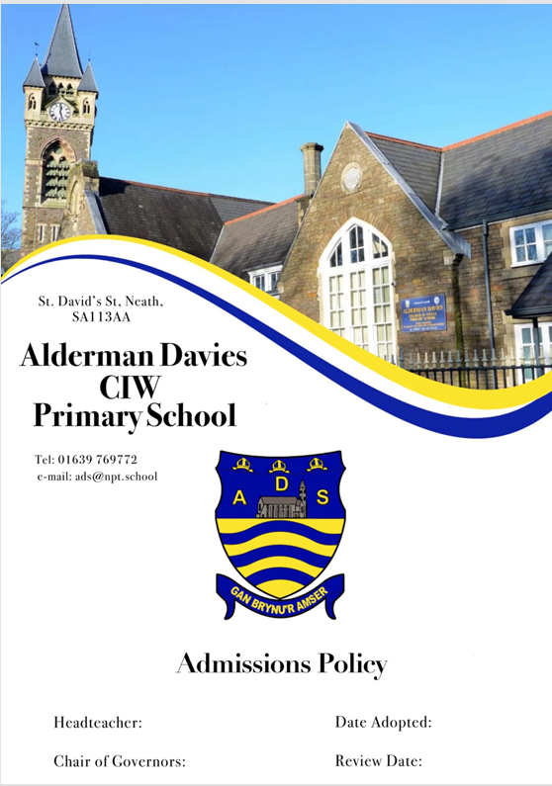

ADMISSIONS POLICY: 2027/28
Introduction

The Governing Body of Alderman Davies Church in Wales Primary School applies the regulations on admissions fairly and equally to all those who wish to attend this school. We are an inclusive school that welcomes children from all backgrounds and abilities. All applications will be treated on merit and in a sensitive manner.

The Governors of this school admit all children whose parents wish them to attend a Church Aided School, provided accommodation is available.

The planned admission limit is the number of admissions that the Governing Body would not wish to exceed. The planned admission limit for this school is 59. The admission number means the number of pupils that the Council can admit to a school. Each school has an admission number which is calculated using the Welsh Government’s ‘Measuring the capacity of schools in Wales’ assessment. Admission to a school cannot be refused unless the admission number has been reached.

For classes containing pupils, the majority of whom will attain the age of five, six and seven years during the course of the academic year, the class size must not exceed 30 pupils save for ‘excepted pupils’ as specified by Regulation.

Children who are in receipt of an LA Maintained IDP which identifies mainstream education within a community school will be guaranteed a place at that setting. Schools have a duty to admit children with a Statement of Special Educational Needs/ LA IDP who have been placed in a school by the LA and these pupils are counted towards the number of pupils to be admitted unless their placement is within a school based Learning Support Centre.

If the number of applications exceeds the available accommodation, the Governors will give priority in the following order:-

- A child who worships regularly* in the Church in Wales or a Church in Communion with it, within the Afan Nedd Ministry Area. A child looked after or previously looked after by a local authority in Wales, as defined in section 74 of the Social Services and Well-being (Wales) Act 2014 or England as defined in Section 22 of the Children Act 1989.
- A child who has a brother or sister already in the school. This includes adopted/step/foster siblings.
- A child who worships regularly in the Church in Wales, or a Church in Communion with it, living outside of the Afan Nedd Ministry Area.
- A child who worships regularly at a Christian place of worship.
- A child of any faith who worships regularly.
- Applications on compassionate grounds will be considered on their own merit, and at the discretion of the Governors.
- If children are equally entitled to a place in the school in categories - 1) to 7) above, then priority will be given to the child living nearest. This is measured by the shortest suitable walking/travel route between the home and the school. The Council uses a Geographical Information System to calculate the shortest distance.

As in all schools, children who attend our Nursery class will not have an automatic right of admission to full-time education at our school.

Should your application be unsuccessful, you have the right to appeal. If you exercise that right, the appeal must be forwarded to the Chair of Governors of Alderman Davies Church in Wales Primary School within 15 school days of receiving the letter refusing a place. Any The appeal will be considered by an independent Admission Appeal Panel, administered by the Llandaff Diocesan Board of Education, according to the Welsh Assembly Governments Code of Practice on School Admission Appeals.

Review:
This policy is required to be reviewed annually in time for a period of formal consultation.

*In this instance regular means at least twice a calendar month for the past year.

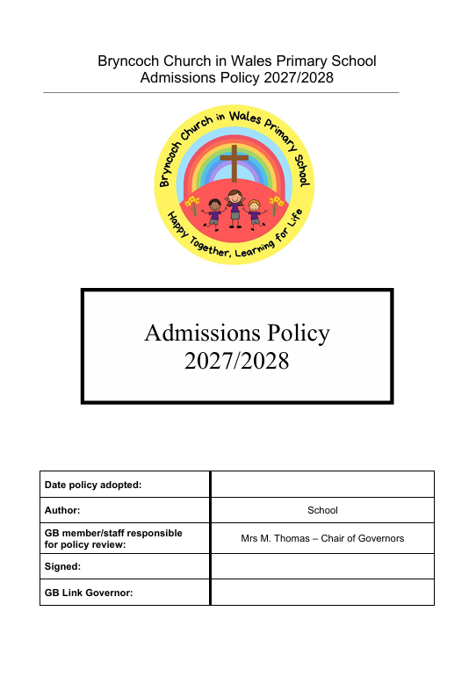

ADMISSIONS POLICY

The Planned Admission Number is the number of pupils that the Governing Body will admit to a year group in the school. The Planned Admission Number for this school calculated by the Local Education Authority is 31. The Governing Body has resolved that the maximum capacity of each year group in the school will be 31 pupils.

For classes in Foundation Phase (i.e. containing pupils, the majority of whom will attain the age of five, six and seven years during the course of the academic year 2027/2028), the class size must not exceed 30 pupils, unless it included “excepted pupils” as specified by Regulation.

“Looked after” children and children with Special Educational Needs
The Governing Body will give first priority to applications for admission for children looked after or previously looked after by a local authority in Wales, as defined in section 74 of the Social Services and Well-being (Wales) Act 2014 or England as defined in Section 22 of the Children Act 1989.

Priority will also be given to children with a Statement of Special Educational Needs/ Local Authority maintained IDP where the school is named as the most appropriate educational setting.

Oversubscription Criteria
If the number of applications exceeds the available pupil places, the Governing Body will admit children whose applications satisfy the over-subscription criteria in the following order:-

- A child who with their family worships regularly in the Church in Wales, within the Parish of Dyffryn.
- A child who has a brother or sister already in the school. This included adopted/step/foster siblings.
- A child who with their family worships regularly in the Church in Wales, living outside of the Parish of Dyffryn.
- A child who worships regularly at a Christian place of worship.
- A child of any faith who worships regularly,
- Children whose parents wish them to be educated in a school with a religious character.
- Other children who live in the Parish of Dyffryn
- Applications on compassionate grounds, will be considered on their own merit, and at the discretion of the Governors.

When dealing with applications based on faith commitment, parish priests or local ministers may be contacted to verify application details.

In the event of oversubscription within one of the criteria, the governors will give priority to children living closest to the school.

As in all school’s children who attend our nursery class will not have an automatic right of admission to full time education at our school.

Should your application be unsuccessful, you have the right to appeal. If you exercise that right, the appeal must be made in writing to the Clerk to the Governors within 15 school days of receiving the letter refusing a place. The appeal will be considered by an independent Admission Appeal Panel, administered by the Llandaff Diocesan Board of Education, according to the Welsh Assembly Government’s Code of Practice on School Admission Appeals.

Definition of a sibling
For the sibling criteria to be applicable one of the following conditions must exist:
- A brother and/or sister is to be permanently resident at the same address
- A stepbrother and /or stepsister (including half brother/sisters) is to be permanently resident at the same address.
Distance from School
Distance to school will be measured in a straight line from the main entrance of the family home to the main gate of the school, using the system adopted by Neath Port Talbot Council for all maintained schools within the county borough.

Place of Residence
The child’s ordinary place of residence will be deemed to be a residential property at which the person or persons with parental responsibility for the child resides at the closing date for receiving applications for admission to the school.
Where parental responsibility is held by more than one person, and those persons reside in separate properties, the child’s ordinary place of residence will be deemed to be that property at which the child resides for the greater part of the week, including weekends.


St. Joseph’s Catholic
infant school

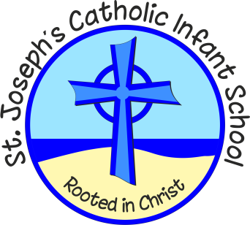

Admission Policy 2027-2028

THIS POLICY WAS REVIEWED/ADOPTED:
SPRING 2026
This Policy will be reviewed as and when required.

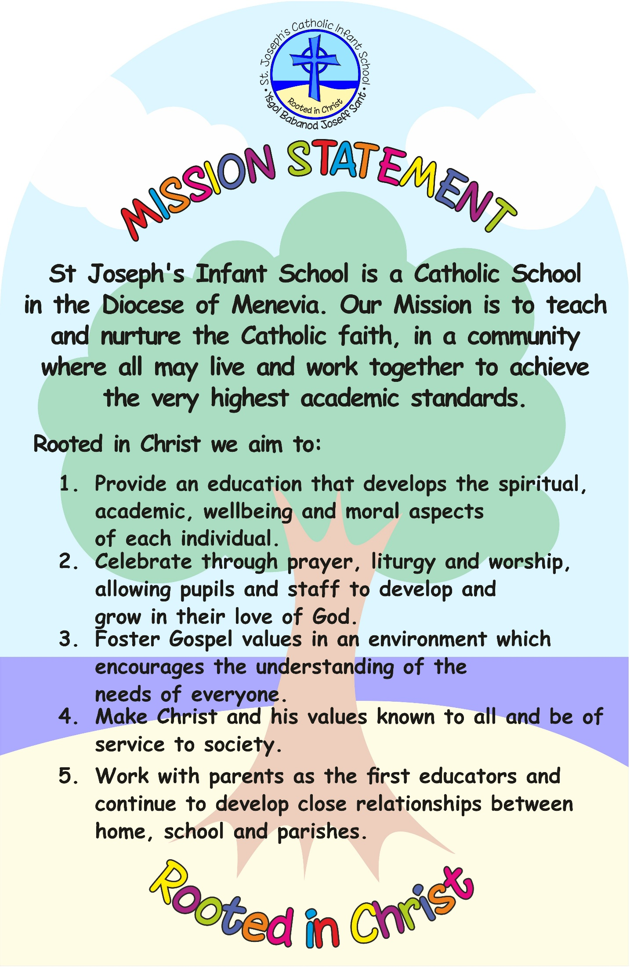

ST JOSEPH’S CATHOLIC INFANT SCHOOL
ADMISSION POLICY 2027-2028
St Joseph’s Catholic Infant School was founded by the Catholic Church to provide education for children of Catholic families. Whenever there are more applications than places available, priority will be given to Catholic children in accordance with the oversubscription criteria listed below. The school is conducted by its governing body as part of the Catholic Church in accordance with its trust deed and instrument of government and seeks, at all times, to be a witness to Our Lord Jesus Christ.
As a Catholic school, we aim to provide a Catholic education for all our pupils. At a Catholic school, Catholic doctrine and practice permeate every aspect of the school’s activity. It is essential that the Catholic character of the school’s education be fully supported by all families in the school. We therefore hope that all parents will give their full, unreserved and positive support for the aims and ethos of the school. This does not affect the right of an applicant who is not Catholic to apply for and be admitted to a place at the school in accordance with these admission arrangements.
The governing body is the admission authority and has responsibility for admissions to this school. The local authority undertakes the co-ordination of admission arrangements during the normal admission round . The admission authority has set the school’s admission number at 30 pupils to be admitted to the reception year in the school year which begins in September 2027.
The admission authority will, where logistically possible, admit twins and all siblings from multiple births where one of the children is the last child ranked within the school’s admission number.

Pupils with Individual Development Plans (Statements of SEN) (see note 1)
The admission of pupils with an Individual Development Plan (or Statements of SEN) is dealt with by a completely separate procedure. Children with an Individual Development Plan (or Statement of SEN) that names the school must be admitted. Where this takes place before the allocation of places under these arrangements this will reduce the number of places available to other children.

Oversubscription Criteria
Where there are more applications for places than the number of places available, places will be offered according to the following order of priority.
- Catholic looked after and previously looked after children. (see notes 2&3)
- Catholic children who are resident in the parishes of St Joseph’s (Port Talbot) and Our Lady of Margam (Margam). (see notes 3&10)
- Other Catholic children. (see note 3)
- Other looked after and previously looked after children. (see note 2)
- Catechumens and members of an Eastern Christian Church. (see notes 4&5)
- Children of other Christian denominations whose membership is evidenced by a minister of religion. (see note 6)
- Children of other faiths whose membership is evidenced by a religious leader. (see note 7)
- Any other children.
Within each of the categories listed above the attendance of a brother or sister at the school at the time of admission will increase the priority of an application within each category so that the application will be placed at the top of the category in which the application is made (see note 8).

Tie Break
Priority will be given to children living closest to the school determined by the shortest available walking route. Distances are calculated using the local authority’s GIS computer programme or such other programme as may be used by the local authority from time to time, which will measure the distance. In the event of distances being the same for two or more children where this would determine the last place to be allocated, random allocation will be carried out and supervised by a person independent of the school. All the names will be entered into a hat and the required number of names will be drawn out.

Application Procedures and Timetable
To apply for a place at this school in the normal admission round, you must complete a Common Application Form available from the local authority in which you live. You are also requested to complete the Supplementary Information Form attached to this policy if you wish to apply under oversubscription criteria 1 to 3 or 5 to 7. The Supplementary Information Form should be returned to Mrs Barbara Murphy, St Joseph’s Catholic Infant School, Water Street, Port Talbot, SA126LF by 15 January 2027.
You will be advised of the outcome of your application on 16th April 2027 or the next working day, by the local authority on our behalf. If you are unsuccessful (unless your child gained a place at a school you ranked higher) you will be informed of the reasons, related to the oversubscription criteria listed above, and you have the right of appeal to an independent appeal panel.
If you do not provide the information required in the SIF and return it by the closing date, together with all supporting documentation, your child may not be placed in criteria 1 to 3 or 5 to 7, and this may affect your child’s chance of being offered a place.
All applications which are submitted on time will be considered at the same time and after the closing date for admissions which is 15th January 2027.

Late Applications
Applications submitted after the published closing date will not be considered until after all on time applications received have been allocated and offered their places on the common offer day.

Admission of Children Below Compulsory School Age and Deferred Entry
The law does not require a child to start school until the start of the term following the child’s fifth birthday. A child is however, entitled to a full-time place in the September following their fourth birthday. A child’s parents may defer the date at which their child, below compulsory school age, is admitted to the school, until later in the same school year. The effect is that the place is held for that child and is not available to be offered to another child. A child’s parents must not, however, defer entry beyond the beginning of the term after the child’s fifth birthday, nor beyond the school year for which the original application was accepted. A child may take up a part-time place until later in the school year, but not beyond the point at which the child reaches compulsory school age. Upon receipt of the offer of a place a parent should notify the school, as soon as possible, that they wish to either defer their child’s entry to the school or take up a part-time place.

Admission of Children outside their Normal Age Group
A request may be made for a child to be admitted outside of their normal age group, for example, if the child is gifted and talented or has experienced problems such as ill health. In addition, the parents of a summer born child, i.e. a child born between 1st April and 31st August, may request that the child be admitted out of their normal age group, to reception rather than year 1.
Any such request should be made in writing to Mrs Barbara Murphy, St Joseph’s Catholic Infant School, Water Street, Port Talbot, SA126LF at the same time as the admission application is made. The admission authority will make its decision about the request based on the circumstances of each case and in the best interests of the child. In addition to taking into account the views of the head teacher, including the head teacher’s statutory responsibility for the internal organisation, management and control of the school, the admission authority will take into account the views of the parents and of appropriate medical and education professionals, as appropriate.

Waiting Lists
In addition to their right of appeal, unsuccessful children will be offered the opportunity to be placed on a waiting list. This waiting list will be maintained in order of the oversubscription criteria set out above and not in the order in which applications are received or added to the list. Waiting lists for admission will operate throughout the school year. The waiting list will be held open until Thursday 20 July 2028.
Inclusion in the school’s waiting list does not mean that a place will eventually become available.

In-Year Applications
An application can be made for a place for a child at any time outside the normal admission round and the child will be admitted where there are available places. Application should be made to the school by contacting:
Mrs Barbara Murphy, St Joseph’s Catholic Infant School, Water Street, Port Talbot, SA126LF
https://st-josephs-catholic-infant school1.j2bloggy.com/?doing_wp_cron=1770300822.4538419246673583984375
Where there are places available but more applications than places, the published oversubscription criteria, as set out above, will be applied.
If there are no places available, the child will be added to the waiting list (see above).
You will be advised of the outcome of your application in writing, and you have the right of appeal to an independent appeal panel.

Hard to Place Children
The school is committed to taking its fair share of children who are vulnerable and/or hard to place, as set out in locally agreed protocols. Accordingly, outside the normal admission round the admission authority is empowered to give absolute priority to a child where admission is requested under any locally agreed protocol. The admission authority has this power, even when admitting the child would mean exceeding the admission number (subject to the infant class size exceptions).

Nursery
For children attending the school’s nursery or any nursery provision delivered in a co-located children’s centre, application to the reception class of the school must be made in the normal way, to the home local authority. Attendance at the school’s nursery or any nursery provision delivered in a co-located children’s centre does not automatically guarantee that a place will be offered at the school.]
The admission authority reserves the right to withdraw the offer of a place or, where a child is already attending the school the place itself, where it is satisfied that the place was offered on the basis of a fraudulent or intentionally misleading application which effectively denied a place to a child with a stronger claim or where a place was offered by the LA rather than by the admission authority in error.
Notes (these notes form part of the oversubscription criteria)
- An Individual Development Plan is a statutory plan made by the local authority under The Additional Needs and Education Tribunal (Wales) Act 2018, specifying the special educational provision required for a child. Section 48 of the Additional Needs and Education Tribunal (Wales) Act 2018 requires the governing body of a maintained school in Wales to admit a child to the school if the school is named in the child’s Individual Development Plan. Individual Development Plans will eventually replace all other statutory or non-statutory plans including any Statement of SEN. For the purposes of this policy, references to an Individual Development Plan also include any other plan currently in place which names the school.
- A ‘looked after child’ has the same meaning as in section 22(1) of the Children Act 1989 and section 74 of the Social Services and Wellbeing (Wales) Act 2014, and means any child who is (a) in the care of a local authority or (b) being provided with accommodation by them in the exercise of their social services functions (e.g. children with foster parents) and whom the local authority has confirmed will be looked after at the time of the child’s admission to school.
A ‘previously looked after child’ is a child who was looked after, but ceased to be so because he or she was adopted, or became subject to a child arrangements order or special guardianship order.
- ‘Catholic’ means a member of a Church in full communion with the See of Rome. This includes the Eastern Catholic Churches. This will normally be evidenced by a certificate of baptism in a Catholic Church or a certificate of reception into the full communion of the Catholic Church. For the purposes of this policy, it includes a looked after child living with a family where at least one of the parents is Catholic.
For a child to be treated as Catholic, evidence of Catholic baptism or reception into the Church will be required. Those who have difficulty obtaining written evidence of baptism should contact their Parish Priest who, after consulting with the Diocese, will decide how the question of baptism is to be resolved and how written evidence is to be produced in accordance with the law of the Church.
- ‘catechumen’ means a member of the catechumenate of a Catholic Church. This will normally be evidenced by a certificate of reception into the order of catechumens.
- ‘Eastern Christian Church’ includes Orthodox Churches, and is normally evidenced by a certificate of baptism or reception from the authorities of that Church.
- “children of other Christian denominations” means children who belong to other churches and ecclesial communities which, acknowledge God’s revelation in Christ, confess the Lord Jesus Christ as God and Saviour according to the Scriptures, and, in obedience to God’s will and in the power of the Holy Spirit commit themselves: to seek a deepening of their communion with Christ and with one another in the Church, which is His body; and to fulfil their mission to proclaim the Gospel by common witness and service in the world to the glory of the one God, Father, Son and Holy Spirit. An ecclesial community which on principle has no credal statements in its tradition, is included if it manifests faith in Christ as witnessed to in the Scriptures and is committed to working in the spirit of the above.
All members of Churches Together in England and CYTÛN are deemed to be included in the above definition, as are all other churches and ecclesial communities that are in membership of any local Churches Together Group (by whatever title) on the above basis.
- “children of other faiths” means children who are members of a religious community that does not fall within the definition of ‘other Christian denominations’ at 6 above and which falls within the definition of a religion for the purposes of charity law. The Charities Act 2011 defines religion to include:
- A religion which involves belief in more than one God, and
- A religion which does not involve belief in a God.
Case law has identified certain characteristics which describe the meaning of religion for the purposes of charity law, which are characterised by a belief in a supreme being and an expression of belief in that supreme being through worship.
- ‘brother or sister’ includes:
- all natural brothers or sisters, half brothers or sisters, adopted brothers or sisters, stepbrothers or sisters, foster brothers or sisters, whether or not they are living at the same address; and
- the child of a parent’s partner where that child lives for at least part of the week in the same family unit at the same home address as the child who is the subject of the application.
- A ‘parent’ means all parents, any person who is not a parent but has parental responsibility for a child, and any person who has care of a child.
- For the purposes of this policy, our school serves the parishes of St Joseph’s (Port Talbot) and Our Lady of Margam (Margam) and includes the areas of Cwmavon and Baglan. This will be applied to the admission arrangements for September 2027
- A child’s “home address” refers to the address where the child usually lives with a parent or carer, and will be the address provided in the Common Application Form (“CAF”). Where parents have shared responsibility for a child, and the child lives for part of the week with each parent, the home address will be the address given in the CAF, provided that the child resides at that address for any part of the school week.

ARCHDIOCESE OF CARDIFF-MENEVIA
ST JOSEPH’S CATHOLIC INFANT SCHOOL
SUPPLEMENTARY INFORMATION FORM
2027-2028
If you are expressing a preference for a place for your child at ST JOSEPH’S CATHOLIC INFANT SCHOOL in NEATH PORT TALBOT and wish to apply under a faith criterion, you should complete this Supplementary Information Form.
- The completed Supplementary Information Form, together with all supporting documentation (see Notes below), should be returned to Mrs Barbara Murphy, St Joseph’s Catholic Infant School, Water Street, Port Talbot, SA126LF at the school by the closing date insert 15th January 2027
- If you are applying to more than one Catholic school you will need to complete a separate Supplementary Information Form for each school.
- If you do not provide the information required in this form and return it to the school, with all supporting documentation, by the closing date, your child may not be placed in the appropriate faith category and this may affect your child’s chance of being offered a place.
- Remember – you must also complete the Common Application Form.
Name of child: ______________________________________
Address of child: ______________________________________
______________________________________
______________________________________
Parent/Carer Name: ______________________________________
Parent/Carer Email: ______________________________________

Please read the relevant school Admissions Policy, noting in particular any faith criteria, and your Local Authority booklet, before completing this form.
NOTE: When completing the Common Application Form, it is important that you provide details of any siblings (brothers or sisters) who will be attending the Catholic school at the proposed time of admission. If this information is not provided the admission authority of the Catholic school may not be able to place the application within the correct criteria.
Religious Status of child (please indicate by placing a tick in the appropriate box – please note that a tick should be indicated in only a single box)
Criteria | Tick Box | Evidence: insert details in accordance with the Notes below
1. Catholic | □
2. Catechumen | □
3. Member of an Eastern Christian Church | □
4. Member of other Christian denomination | □
5. Member of other faith | □

Catholic [Parish] [Deanery] in which your child lives:

In compliance with the UK General Data Protection Regulation (UK GDPR) and the Data Protection Act 2018, we wish to ensure that you are aware of the purpose for which we collect and process the data we have asked you to provide on this form.
- We are
St Joseph’s Catholic Infant School, Water Street, Port Talbot, SA126LF
- Being a Catholic education provider, we work closely with the School’s Diocesan Authority, the School’s Trustees, the Local Authority, the Catholic Education Service and the Welsh Government, and may share the information you provide on this application form if we consider it is necessary in order to fulfil our functions.
- The person responsible for data protection within our organisation is Mrs Barbara Murphyand you can contact them with questions relating to our handling of the data. You can contact them by phone on 01639882579 or email at Office@stjosinf.npt.school
- We require the information we have requested for reasons relating to our functions as the admission authority of the school.
- It is necessary for us to process personal data for the performance of a task carried out in the public interest or in the exercise of official authority vested in the controller (Article 6(1)(e) of the UK GDPR).
- To the extent that you have shared any special categories of data this will not be shared with any third parties except as detailed in paragraph 2 above, unless a legal obligation should arise.
- It is necessary for us to process special category data for the performance of a task carried out in the public interest or in the exercise of official authority vested in the controller (Article 6(1)(e) of the UK GDPR). Additionally, processing is necessary for reasons of substantial public interest on the basis of domestic law which is proportionate to the aim pursued and which contains appropriate safeguards (Article 9(2)(g) of the UK GDPR).
- If the application is successful, the information you have provided on this form will be migrated to the school’s enrolment system, and the data will be retained and processed on the basis of the school’s fair processing notice and data protection policies which apply to that data.
- If the application is unsuccessful, the application form and any documents submitted in support of the application will be destroyed after a period of 12 months. The school may keep a simple record of all applications and their outcome as part of their permanent archives in accordance with the school’s data retention policy.
- To read about your individual rights you can refer to the school’s fair processing notice and data protection policies.
- If you wish to complain about how we have collected and processed the information you have provided on this form, you can make a complaint to our organisation by contacting our designated person, Mrs Barbara Murphy. If you are unhappy with how your complaint has been handled, you can contact the Information Commissioner’s Office via their website at: ico.org.uk.
I confirm that I have read the Admissions Policy of the school and that the information I have provided is correct. I understand that I must notify the school immediately if there is any change to these details and that, should any information I have given prove to be inaccurate, the Admission Authority may withdraw any offer of a place even if the child has already started school.

Signed……………………….. Date………………………………

Notes
1. Evidence of Catholic Baptism
If an application is being made for a place at the school for Catholic child evidence of Catholic baptism or reception into the Church is required. A certificate of baptism or certificate of reception into the full communion of the Catholic Church should be provided at the same time as this form is returned to the school.
The admission authority may request additional supporting evidence if the written documents that are provided do not clarify the fact that the child was baptised or received into the Catholic Church, e.g. where the name and address of the church is not on the certificate or where the name of the church does not state whether it is a Catholic church or not. Those who have difficulty obtaining written evidence of baptism or reception into the Church should contact their Parish Priest.
2. Evidence for Catechumens
If an application is being made for a place at the school/academy for a catechumen evidence of their being a member of the catechumenate of a Catholic Church will be required. A certificate of reception into the order of catechumens should be provided at the same time as this form is returned to the school.
3. Evidence of Membership of an Eastern Christian Church
If an application is being made for a place at the school for a member of an Eastern Christian Church, including Orthodox Churches, evidence of membership will be required. A certificate of baptism or reception from the authorities of that Church should be provided at the same time as this form is returned to the school.
5. Evidence for Other Christian Denominations and Other Faiths
If an application is being made for a place at the school as a member of another Christian denomination or another faith evidence confirming membership of that Christian denomination or faith and signed by the appropriate minister of religion or faith leader, will be required. The evidence should be provided at the same time as this form is returned to the school.
Checklist:
Have you enclosed?
- Copy of baptism or certificate of reception into the Catholic Church (where applicable).
- Evidence confirming membership of a Christian denomination or other faith (where applicable).
Have you completed and returned your local authority’s Common Application Form?

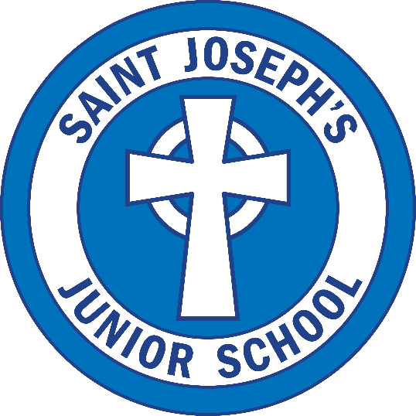

Admissions Policy
2027-2028


In Catholic voluntary aided schools, the admission authority is the governing body. The term “school” is used throughout the document to mean all Catholic schools, including schools in the trusteeship of a religious order.
St. Joseph’s Catholic Junior School
ADMISSION POLICY 2027-2028
St. Joseph’s Junior School Catholic Primary School was founded by the Catholic Church to provide education for children of Catholic families. Whenever there are more applications than places available, priority will be given to Catholic children in accordance with the oversubscription criteria listed below. The school is conducted by its governing body as part of the Catholic Church in accordance with its trust deed and instrument of government and seeks at all times to be a witness to Our Lord Jesus Christ.
As a Catholic school, we aim to provide a Catholic education for all our pupils. At a Catholic school, Catholic doctrine and practice permeate every aspect of the school’s activity. It is essential that the Catholic character of the school’s education be fully supported by all families in the school. We therefore hope that all parents will give their full, unreserved and positive support for the aims and ethos of the school. This does not affect the right of an applicant who is not Catholic to apply for and be admitted to a place at the school in accordance with these admission arrangements.
The governing body is the admission authority and has responsibility for admissions to this school. The local authority undertakes the co-ordination of admission arrangements during the normal admission round . The admission authority has set the school’s admission number at 39 pupils to be admitted to year 3 in the school year which begins in September, 2027.
The admission authority will, where logistically possible, admit twins and all siblings from multiple births where one of the children is the last child ranked within the school’s admission number.

Pupils with Individual Development Plans (Statements of SEN) (see note 1)
The admission of pupils with an Individual Development Plan (or Statements of SEN) is dealt with by a separate procedure. Children with an Individual Development Plan (or Statement of SEN) that names the school must be admitted. Where this takes place before the allocation of places under these arrangements this will reduce the number of places available to other children.

Oversubscription Criteria
Where there are more applications for places than the number of places available, places will be offered according to the following order of priority.
- Catholic looked after and previously looked after children. (see notes 2&3)
- Catholic children who are resident in the parish(es) of Port Talbot, Margam and Cwmafan. (see notes 3&10)
- Other Catholic children. (see note 3)
- Other looked after and previously looked after children. (see note 2)
- Catechumens and members of an Eastern Christian Church. (see notes 4&5)
- Children of other Christian denominations whose membership is evidenced by a minister of religion. (see note 6)
- Children of other faiths whose membership is evidenced by a religious leader. (see note 7)
- Any other children.
Within each of the categories listed above the attendance of a brother or sister at the school at the time of admission will increase the priority of an application within each category so that the application will be placed at the top of the category in which the application is made (see note 8).
Tie Break
Priority will be given to children living closest to the school determined by the shortest available walking route. Distances are calculated using the local authority’s GIS computer programme or such other programme as may be used by the local authority from time to time, which will measure the distance from [outside the entrance to the property (house or flat)] [the nearest recognised public road access point from the property (house or flat)] to the nearest official school entrance. In the event of distances being the same for two or more children where this would determine the last place to be allocated, random allocation will be carried out and supervised by a person independent of the school. All the names will be entered into a hat and the required number of names will be drawn out.

Application Procedures and Timetable
To apply for a place at this school in the normal admission round, you must complete a Common Application Form available from the local authority in which you live. You are also requested to complete the Supplementary Information Form attached to this policy if you wish to apply under oversubscription criteria 1 to 3 or 5 to 7. The Supplementary Information Form should be returned to the school by 15 January 2027
You will be advised of the outcome of your application on [16th April 2027 or the next working day, by the local authority on our behalf. If you are unsuccessful (unless your child gained a place at a school you ranked higher) you will be informed of the reasons, related to the oversubscription criteria listed above, and you have the right of appeal to an independent appeal panel.
If you do not provide the information required in the SIF and return it by the closing date, together with all supporting documentation, your child may not be placed in criteria 1 to 3 or 5 to 7, and this may affect your child’s chance of being offered a place.
All applications which are submitted on time will be considered at the same time and after the closing date for admissions which is 15th January 2027.
Late Applications
Late applications will be accepted provided that a good reason is given and provided that any application is received before offers of places are made. You are encouraged to ensure that your application is received on time.]
Admission of Children outside their Normal Age Group
A request may be made for a child to be admitted outside of their normal age group, for example, if the child is gifted and talented or has experienced problems such as ill health. In addition, the parents of a summer born child, i.e. a child born between 1st April and 31st August, may request that the child be admitted out of their normal age group, to reception rather than year 1.
Any such request should be made in writing to The Governing Body Admissions Subcommittee at St. Joseph’s Junior School at the same time as the admission application is made. The admission authority will make its decision about the request based on the circumstances of each case and in the best interests of the child. In addition to considering the views of the head teacher, including the head teacher’s statutory responsibility for the internal organisation, management and control of the school, the admission authority will take into account the views of the parents and of appropriate medical and education professionals, as appropriate.
Waiting Lists
In addition to their right of appeal, which will conclude on the 14th May 2027, unsuccessful children will be offered the opportunity to be placed on a waiting list. This waiting list will be maintained in order of the oversubscription criteria set out above and not in the order in which applications are received or added to the list. Waiting lists for admission will operate throughout the school year. The waiting list will be held open the last day of the summer term.
Inclusion in the school’s waiting list does not mean that a place will eventually become available.
In-Year Applications
An application can be made for a place for a child at any time outside the normal admission round and the child will be admitted where there are available places. Application should be made the central admissions officer in the local authority.
Where there are places available but more applications than places, the published oversubscription criteria, as set out above, will be applied.
If there are no places available, the child will be added to the waiting list (see above).
You will be advised of the outcome of your application in writing, and you have the right of appeal to an independent appeal panel.

Hard to Place Children
The school is committed to taking its fair share of children who are vulnerable and/or hard to place, as set out in locally agreed protocols. Accordingly, outside the normal admission round the admission authority is empowered to give absolute priority to a child where admission is requested under any locally agreed protocol. The admission authority has this power, even when admitting the child would mean exceeding the admission number (subject to the infant class size exceptions).
The admission authority reserves the right to withdraw the offer of a place or, where a child is already attending the school the place itself, where it is satisfied that the place was offered on the basis of a fraudulent or intentionally misleading application which effectively denied a place to a child with a stronger claim or where a place was offered by the LA rather than by the admission authority in error.
Notes (these notes form part of the oversubscription criteria)
- An Individual Development Plan is a statutory plan made by the local authority under The Additional Needs and Education Tribunal (Wales) Act 2018, specifying the special educational provision required for a child. Section 48 of the Additional Needs and Education Tribunal (Wales) Act 2018 requires the governing body of a maintained school in Wales to admit a child to the school if the school is named in the child’s Individual Development Plan. Individual Development Plans will eventually replace all other statutory or non-statutory plans including any Statement of SEN. For the purposes of this policy, references to an Individual Development Plan also include any other plan currently in place which names the school.
- A ‘looked after child’ has the same meaning as in section 22(1) of the Children Act 1989 and section 74 of the Social Services and Wellbeing (Wales) Act 2014, and means any child who is (a) in the care of a local authority or (b) being provided with accommodation by them in the exercise of their social services functions (e.g. children with foster parents) and whom the local authority has confirmed will be looked after at the time of the child’s admission to school.
A ‘previously looked after child’ is a child who was looked after but ceased to be so because he or she was adopted or became subject to a child arrangements order or special guardianship order.
- ‘Catholic’ means a member of a Church in full communion with the See of Rome. This includes the Eastern Catholic Churches. This will normally be evidenced by a certificate of baptism in a Catholic Church or a certificate of reception into the full communion of the Catholic Church. For the purposes of this policy, it includes a looked after child living with a family where at least one of the parents is Catholic.
For a child to be treated as Catholic, evidence of Catholic baptism or reception into the Church will be required. Those who have difficulty obtaining written evidence of baptism should contact their Parish Priest who, after consulting with the Diocese, will decide how the question of baptism is to be resolved and how written evidence is to be produced in accordance with the law of the Church.
- ‘catechumen’ means a member of the catechumenate of a Catholic Church. This will normally be evidenced by a certificate of reception into the order of catechumens.
- ‘Eastern Christian Church’ includes Orthodox Churches and is normally evidenced by a certificate of baptism or reception from the authorities of that Church.
- “children of other Christian denominations” means children who belong to other churches and ecclesial communities which, acknowledge God’s revelation in Christ, confess the Lord Jesus Christ as God and Saviour according to the Scriptures, and, in obedience to God’s will and in the power of the Holy Spirit commit themselves: to seek a deepening of their communion with Christ and with one another in the Church, which is His body; and to fulfil their mission to proclaim the Gospel by common witness and service in the world to the glory of the one God, Father, Son and Holy Spirit. An ecclesial community which on principle has no credal statements in its tradition, is included if it manifests faith in Christ as witnessed to in the Scriptures and is committed to working in the spirit of the above.
All members of Churches Together in England and CYTÛN are deemed to be included in the above definition, as are all other churches and ecclesial communities that are in membership of any local Churches Together Group (by whatever title) on the above basis.
- “children of other faiths” means children who are members of a religious community that does not fall within the definition of ‘other Christian denominations’ at 6 above and which falls within the definition of a religion for the purposes of charity law. The Charities Act 2011 defines religion to include:
- A religion which involves belief in more than one God, and
- A religion which does not involve belief in a God.
Case law has identified certain characteristics which describe the meaning of religion for the purposes of charity law, which are characterised by a belief in a supreme being and an expression of belief in that supreme being through worship.
- ‘brother or sister’ includes:
- all natural brothers or sisters, half brothers or sisters, adopted brothers or sisters, stepbrothers or sisters, foster brothers or sisters, whether or not they are living at the same address; and
- the child of a parent’s partner where that child lives for at least part of the week in the same family unit at the same home address as the child who is the subject of the application.
- A ‘parent’ means all parents, any person who is not a parent but has parental responsibility for a child, and any person who has care of a child.
- For the purposes of this policy, parish boundaries will be applied to the admission arrangements for 2027-2028.
- A child’s “home address” refers to the address where the child usually lives with a parent or carer and will be the address provided in the Common Application Form (“CAF”). Where parents have shared responsibility for a child, and the child lives for part of the week with each parent, the home address will be the address given in the CAF, provided that the child resides at that address for any part of the school week.

ARCHDIOCESE OF CARDIFF MENEVIA
ST. JOSEPH’S CATHOLIC JUNIOR SCHOOL
SUPPLEMENTARY INFORMATION FORM
2027/2028
If you are expressing a preference for a place for your child at St. Joseph’s Catholic Junior School in Neath Port Talbot and wish to apply under a faith criterion, you should complete this Supplementary Information Form.
- The completed Supplementary Information Form, together with all supporting documentation (see Notes below), should be returned to the clerk of the governors at the school by the closing date 15th January 2027.
- If you are applying to more than one Catholic school, you will need to complete a separate Supplementary Information Form for each school.
- If you do not provide the information required in this form and return it to the school, with all supporting documentation, by the closing date, your child may not be placed in the appropriate faith category and this may affect your child’s chance of being offered a place.
- Remember – you must also complete the Common Application Form.
Name of child: ______________________________________
Address of child: ______________________________________
______________________________________
______________________________________
Parent/Carer Name: ______________________________________
Parent/Carer Email: ______________________________________

Please read the relevant school Admissions Policy, noting any faith criteria, and your Local Authority booklet, before completing this form.
NOTE: When completing the Common Application Form, it is important that you provide details of any siblings (brothers or sisters) who will be attending the Catholic school at the proposed time of admission. If this information is not provided the admission authority of the Catholic school may not be able to place the application within the correct criteria.
Religious Status of child (please indicate by placing a tick in the appropriate box – please note that a tick should be indicated in only a single box)
Criteria | Tick Box | Evidence: insert details in accordance with the Notes below
1. Catholic | □
2. Catechumen | □
3. Member of an Eastern Christian Church | □
4. Member of other Christian denomination | □
5. Member of other faith | □

Catholic [Parish] [Deanery] in which your child lives:

In compliance with the UK General Data Protection Regulation (UK GDPR) and the Data Protection Act 2018, we wish to ensure that you are aware of the purpose for which we collect and process the data we have asked you to provide on this form.
- We are St. Joseph’s Catholic Junior School.
- Being a Catholic education provider, we work closely with the School’s Diocesan Authority, the School’s Trustees, the Local Authority, the Catholic Education Service and the Welsh Government, and may share the information you provide on this application form if we consider it is necessary in order to fulfil our functions.
- The person responsible for data protection within our organisation is the headteacher and you can contact them with questions relating to our handling of the data. You can contact them by in the school.
- We require the information we have requested for reasons relating to our functions as the admission authority of the school.
- It is necessary for us to process personal data for the performance of a task carried out in the public interest or in the exercise of official authority vested in the controller (Article 6(1)(e) of the UK GDPR).
- To the extent that you have shared any special categories of data this will not be shared with any third parties except as detailed in paragraph 2 above, unless a legal obligation should arise.
- It is necessary for us to process special category data for the performance of a task carried out in the public interest or in the exercise of official authority vested in the controller (Article 6(1)(e) of the UK GDPR). Additionally, processing is necessary for reasons of substantial public interest based on domestic law which is proportionate to the aim pursued and which contains appropriate safeguards (Article 9(2)(g) of the UK GDPR).
- If the application is successful, the information you have provided on this form will be migrated to the school’s enrolment system, and the data will be retained and processed based on the school’s fair processing notice and data protection policies which apply to that data.
- If the application is unsuccessful, the application form and any documents submitted in support of the application will be destroyed after a period of 12 months. The school may keep a simple record of all applications and their outcome as part of their permanent archives in accordance with the school’s data retention policy.
- To read about your individual rights you can refer to the school’s fair processing notice and data protection policies.
- If you wish to complain about how we have collected and processed the information you have provided on this form, you can make a complaint to our organisation in writing. If you are unhappy with how your complaint has been handled, you can contact the Information Commissioner’s Office via their website at: ico.org.uk.
I confirm that I have read the Admissions Policy of the school and that the information I have provided is correct. I understand that I must notify the school immediately if there is any change to these details and that, should any information I have given prove to be inaccurate, the Admission Authority may withdraw any offer of a place even if the child has already started school.

Signed……………………….. Date………………………………

Notes
1. Evidence of Catholic Baptism
If an application is being made for a place at the school for Catholic child evidence of Catholic baptism or reception into the Church is required. A certificate of baptism or certificate of reception into the full communion of the Catholic Church should be provided at the same time as this form is returned to the school.
The admission authority may request additional supporting evidence if the written documents that are provided do not clarify the fact that the child was baptised or received into the Catholic Church, e.g. where the name and address of the church is not on the certificate or where the name of the church does not state whether it is a Catholic church or not. Those who have difficulty obtaining written evidence of baptism or reception into the Church should contact their Parish Priest.

2. Evidence for Catechumens
If an application is being made for a place at the school/academy for a catechumen evidence of their being a member of the catechumenate of a Catholic Church will be required. A certificate of reception into the order of catechumens should be provided at the same time as this form is returned to the school.
3. Evidence of Membership of an Eastern Christian Church
If an application is being made for a place at the school for a member of an Eastern Christian Church, including Orthodox Churches, evidence of membership will be required. A certificate of baptism or reception from the authorities of that Church should be provided at the same time as this form is returned to the school.
5. Evidence for Other Christian Denominations and Other Faiths
If an application is being made for a place at the school as a member of another Christian denomination or another faith evidence confirming membership of that Christian denomination or faith and signed by the appropriate minister of religion or faith leader, will be required. The evidence should be provided at the same time as this form is returned to the school.
Checklist:
Have you enclosed?
- Copy of baptism or certificate of reception into the Catholic Church (where applicable).
- Evidence confirming membership of a Christian denomination or other faith (where applicable).
Have you completed and returned your local authority’s Common Application Form?

Saint Joseph’s
Catholic Primary School
Ysgol Gynradd Catholig San Joseff



Admissions Policy
2027-2028

STATUTORY POLICY
THIS POLICY WAS ADOPTED: Spring 2026

This Policy will be reviewed: Spring 2027

Vision Statement

St. Joseph’s Primary School provides a small, caring, nurturing Catholic environment where all pupils receive encouragement and guidance to develop their abilities and talents to the full. This reflects our Mission Statement, “One Family, Many Gifts”, whilst living out the Gospel Values.

We aim to create an inclusive environment where pupils become literate, numerate and digitally competent. Whilst at our school, they are developed to become creative, healthy, ambitious and resilient learners. We aim to create a bilingual environment where learners are proud of their Welsh heritage. We challenge and support our pupils to reach their full potential, equipping them with the skills necessary to continue their journey of life-long learning. Above all, we aspire to shape confident learners with strong morals and values, that leave our school with happy memories of their formative years.
religious order.
ST JOSEPH’S CATHOLIC PRIMARY SCHOOL
ADMISSION POLICY 2027-2028
St Joseph’s Catholic Primary School was founded by the Catholic Church to provide education for children of Catholic families. Whenever there are more applications than places available, priority will be given to Catholic children in accordance with the oversubscription criteria listed below. The school is conducted by its governing body as part of the Catholic Church in accordance with its trust deed and instrument of government and seeks at all times to be a witness to Our Lord Jesus Christ.
As a Catholic school, we aim to provide a Catholic education for all our pupils. At a Catholic school, Catholic doctrine and practice permeate every aspect of the school’s activity. It is essential that the Catholic character of the school’s education be fully supported by all families in the school. We therefore hope that all parents will give their full, unreserved and positive support for the aims and ethos of the school. This does not affect the right of an applicant who is not Catholic to apply for and be admitted to a place at the school in accordance with these admission arrangements.
The governing body is the admission authority and has responsibility for admissions to this school. The local authority undertakes the co-ordination of admission arrangements during the normal admission round . The admission authority has set the school’s admission number at 29 pupils to be admitted to the reception year in the school year which begins in September, 2027.
The admission authority will, where logistically possible, admit twins and all siblings from multiple births where one of the children is the last child ranked within the school’s admission number.

Pupils with Individual Development Plans (Statements of SEN) (see note 1)
The admission of pupils with an Individual Development Plan (or Statements of SEN) is dealt with by a completely separate procedure. Children with an Individual Development Plan (or Statement of SEN) that names the school must be admitted. Where this takes place before the allocation of places under these arrangements this will reduce the number of places available to other children.

Oversubscription Criteria
Where there are more applications for places than the number of places available, places will be offered according to the following order of priority.
- Catholic looked after and previously looked after children. (see notes 2&3)
- Catholic children who are resident in the parish(es) of [name]. (see notes 3&10)
- Other Catholic children. (see note 3)
- Other looked after and previously looked after children. (see note 2)
- Catechumens and members of an Eastern Christian Church. (see notes 4&5)
- Children of other Christian denominations whose membership is evidenced by a minister of religion. (see note 6)
- Children of other faiths whose membership is evidenced by a religious leader. (see note 7)
- Any other children.
Within each of the categories listed above the attendance of a brother or sister at the school at the time of admission will increase the priority of an application within each category so that the application will be placed at the top of the category in which the application is made (see note 8).
Tie Break
Priority will be given to children living closest to the school determined by the shortest available walking route. Distances are calculated using the local authority’s GIS computer programme or such other programme as may be used by the local authority from time to time, which will measure the distance. In the event of distances being the same for two or more children where this would determine the last place to be allocated, random allocation will be carried out and supervised by a person independent of the school. All the names will be entered into a hat and the required number of names will be drawn out.

Application Procedures and Timetable
To apply for a place at this school in the normal admission round, you must complete a Common Application Form available from the local authority in which you live. You are also requested to complete the Supplementary Information Form attached to this policy if you wish to apply under oversubscription criteria 1 to 3 or 5 to 7. The Supplementary Information Form should be returned to Mrs. Philippa Brooks, St. Joseph’s Catholic Primary School, Cook Rees Avenue, SA11 1UR by 15 January 2027.
You will be advised of the outcome of your application on 16th April 2027 or the next working day, by the local authority on our behalf. If you are unsuccessful (unless your child gained a place at a school you ranked higher) you will be informed of the reasons, related to the oversubscription criteria listed above, and you have the right of appeal to an independent appeal panel.
If you do not provide the information required in the SIF and return it by the closing date, together with all supporting documentation, your child may not be placed in criteria 1 to 3 or 5 to 7, and this may affect your child’s chance of being offered a place.
All applications which are submitted on time will be considered at the same time and after the closing date for admissions which is 15th January 2027.

Late Applications
Late applications will be accepted provided that a good reason is given and provided that any application is received before offers of places are made. You are encouraged to ensure that your application is received on time.

NPT – Applications submitted after the published closing date will not be considered until after all on time applications received have been allocated and offered their places on the common offer day.

Admission of Children Below Compulsory School Age and Deferred Entry
The law does not require a child to start school until the start of the term following the child’s fifth birthday. A child is however, entitled to a full-time place in the September following their fourth birthday. A child’s parents may defer the date at which their child, below compulsory school age, is admitted to the school, until later in the same school year. The effect is that the place is held for that child and is not available to be offered to another child. A child’s parents must not, however, defer entry beyond the beginning of the term after the child’s fifth birthday, nor beyond the school year for which the original application was accepted. A child may take up a part-time place until later in the school year, but not beyond the point at which the child reaches compulsory school age. Upon receipt of the offer of a place a parent should notify the school, as soon as possible, that they wish to either defer their child’s entry to the school or take up a part-time place.

Admission of Children outside their Normal Age Group
A request may be made for a child to be admitted outside of their normal age group, for example, if the child is gifted and talented or has experienced problems such as ill health. In addition, the parents of a summer born child, i.e. a child born between 1st April and 31st August, may request that the child be admitted out of their normal age group, to reception rather than year 1.
Any such request should be made in writing to Mrs. Philippa Brooks, St. Joseph’s Catholic Primary School, Cook Rees Avenue, SA11 1UR by 15 January 2027 at the same time as the admission application is made. The admission authority will make its decision about the request based on the circumstances of each case and in the best interests of the child. In addition to taking into account the views of the head teacher, including the head teacher’s statutory responsibility for the internal organisation, management and control of the school, the admission authority will take into account the views of the parents and of appropriate medical and education professionals, as appropriate.

Waiting Lists
In addition to their right of appeal, unsuccessful children will be offered the opportunity to be placed on a waiting list. This waiting list will be maintained in order of the oversubscription criteria set out above and not in the order in which applications are received or added to the list. Waiting lists for admission will operate throughout the school year. The waiting list will be held open until Wednesday 21st July 2027.
Inclusion in the school’s waiting list does not mean that a place will eventually become available.

In-Year Applications
An application can be made for a place for a child at any time outside the normal admission round and the child will be admitted where there are available places. Application should be made to the school by contacting Mrs. Philippa Brooks, St. Joseph’s Catholic Primary School, SA11 1UR by 15 January 2027.
Where there are places available but more applications than places, the published oversubscription criteria, as set out above, will be applied.
If there are no places available, the child will be added to the waiting list (see above).
You will be advised of the outcome of your application in writing, and you have the right of appeal to an independent appeal panel.

Hard to Place Children
The school is committed to taking its fair share of children who are vulnerable and/or hard to place, as set out in locally agreed protocols. Accordingly, outside the normal admission round the admission authority is empowered to give absolute priority to a child where admission is requested under any locally agreed protocol. The admission authority has this power, even when admitting the child would mean exceeding the admission number (subject to the Primary class size exceptions).

Nursery
For children attending the school’s nursery or any nursery provision delivered in a co-located children’s centre, application to the reception class of the school must be made in the normal way, to the home local authority. Attendance at the school’s nursery or any nursery provision delivered in a co-located children’s centre does not automatically guarantee that a place will be offered at the school.
The admission authority reserves the right to withdraw the offer of a place or, where a child is already attending the school the place itself, where it is satisfied that the place was offered on the basis of a fraudulent or intentionally misleading application which effectively denied a place to a child with a stronger claim or where a place was offered by the LA rather than by the admission authority in error.
Notes (these notes form part of the oversubscription criteria)
- An Individual Development Plan is a statutory plan made by the local authority under The Additional Needs and Education Tribunal (Wales) Act 2018, specifying the special educational provision required for a child. Section 48 of the Additional Needs and Education Tribunal (Wales) Act 2018 requires the governing body of a maintained school in Wales to admit a child to the school if the school is named in the child’s Individual Development Plan. Individual Development Plans will eventually replace all other statutory or non-statutory plans including any Statement of SEN. For the purposes of this policy, references to an Individual Development Plan also include any other plan currently in place which names the school.
- A ‘looked after child’ has the same meaning as in section 22(1) of the Children Act 1989 and section 74 of the Social Services and Wellbeing (Wales) Act 2014, and means any child who is (a) in the care of a local authority or (b) being provided with accommodation by them in the exercise of their social services functions (e.g. children with foster parents) and whom the local authority has confirmed will be looked after at the time of the child’s admission to school.
A ‘previously looked after child’ is a child who was looked after, but ceased to be so because he or she was adopted, or became subject to a child arrangements order or special guardianship order.
- ‘Catholic’ means a member of a Church in full communion with the See of Rome. This includes the Eastern Catholic Churches. This will normally be evidenced by a certificate of baptism in a Catholic Church or a certificate of reception into the full communion of the Catholic Church. For the purposes of this policy, it includes a looked after child living with a family where at least one of the parents is Catholic.
For a child to be treated as Catholic, evidence of Catholic baptism or reception into the Church will be required. Those who have difficulty obtaining written evidence of baptism should contact their Parish Priest who, after consulting with the Diocese, will decide how the question of baptism is to be resolved and how written evidence is to be produced in accordance with the law of the Church.
- ‘catechumen’ means a member of the catechumenate of a Catholic Church. This will normally be evidenced by a certificate of reception into the order of catechumens.
- ‘Eastern Christian Church’ includes Orthodox Churches, and is normally evidenced by a certificate of baptism or reception from the authorities of that Church.
- “children of other Christian denominations” means children who belong to other churches and ecclesial communities which, acknowledge God’s revelation in Christ, confess the Lord Jesus Christ as God and Saviour according to the Scriptures, and, in obedience to God’s will and in the power of the Holy Spirit commit themselves: to seek a deepening of their communion with Christ and with one another in the Church, which is His body; and to fulfil their mission to proclaim the Gospel by common witness and service in the world to the glory of the one God, Father, Son and Holy Spirit. An ecclesial community which on principle has no credal statements in its tradition, is included if it manifests faith in Christ as witnessed to in the Scriptures and is committed to working in the spirit of the above.
All members of Churches Together in England and CYTÛN are deemed to be included in the above definition, as are all other churches and ecclesial communities that are in membership of any local Churches Together Group (by whatever title) on the above basis.
- “children of other faiths” means children who are members of a religious community that does not fall within the definition of ‘other Christian denominations’ at 6 above and which falls within the definition of a religion for the purposes of charity law. The Charities Act 2011 defines religion to include:
- A religion which involves belief in more than one God, and
- A religion which does not involve belief in a God.
Case law has identified certain characteristics which describe the meaning of religion for the purposes of charity law, which are characterised by a belief in a supreme being and an expression of belief in that supreme being through worship.
- ‘brother or sister’ includes:
- all natural brothers or sisters, half brothers or sisters, adopted brothers or sisters, stepbrothers or sisters, foster brothers or sisters, whether or not they are living at the same address; and
- the child of a parent’s partner where that child lives for at least part of the week in the same family unit at the same home address as the child who is the subject of the application.
- A ‘parent’ means all parents, any person who is not a parent but has parental responsibility for a child, and any person who has care of a child.
- For the purposes of this policy, our school serves the parishes of St. Joseph’s, Neath, St. John Kemble, Glynneath and Our Lady of the Assumption, Briton Ferry and will be applied to the admission arrangements for September 2027.
- A child’s “home address” refers to the address where the child usually lives with a parent or carer, and will be the address provided in the Common Application Form (“CAF”). Where parents have shared responsibility for a child, and the child lives for part of the week with each parent, the home address will be the address given in the CAF, provided that the child resides at that address for any part of the school week.


ARCHDIOCESE OF CARDIFF-MENEVIA
ST JOSEPH’S CATHOLIC PRIMARY SCHOOL
SUPPLEMENTARY INFORMATION FORM
2027-2028
If you are expressing a preference for a place for your child at ST JOSEPH’S CATHOLIC PRIMARY SCHOOL in NEATH PORT TALBOT and wish to apply under a faith criterion, you should complete this Supplementary Information Form.
- The completed Supplementary Information Form, together with all supporting documentation (see Notes below), should be returned to Mrs Philippa Brooks, St Joseph’s Catholic Primary School, Cook Rees Avenue, Neath, SA11 1UR by the closing date insert 15th January 2027
- If you are applying to more than one Catholic school, you will need to complete a separate Supplementary Information Form for each school.
- If you do not provide the information required in this form and return it to the school, with all supporting documentation, by the closing date, your child may not be placed in the appropriate faith category and this may affect your child’s chance of being offered a place.
- Remember – you must also complete the Common Application Form.

Name of child: ______________________________________
Address of child: ______________________________________
______________________________________
______________________________________
Parent/Carer Name: ______________________________________
Parent/Carer Email: ______________________________________

Please read the relevant school Admissions Policy, noting in particular any faith criteria, and your Local Authority booklet, before completing this form.
NOTE: When completing the Common Application Form, it is important that you provide details of any siblings (brothers or sisters) who will be attending the Catholic school at the proposed time of admission. If this information is not provided the admission authority of the Catholic school may not be able to place the application within the correct criteria.
Religious Status of child (please indicate by placing a tick in the appropriate box – please note that a tick should be indicated in only a single box)
Criteria | Tick Box | Evidence: insert details in accordance with the Notes below
1. Catholic | □
2. Catechumen | □
3. Member of an Eastern Christian Church | □
4. Member of other Christian denomination | □
5. Member of other faith | □

Catholic [Parish] [Deanery] in which your child lives:

In compliance with the UK General Data Protection Regulation (UK GDPR) and the Data Protection Act 2018, we wish to ensure that you are aware of the purpose for which we collect and process the data we have asked you to provide on this form.
- We are
St Joseph’s Catholic Primary School, Cook Rees Avenue, Neath, SA11 1UR.
- Being a Catholic education provider, we work closely with the School’s Diocesan Authority, the School’s Trustees, the Local Authority, the Catholic Education Service and the Welsh Government, and may share the information you provide on this application form if we consider it is necessary in order to fulfil our functions.
- The person responsible for data protection within our organisation is Mrs Philippa Brooks and you can contact them with questions relating to our handling of the data. You can contact them by phone on 01639 635099 or email at Office@stjosephsprimary.npt.school
- We require the information we have requested for reasons relating to our functions as the admission authority of the school.
- It is necessary for us to process personal data for the performance of a task carried out in the public interest or in the exercise of official authority vested in the controller (Article 6(1)(e) of the UK GDPR).
- To the extent that you have shared any special categories of data this will not be shared with any third parties except as detailed in paragraph 2 above, unless a legal obligation should arise.
- It is necessary for us to process special category data for the performance of a task carried out in the public interest or in the exercise of official authority vested in the controller (Article 6(1)(e) of the UK GDPR). Additionally, processing is necessary for reasons of substantial public interest on the basis of domestic law which is proportionate to the aim pursued and which contains appropriate safeguards (Article 9(2)(g) of the UK GDPR).
- If the application is successful, the information you have provided on this form will be migrated to the school’s enrolment system, and the data will be retained and processed on the basis of the school’s fair processing notice and data protection policies which apply to that data.
- If the application is unsuccessful, the application form and any documents submitted in support of the application will be destroyed after a period of 12 months. The school may keep a simple record of all applications and their outcome as part of their permanent archives in accordance with the school’s data retention policy.
- To read about your individual rights you can refer to the school’s fair processing notice and data protection policies.
- If you wish to complain about how we have collected and processed the information you have provided on this form, you can make a complaint to our organisation by contacting our designated person, Mrs Philippa Brooks. If you are unhappy with how your complaint has been handled, you can contact the Information Commissioner’s Office via their website at: ico.org.uk.
I confirm that I have read the Admissions Policy of the school and that the information I have provided is correct. I understand that I must notify the school immediately if there is any change to these details and that, should any information I have given prove to be inaccurate, the Admission Authority may withdraw any offer of a place even if the child has already started school.

Signed……………………….. Date………………………………

Notes
1. Evidence of Catholic Baptism
If an application is being made for a place at the school for Catholic child evidence of Catholic baptism or reception into the Church is required. A certificate of baptism or certificate of reception into the full communion of the Catholic Church should be provided at the same time as this form is returned to the school.
The admission authority may request additional supporting evidence if the written documents that are provided do not clarify the fact that the child was baptised or received into the Catholic Church, e.g. where the name and address of the church is not on the certificate or where the name of the church does not state whether it is a Catholic church or not. Those who have difficulty obtaining written evidence of baptism or reception into the Church should contact their Parish Priest.
2. Evidence for Catechumens
If an application is being made for a place at the school/academy for a catechumen evidence of their being a member of the catechumenate of a Catholic Church will be required. A certificate of reception into the order of catechumens should be provided at the same time as this form is returned to the school.
3. Evidence of Membership of an Eastern Christian Church
If an application is being made for a place at the school for a member of an Eastern Christian Church, including Orthodox Churches, evidence of membership will be required. A certificate of baptism or reception from the authorities of that Church should be provided at the same time as this form is returned to the school.
5. Evidence for Other Christian Denominations and Other Faiths
If an application is being made for a place at the school as a member of another Christian denomination or another faith evidence confirming membership of that Christian denomination or faith and signed by the appropriate minister of religion or faith leader, will be required. The evidence should be provided at the same time as this form is returned to the school.
Checklist:
Have you enclosed?
- Copy of baptism or certificate of reception into the Catholic Church (where applicable).
- Evidence confirming membership of a Christian denomination or other faith (where applicable).
Have you completed and returned your local authority’s Common Application Form?

St. Joseph’s Catholic School & Sixth Form Centre
Ysgol Gatholig San Joseff

Admissions Policy
For admission in the academic year starting September 2027



This policy is modelled on the Diocese of Menevia Secondary Model Admission Policy.

Signed by Chair 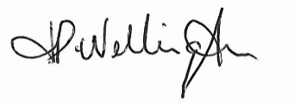 Date: 25/03/2026

Name of School: St Joseph’s Catholic School & Sixth Form Centre

The Admission Policy of the Governors of St Joseph’s is as follows:

- The ethos of this school is Catholic. The school was founded by the Catholic Church to provide education for children of Catholic families. The school is conducted by its governing body as part of the Catholic Church in accordance with its Trust Deed and Instrument of Government and seeks at all times to be a witness to Jesus Christ. We ask all parents applying for a place here to respect this ethos and its importance to the school community. This does not affect the right of parents who are not of the faith of this school to apply for and be considered for a place here.

- The School’s Admission Number for the school year 2027/28 is 144 (NPT Secondary School Capacity Calculation, summer 2021).

- If the number of applications exceeds the admission number, the governors will give priority to applications in accordance with the criteria listed, provided that the governors are made aware of that application before decisions on admissions are made (see Note 1 below).

- In all categories the governors will give priority to those who have a brother or sister (see Note 3 below) attending St Joseph’s at the time of admission and then to those children living closest to the school determined by shortest distance (see Note 5).

- Baptised Catholic children (see Note 2 below) who are (or who have ever been) in the care of the local authority (children in care) or provided with accommodation by the local authority (e.g. children with foster parents) (Section 22 of the Children Act 1989); and baptised Catholic children who are adopted or who are the children of military personnel.

- Non-Catholic children who are (or who have ever been) in the care of a local authority (children in care) or provided with accommodation by the local authority (e.g. children with foster parents) (Section 22 of the Children Act 1989); and children who are adopted or who are the children of military personnel.

- Baptised Catholic children who currently attend a designated Catholic feeder school (see Note 4 below).

- Baptised Catholic children who currently live in the parish area of a designated Catholic feeder school who are not currently attending the designated Catholic feeder school (see note 4 below).

- Other Baptised Catholic children.

- Non-Catholic children who currently attend a designated Catholic feeder school.

- Other Non-Catholic children.

NOTES

Note 1
Children with a Statement of Special Educational Needs that name the school must be admitted. This will reduce the number of places available to other applicants.

Note 2
In all categories, for a child to be considered as a Catholic, evidence of Catholic Baptism or Reception into the Church will be required. For a definition of Baptised Catholic see the Appendix. Those who face difficulties in producing written evidence of baptism should contact their Parish Priest.
Parents making an application for a Catholic child should also complete a supplementary information form (SIF). Failure to complete the SIF may affect the criterion the child’s name is placed in.

Note 3
For Catholic and non-Catholic children the definition of a brother or sister is:

- A brother or sister sharing the same parents;
- Half-brother or half-sister, where two children share one common parent;
- Step-brother or step-sister, where two children are related by a parent’s marriage;
- Adopted or fostered children

The children must be living permanently in the same household.

Note 4
The designated feeder schools for St Joseph’s Catholic School & Sixth Form Centre are:

St. Joseph’s Catholic Junior School, Port Talbot;
St. Therese’s Catholic Primary School, Sandfields;
St. Joseph’s Catholic Primary School, Neath.

N.B. Traditionally some Catholic pupils from Neath-Port Talbot attend St. Joseph’s in Clydach and may choose to return to educational provision in their own local authority by electing to attend St. Joseph’s Catholic School & Sixth Form Centre.

The parish areas for the feeder schools are as follows:
St. Joseph, Port Talbot;
St. Philip Evans, Cwmavon;
St. Therese of Lisieux, Sandfields;
Our Lady of Margam, Margam;
St Joseph, Cymer;
St. Joseph, Neath;
Our Lady of the Assumption, Briton Ferry;
St. John Kemble, Glynneath;
St. Benedict, Clydach;
Sacred Heart, Ystradgynlais.
Parish maps are available in the parishes and at the schools or by post on request.

Note 5
Distances are calculated on the basis of nearest suitable walking distance between the applicant’s home address and a point decided by the school, usually the front gate. The local authority uses a computerised system, which measures all distances in metres. Ordnance Survey supplies the co-ordinates that are used to plot an applicant’s home address within this system.

The home address of a pupil is considered to be the permanent residence of a child. The address must be the child’s only or main residence for the majority of the school week. Documentary evidence may be required.

Where care is split equally between mother and father, parents must name which address is to be used for the purpose of allocating a school place and proof may be requested.

APPLICATIONS

Applications may be made via NPT’s online process or by means of a written application form (obtainable from the school and printable from the school’s website). In accordance with the new statutory code letters confirming secondary places will be issued on the same date, the common offer date for the local authority.

APPEALS

Parents who wish to appeal against the decision of the Governors to refuse their child a place in the school may apply in writing to Chair of Governors. Appeals will be heard by an independent panel.

REPEAT APPLICATIONS

Unless there are significant and material changes in the circumstances of a parent’s application for their child or the school, the governors will not consider a repeat application in the same academic year.

LATE APPLICATIONS

Late applications will be dealt with according to the local authority co-ordinated scheme.

CHANGE OF PREFERENCE
Once parent/carers have submitted their preferences they will not be allowed to change them without an exceptional change in circumstances, for example, if the family has recently moved address or an older sibling has changed schools.

All requests to change preferences should be made in writing to the Local Authority.

Any parent/carer who submits an application for a change of preference for an oversubscribed school, without an exceptional change in their circumstances, will have that application refused.

APPLICATIONS OTHER THAN THE NORMAL INTAKE TO Y7

For transfers for other schools in NPTCBC, applications should be made to the local authority who will need to consult with the school. For transfers from out of county (or from abroad), applicants may contact the local authority, who will contact the school, or directly to the school.

WAITING LISTS

Parents whose children have not been offered their preferred school will be informed of their right of appeal and will be added to their preferred school’s waiting list.

The Local Authority will send voluntary aided and foundation schools their waiting lists following the offer of school places.

Waiting lists for admission will remain open until the 30 September and will then be discarded. Parents may apply for their child’s name to be reinstated until the end of the academic year when the list will be discarded.

Waiting lists will not be fixed following the offer of places. They will be held in accordance with the order of priority for allocating places and are therefore subject to change. This means that a child’s position on the waiting list could go up or down. Any late applicants accepted will be added to the school’s list in accordance with the order of priority for allocating places.

Inclusion on a school’s waiting list does not mean that a place will eventually become available. It may be that those already offered places may accept them, thereby filling all available places.

Children who are the subject of a direction by a local authority to admit or who are allocated to a school in accordance with a Fair Access Protocol take precedence over those on a waiting list.

IN YEAR FAIR ACCESS PROTOCOL

The governing body has adopted the LA fair access protocol for admission of previously excluded or hard to place children.

YEAR 12 ADMISSIONS POLICY

The School’s Admission Number for year 12 for 2026 – 27 is 143 (NPT Secondary School Capacity Calculation, summer 2021).

Students who are already on roll at St. Joseph’s Catholic School & Sixth Form Centre do not need to apply (though they will be asked to indicate whether or not they intend to remain and if so, will state their preferred subject options). If the number of applications exceeds 143, the governors will give priority to applications in accordance with the same criteria set out for Year 7 entry.

There is no charge or cost related to the admission of a child to St. Joseph’s Catholic School & Sixth Form Centre.

Appendix

DEFINITION OF A “BAPTISED CATHOLIC”

A “Baptised Catholic” is one who:
Has been baptised into full communion (Cf. Catechism of the Catholic Church, 837) with the Catholic Church by the Rites of Baptism of one of the various ritual Churches in communion with the See of Rome (i.e. Latin Rite, Byzantine Rite, Coptic, Syriac, etc, Cf. Catechism of the Catholic Church, 1203). Written evidence* of this baptism can be obtained by recourse to the Baptismal Registers of the church in which the baptism took place (Cf. Code of Canon Law, 877 & 878).

Or
Has been validly baptised in a separated ecclesial community and subsequently received into full communion with the Catholic Church by the Right of Reception of Baptised Christians into the Full Communion of the Catholic Church. Written evidence of their baptism and reception into full communion with the Catholic Church can be obtained by recourse to the Register of Receptions, or in some cases, a sub-section of the Baptismal Registers of the church in which the Rite of Reception took place (Cf. Rite of Christian Initiation, 399).

WRITTEN EVIDENCE OF BAPTISM
The Governing bodies of Catholic schools will require written evidence in the form of a Certificate of Baptism or Certificate of Reception before applications for school places can be considered for categories of “Baptised Catholics”. A Certificate of Baptism or Reception is to include: the full name, date of birth, date of baptism or reception, and parent(s) name(s). The certificate must also show that it is copied from the records kept by the place of baptism or reception.

Those who would have difficulty obtaining written evidence of baptism for a good reason, may still be considered as baptised Catholics but only after they have been referred to their parish priest who, after consulting the Judicial Vicar, will decide how the question of baptism is to be resolved and how written evidence is to be produced in accordance with the law of the Church.

Those who would be considered to have good reason for not obtaining written evidence would include those who cannot contact the place of baptism due to persecution or fear, the destruction of the church and the original records, or where baptism was administered validly but not in the Parish church where records are kept.

Governors may request extra supporting evidence when the written documents that are produced do not clarify the fact that a person was baptised or received into the Catholic Church, (i.e. where the name and address of the Church is not on the certificate or where the name of the Church does not state whether it is a Catholic Church or not.)



Be Joyful, Learn and Keep the Faith
Byddwch yn Hapus, Dysgwch a Chadwch y Ffydd

St Therese’s Catholic Primary School


ADMISSION POLICY
(including Appeals Procedures)
Academic Year 2027-2028

Date Reviewed by Governing Body: 23rd March, 2026

Signature of Chair:

Signature of Headteacher:

Date to be further reviewed: Spring Term 2027

St Therese’s Catholic Primary School - Admission Policy

- St Therese’s is a Catholic Primary School situated in the Diocese of Menevia and is maintained by the Neath Port Talbot Local Education Authority.
- The Governing Body is responsible for determining and administrating the policy relating to admission of pupils to the school. It is guided in that responsibility by:
- the requirement of the law;
- the advice of the Diocesan Trustees on the nature and purpose of its duties and in fulfilment of its Trust Deed and Instrument of Government;
- its duty towards the school and Catholic community it serves;
- the Catholic character of the school and its Mission Statement.

The ethos of this school is Catholic. The school was founded by the Catholic Church to provide education for children of Catholic families. We ask all parents applying for a place here to support and respect this ethos, its importance to the school community and the education it provides. This does not affect the right of parents who are not of the faith of this school to apply for and be considered for a place here.

The School’s Admission Number for the school year beginning in September is 30.

If the number of applications exceeds the admission number, the governors will give priority to applications in accordance with the criteria listed provided that the governors are made aware of that application before decisions on admissions are made (see Note 1 below). If there is oversubscription within a category, the governors will give priority to children living closest to the school determined by the shortest distance (see Note 4).

- The school serves in the first instance Baptised Catholic children living in the parishes of St Therese’s, St Joseph’s Port Talbot, Our Lady of The Assumption, Briton Ferry and Our Lady of Margam.

- Applications for a place in the school must be made on the enclosed form and returned to the school no later than April prior to child starting school.

- The Governing Body has delegated responsibility for determining admissions to its Admissions Committee, which will consider all applications at the same time and after the closing date for admissions, made in accordance with the criteria set out over.

- Pupils who are admitted to the school will enter the Reception class in the month of September.

- If an application for admission has been turned down by the Governing Body, parents can appeal to an Independent Appeals Panel. This appeal must be sent in writing to the Clerk to the Governors at the school within 14 days (10 working days) of refusal. Parents must give reasons for appealing in writing and the decision of the appeals panel is binding on the Governors.
If the school is named in a statement of Special Educational Needs, the Governing Body has a duty to admit the child to the school.
As required by law the Governing Body will not admit more than 30 pupils to any one Reception or Infant class.

Admissions Criteria

Where the number of applications exceeds the number of places available, the Governing Body will apply the following over-subscription criteria in priority order:

- Baptised Catholic ‘Looked After’ children (or previously looked after), in the care of a local authority, within the parishes served by the school.

- Looked After Children (or previously looked after) who are in the care of a local authority (children in care) or provided with accommodation by them (e.g. children with foster parents)

- Baptised Catholic children within the parishes served by the school.

- Other Baptised Catholic children.

- Baptised Catholic children who have a brother or a sister at the school at the time of likely admission.

- Any other children who have a brother or sister in the school at the time of admission.

- Children of other Christian Denominations whose parents seek Catholic schooling.

- Children of other faiths whose parents seek Catholic education for their child.

- Any other children whose parents seek Catholic education for their child.

- Children for whom the LEA has specifically asked for a place at the school.

Tie breaker for all categories

In the event of a tie breaker being required in any of the categories above, the governors will admit those applicants who live nearest the school. In the case of a child whose parents have joint/shared responsibility the parent who has the greater responsibility during the school week and whose residence is nearer the school will be the determining factor. Proof of residency will be required in the form of one of the following:

- Current council tax notification letter for the address on the application
- Current child tax credit note
- Current child benefit notification letter
- Current income support notification
- Current pension award notification
- Current housing benefit notification

The governors will use the shortest walking route calculated using Ordnance Survey customised route data from the front door of the school to the front door of the house or flat of the applicant. Where necessary, the governors will request assistance from the local authority to determine the shortest route.

Waiting List

A waiting list of unsuccessful applications will be maintained. If a place becomes available, the governors will consider those on the waiting list on the basis of the published oversubscription criteria, not on the date the application was received. If the governors place an application on the waiting list it will not affect the parent’s right of appeal. The waiting list will be maintained until 30th September in the school year that the application was made. After that date, the parent must inform the school that the application should be taken forward to the next academic year.

NOTES

Note 1.
Children with a Statement of Special Educational Needs who name the school must be admitted. This will reduce the number of places available to applicants.
Note 2.
In all categories, for a child to be considered as a Catholic, evidence of Catholic Baptism or Reception into the Church will be required. Those who face difficulties in producing written evidence of Catholic Baptism/Reception should contact their Parish Priest.

Parents making an application for a Catholic child should also complete a supplementary information form (SIF). Failure to complete the SIF/provide evidence of Catholic Baptism/Reception may affect the criterion the child’s name is placed in.
Note 3.
For Catholic and non-Catholic children the definition of a brother or sister is:
- A brother or sister sharing the same parents;
- Half-brother or half-sister, where two children share one common parent;
- Step-brother or step-sister, where two children are related by a parent’s marriage;
- Step-brother or step-sister;
- Adopted or fostered children
The children must be living permanently in the same household.

Note 4.
Distances are calculated on the basis of a straight-line measurement between the applicant’s home address and a point decided by the school, usually the front gate. The local authority uses a computerised system, which measures all distances in metres. Ordnance Survey supply the co-ordinates that are used to plot an applicant’s home address within this system.

In a very small number of cases it may not be able to decide between the applicants of those pupils who are qualifiers for a place, when applying the published admission criteria.

For example, this may occur when children in the same year group live at the same address, or where there are twins, or if the distance between the home and school is exactly the same, for example, blocks of flats. If there is no other way of separating the application according to the admissions criteria and to admit both or all of the children would cause the legal limit to be exceeded, the local authority will use a computerised system to randomly select the child to be offered the final place.

The home address of a pupil is considered to be the permanent residence of a child. The address must be the child’s only or main residence for the majority of the school week. Documentary evidence may be required.

Where care is split equally between mother and father, parents must name which address is to be used for the purpose of allocating a school place and proof may be requested.

Note 5
- Admissions to the Nursery classes do not necessarily secure admissions to the Primary School.
- The Governing Body reserve the right to admit children with proven and exceptional medical and social needs where admission to the Nursery class may best satisfy those exceptional needs, providing that such an application is submitted with appropriate evidence or report from the doctor or social worker. If the school is named in a statement of special educational needs the Governing Body has a duty to admit the child to the school. All Christian applicants will be required to produce baptismal certificates.
- The decision with regard to the allocation of a morning or afternoon place rests with the Headteacher.

How to apply for academic year 2027 - 2028?

Prospective parents may ring or call into the school to fill out an application form. Applications open from the first day of September and close Friday 20th November, 2026.

The school will need to see the full original birth certificate.

St Therese’s Catholic Primary School Ysgol Catholig San Therese



E-mail: stthereses@npt.school
Website: http://st-thereses-catholic-primary-school.j2bloggy.com/

ADMISSION APPLICATION
AND
HOME-SCHOOL-PUPIL-AGREEMENT

As a Parent/Guardian I will:
- Support the school in its efforts to live, learn and grow as a Catholic Christian community
- Ensure that my child attends school regularly, on time, properly equipped and in school uniform
- Inform the school of any concerns or problems that might affect my child’s well-being, work or behaviour
- Support the school’s policies and guidelines, including those relating to behaviour
- Support my child in homework and other opportunities for home learning
- Attend Parents’ Evenings on designated dates and any discussions about my child’s progress
- Provide a note of explanation if my child is absent and consider carefully the effects of missing school before booking family holidays during term time

As a School we will:
- Encourage children to achieve their full potential in a secure and stimulating environment informed by Catholic Christian values
- Contact parents if there is a problem with attendance, punctuality or equipment
- Arrange Parents’ Evenings during which progress will be discussed and any problems that affect your child’s work, behaviour or well being
- Keep parents informed about school life through termly newsletters, regular letters and notices about special events
- Set, mark and monitor homework

As a pupil I will:
- As a member of a Christian Community show respect, care and concern to children, staff and visitors alike
- Attend school regularly, on time and in uniform
- Do all my classwork and homework to the best of my ability and hand it in on time
- Follow the school’s Code of Conduct and rules for good behaviour
- Take home newsletters, school letters and notices about special events

- Name of Pupil………………………………………………(Male/Female)

- Date………………………………

- Signed…………………………………………….…………….(Parent)

- Signed…………………………(Pupil – Key Stage 2 only)

Signed………………………………………………….… (Headteacher)

You have requested admission of your child into St Therese’s Catholic Primary School. The procedure is as follows:
- Please fill in the form as completely as possible.
- If your child was baptised at St Therese's and you are attending this Church, please make an appointment to see Father Paul Brophy to confirm facts. His telephone number is 01639 - 884791.
- The application will be considered by the Admissions Panel and signed by the Chair of Governors.

Name of Child............................................................................(Male/Female)

Full
Address.....................................................................................................

Post Code………………………………………………………………..

Telephone Number.....................................................................................................

Father’s Full Name........................................................................................................

Mother’s Full Name........................................................................................................

Child’s Date of Birth..........................................................................................................

Church of Child’s Baptism.....................................................................................................

Date of Child’s Baptism...............................................................................................

Signature of Parish Priest where child was baptized (if applicable)

……………………………………………………………………….

Signature of Chairman of Governors.............................................................................................

Medical Information: please give any information which the school needs to be aware of:

..................................................................................................................

Declaration: (*delete as appropriate)
*We/I agree to abide by the above rules of St Therese's Catholic Primary School.

Signed..........................................................................................(parent)

Date………………………………………………………………..…...

Child's Name...........................................................................................

Signed………………………………………(Pupil – Key Stage 2 only)


Cyngor Bwrdeistref Sirol Castell-nedd Port Talbot (Rhestr Ysgolion)

Andrew D Thomas Cyfarwyddwr Addysg Hamdden a Dysgu Hyd Oes Cyngor Bwrdeistref Sirol Castell-nedd Port Talbot
Y Ganolfan Ddinesig
Port Talbot SA13 1PJ
Neath Port Talbot County Borough Council (School List)

Andrew D Thomas
Director of Education, Leisure & Lifelong Learning Neath Port Talbot County Borough Council
Civic Centre Port Talbot SA13 1PJ

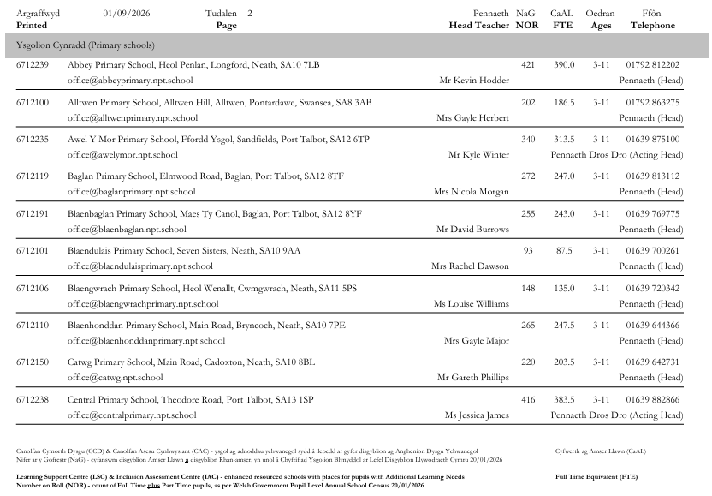
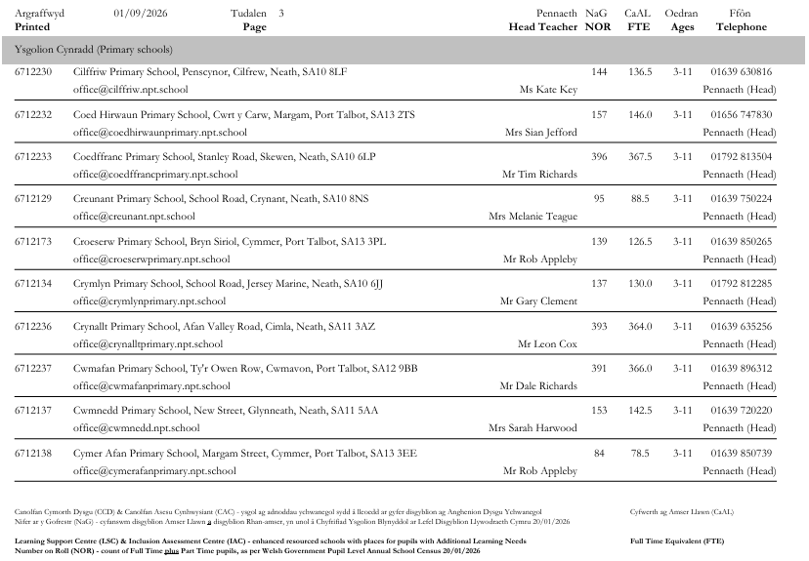
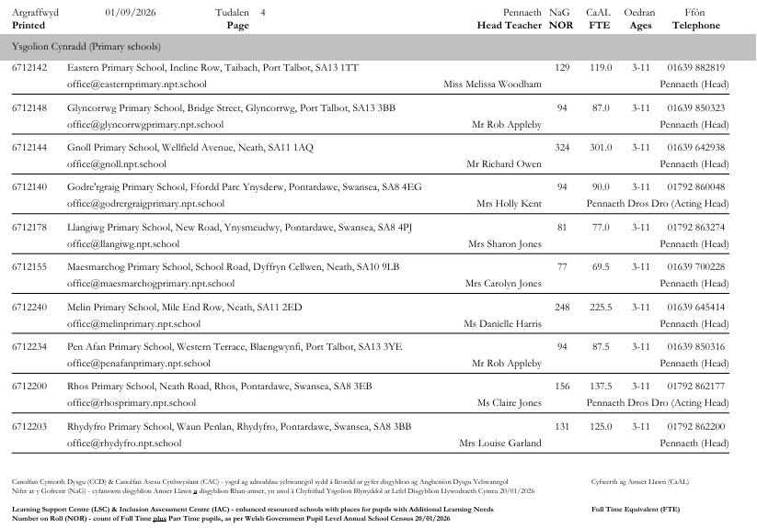
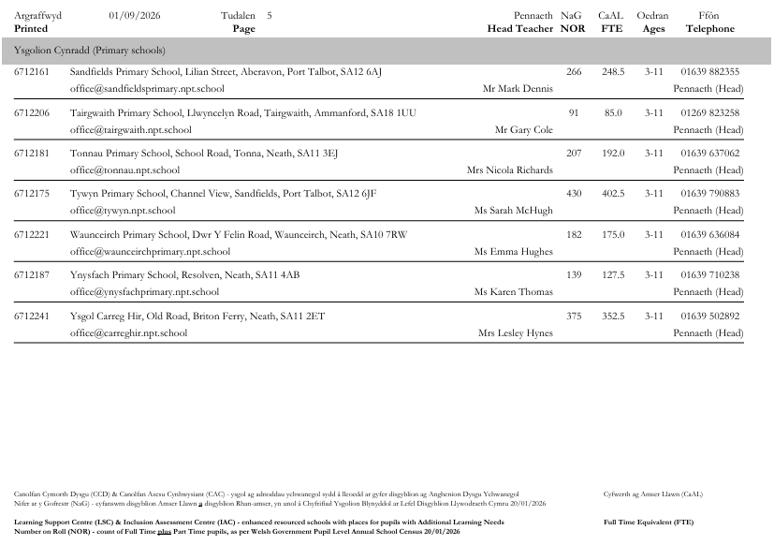
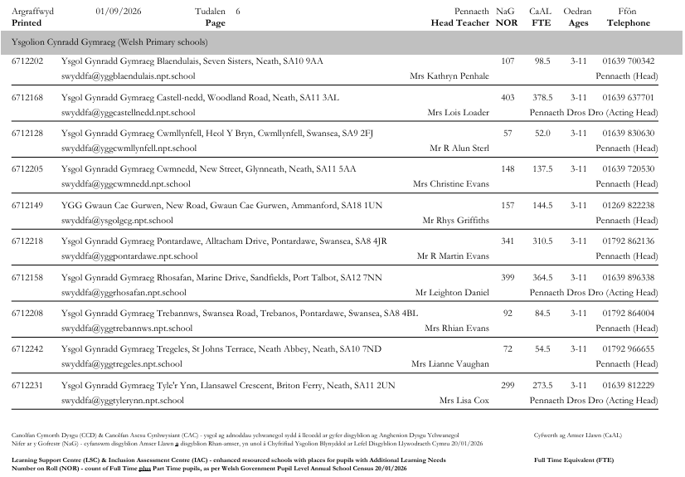
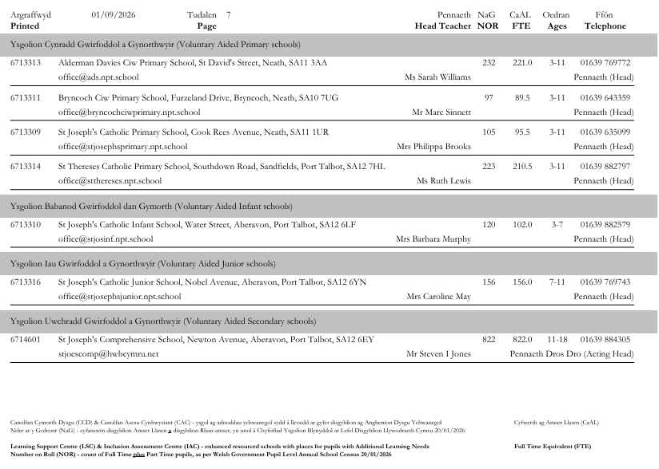
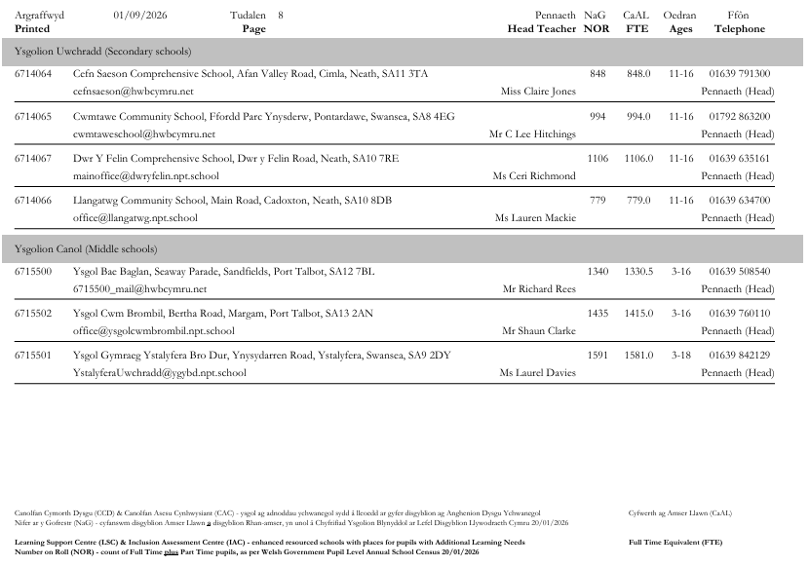
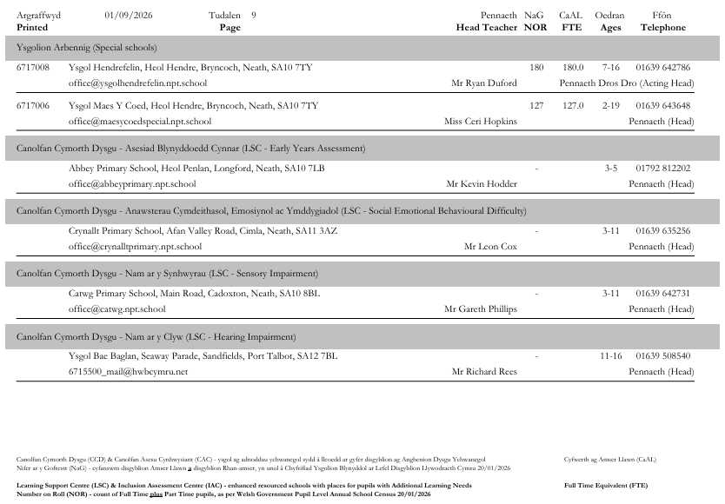
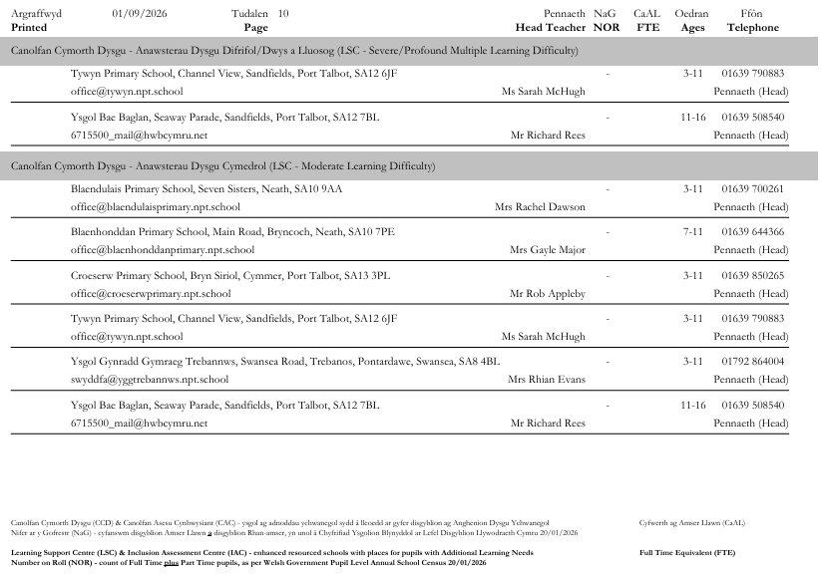
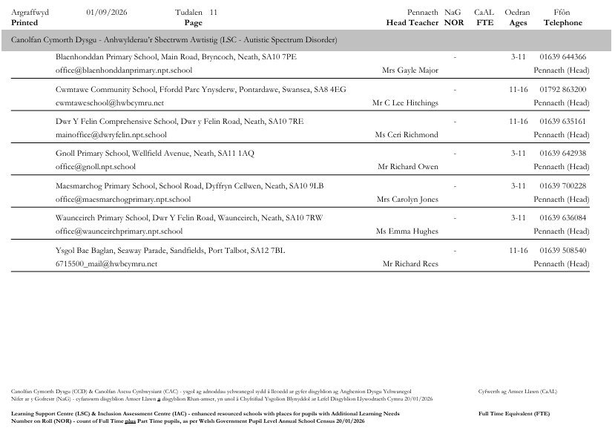
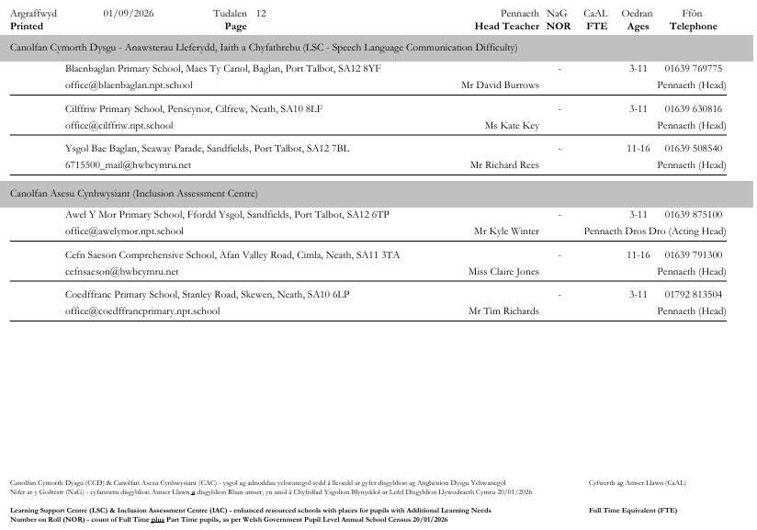

School Terms and Holiday Dates
2027/2028 Academic Year

 |  | Mid Term Holiday
Term | Term Begins | Begins | Ends | Term Ends | Days
Autumn  2027 | Wednesday  1st  September | Monday  25th October  October | Friday  29th  October | Friday  17th December | 73
Spring  2028 | Tuesday  4th  January | Monday  21st  February | Friday  25th  February | Friday  7th  April | 64
Summer  2028 | Monday  24th  April | Monday  29th  May | Friday  2nd  May | Thursday  20th  July | 58
 |  |  |  | Total | 195

Schools will be closed to pupils for INSET/Staff Preparation on five days between Wednesday 1st September 2027 and Thursday 20th July 2028.

Bank Holidays
Good Friday Friday 14th April 2028
Easter Monday Monday 17th April 2028
May Bank Holiday Monday 1st May 2028
Spring Bank Holiday Monday 29th May 2028

A looked after child refers to a child who is looked after by the local authority, in accordance with section 74 of the Social Services and Well-being (Wales) Act 2014 or under Section 22(1) of the Children Act 1989 at the time an application to a school is made and who the local authority has confirmed will still be looked after at the time of admission to the school. Previously looked after children: looked after children who cease to be so because they were adopted or become subject to a residence order, or special guardianship order immediately following having been looked after.
Reference to a partner primary school is in relation to the school for which the application is made. For the definition of a partner primary school see para. 8
Reference to a partner primary school is in relation to the school for which the application is made. For the definition of a partner primary school see para. 8
Children admitted to the primary phase of an ‘all-through’ school do not have to apply for a place at the same school at secondary transfer.
Voluntary aided (i.e. Faith) schools admission numbers included
This is for admission to the school at the start of the school year in September and not for applications made in-year
This is for admission to the school at the start of the school year in September and not for applications made in-year.
This is for admission to the school at the start of the school year in September and not for applications made in-year
Please delete the words in square brackets as appropriate.
This is for admission to the school at the start of the school year in September and not for applications made in-year.
This does not require completion where an application is being made by a pupil on their own behalf for entry to year 12.
This is for admission to the school at the start of the school year in September and not for applications made in-year
This is for admission to the school at the start of the school year in September and not for applications made in-year.
This section will need to be tailored to follow the procedure within the school’s home local authority to ensure that it is in accordance with the local authority’s scheme for co-ordination of admissions.

